Philippine Bidding Documents
PROCUREMENT OF GOODS

TITLE: SUPPLY AND DELIVERY OF HDPE TUBING AND PLASTIC FITTINGS REQUIREMENT OF THE SMWD FOR CY 2024
Project Reference No. PB2024-SMWD-G-01-004

Government of the Republic of the Philippines

Sixth Edition
July 2020

Preface

These Philippine Bidding Documents (PBDs) for the procurement of Goods through Competitive Bidding have been prepared by the Government of the Philippines for use by any branch, constitutional commission or office, agency, department, bureau, office, or instrumentality of the Government of the Philippines, National Government Agencies, including Government-Owned and/or Controlled Corporations, Government Financing Institutions, State Universities and Colleges, and Local Government Unit. The procedures and practices presented in this document have been developed through broad experience, and are for mandatory use in projects that are financed in whole or in part by the Government of the Philippines or any foreign government/foreign or international financing institution in accordance with the provisions of the 2016 revised Implementing Rules and Regulations of Republic Act No. 9184.

The Bidding Documents shall clearly and adequately define, among others: (i) the objectives, scope, and expected outputs and/or results of the proposed contract or Framework Agreement, as the case may be; (ii) the eligibility requirements of Bidders; (iii) the expected contract or Framework Agreement duration, the estimated quantity in the case of procurement of goods, delivery schedule and/or time frame; and (iv) the obligations, duties, and/or functions of the winning bidder.

Care should be taken to check the relevance of the provisions of the PBDs against the requirements of the specific Goods to be procured. If duplication of a subject is inevitable in other sections of the document prepared by the Procuring Entity, care must be exercised to avoid contradictions between clauses dealing with the same matter.

Moreover, each section is prepared with notes intended only as information for the Procuring Entity or the person drafting the Bidding Documents. They shall not be included in the final documents. The following general directions should be observed when using the documents:

- All the documents listed in the Table of Contents are normally required for the procurement of Goods. However, they should be adapted as necessary to the circumstances of the particular Procurement Project.

- Specific details, such as the “name of the Procuring Entity” and “address for bid submission,” should be furnished in the Instructions to Bidders, Bid Data Sheet, and Special Conditions of Contract. The final documents should contain neither blank spaces nor options.

- This Preface and the footnotes or notes in italics included in the Invitation to Bid, Bid Data Sheet, General Conditions of Contract, Special Conditions of Contract, Schedule of Requirements, and Specifications are not part of the text of the final document, although they contain instructions that the Procuring Entity should strictly follow.

- The cover should be modified as required to identify the Bidding Documents as to the Procurement Project, Project Identification Number, and Procuring Entity, in addition to the date of issue.

- Modifications for specific Procurement Project details should be provided in the Special Conditions of Contract as amendments to the Conditions of Contract. For easy completion, whenever reference has to be made to specific clauses in the Bid Data Sheet or Special Conditions of Contract, these terms shall be printed in bold typeface on Sections I (Instructions to Bidders) and III (General Conditions of Contract), respectively.

- For guidelines on the use of Bidding Forms and the procurement of Foreign-Assisted Projects, these will be covered by a separate issuance of the Government Procurement Policy Board.

Table of Contents
Glossary of Acronyms, Terms, and Abbreviations ………………………….Error! Bookmark not defined.
Section I. Invitation to Bid……………………………………………………..2
Section II. Instructions to Bidders…………………………………………...6
1. Scope of Bid ………………………………………………………………………. 8
2. Funding Information………………………………………………………………. 8
3. Bidding Requirements ……………………………………………………………. 8
4. Corrupt, Fraudulent, Collusive, and Coercive Practices 8
5. Eligible Bidders…………………………………………………………………… 9
6. Origin of Goods ………………………………………………………………….. 9
7. Subcontracts ……………………………………………………………………… 9
8. Pre-Bid Conference ………………………………………………………………. 9
9. Clarification and Amendment of Bidding Documents …………………………… 10
10. Documents comprising the Bid: Eligibility and Technical Components …………. 10
11. Documents comprising the Bid: Financial Component …………………………... 10
12. Bid Prices …………………………………………………………………………. 11
13. Bid and Payment Currencies ……………………………………………………… 11
14. Bid Security ………………………………………………………………………. 12
15. Sealing and Marking of Bids ……………………………………………………… 12
16. Deadline for Submission of Bids …………………………………………………. 12
17. Opening and Preliminary Examination of Bids ………………………………….. 13
18. Domestic Preference ……………………………………………………………… 13
19. Detailed Evaluation and Comparison of Bids ……………………………………. 13
20. Post-Qualification ………………………………………………………………… 14
21. Signing of the Contract …………………………………………………………… 14
Section III. Bid Data Sheet …………………………………………………..16
Section IV. General Conditions of Contract ……………………...………..21
1. Scope of Contract ………………………………………………………………… 22
2. Advance Payment and Terms of Payment ……………………………………….. 22
3. Performance Security ……………………………………………………………. 22
4. Inspection and Tests ……………………………………………………………… 22
5. Warranty …………………………………………………………………………. 23
6. Liability of the Supplier ………………………………………………………….. 23
Section V. Special Conditions of Contract ………………………………….24
Section VI. Schedule of Requirements ……………………………………....30
Section VII. Technical Specifications …………………………………………31
Section VIII. Checklist of Technical and Financial Documents …………..37

Section I. Invitation to Bid

Invitation to Bid for
SUPPLY AND DELIVERY OF HDPE TUBING AND PLASTIC FITTINGS REQUIREMENT OF THE SMWD FOR CY 2024

- The Santa Maria Water District has included in its 2023 Annual Procurement Plan (APP) procurement of HDPE Tubing and Plastic Fittings for new service connections, repairs and rehabilitation purposes. The sum of Two Million Three Hundred Forty-Eight Thousand Pesos (PhP2,348,000.00) has been intended to payments under the contract for Supply and Delivery of HDPE Tubing and Plastic Fittings Requirement of the SMWD for CY 2024 with Reference No. PB2024-SMWD-G-01-004. Bids received in excess of the ABC shall be automatically rejected at bid opening.

- The Santa Maria Water District now invites manufacturers of HDPE Tubing and Authorized Distributors of Plastic Fittings to bid for the following:

ITEMS/DESCRIPTION | UNIT | QTY
LOT 1
HDPE TUBING 1/2 SDR 11 (BLUE) | MTR | 15266
HDPE TUBING 3/4 SDR 11 (BLUE) | MTR | 18
HDPE TUBING 1 SDR 11 (BLUE) | MTR | 2091
LOT 2
PLASTIC ADAPTOR 1/2 | PC | 3600
PLASTIC ADAPTOR 3/4 | PC | 22
PLASTIC ADAPTOR 1 | PC | 712
PLASTIC ELBOW 1 X 90 (32MM) | PC | 95
PLASTIC ELBOW ½ X 90 (20mm) | PC | 200
PLASTIC ELBOW 3/4 X 90 | PC | 6
PLASTIC SADDLE CLAMP 2 X 1 WITH TAPPING FERRULE | PC | 198
PLASTIC SADDLE CLAMP 3 X 1 WITH TAPPING FERRULE | PC | 198
PLASTIC SADDLE CLAMP 4 X 1 WITH TAPPING FERRULE | PC | 240
PLASTIC SADDLE CLAMP 6 X 1 WITH TAPPING FERRULE | PC | 114
PLASTIC SADDLE CLAMP 8 X 1 WITH TAPPING FERRULE | PC | 35
UPVC UNION COUPLING 1/2 | PC | 930
UPVC UNION COUPLING 3/4 | PC | 10
UPVC UNION COUPLING 1 | PC | 140
*** NOTHING FOLLOWS ***

Delivery of the Goods is required within fifteen (15) days upon receipt of Purchase Order (P.O). Bidders should have completed, within two (2) years from the date of submission and receipt of bids, a contract similar to the Project which is at least twenty five percent

(25%) of the ABC. The description of an eligible bidder is contained in the Bidding Documents, particularly, in Section II (Instructions to Bidders).

- Bidding will be conducted through open competitive bidding procedures using a non-discretionary “pass/fail” criterion as specified in the 2016 revised Implementing Rules and Regulations (IRR) of Republic Act (RA) No. 9184. The approved budget for the contract (ABC) of Two Million Three Hundred Forty-Eight Thousand Pesos (P2,348,000.00) will be divided into two (2) lots:

Lot 1 - HDPE Tubing …………………………………P 533,000.00
Lot 2 – Plastic Fittings………………………………… 1,815,000.00

Suppliers/manufacturers can bid to each lot separately or for the whole lots (Lot 1 & 2)

Bidding is restricted to Filipino citizens/sole proprietorships, partnerships, or organizations with at least sixty percent (60%) interest or outstanding capital stock belonging to citizens of the Philippines, and to citizens or organizations of a country the laws or regulations of which grant similar rights or privileges to Filipino citizens, pursuant to RA No. 5183.

- Prospective Bidders may obtain further information from Santa Maria Water District and may view and inspect the Bidding Documents in PhilGEPs and Santa Maria Water District’s website at www.smwdbulacan.gov.ph.

- A complete set of Bidding Documents may be acquired by interested Bidders on January 29 to February 19, 2024 from the given address below and upon payment of a non-refundable fee of Three Thousand Pesos (PhP3,000.00), if the bidder/s opt to bid for two (2) lots. If the bidder will bid per lot, the fee shall be as follows:

Lot No. 1 - HDPE Tubing ………………………P 1,000.00
Lot No. 2 - Plastic Fittings……………………… 3,000.00

The Procuring Entity shall allow the bidders to present its proof of payment for the fees
through email indicated below.

It may also be downloaded free of charge from the website of the Philippine Government Electronic Procurement System (PhilGEPS). and the website of the Procuring Entity, provided that Bidders shall pay the applicable fee for the Bidding Documents not later than the submission of their bids.

- The Santa Maria Water District will hold a Pre-Bid Conference on February 7, 2024 1:30 PM face to face, which shall be open to all prospective bidders.

- Bids must be duly received by the BAC Secretariat through manual submission, LBC or any Freight Service at the office address indicated below on or before 12:00 PM on
February 19, 2024. The official time is the one reflected in the biometrics located in the ground floor of the SMWD Building. Late bids shall not be accepted.

- All Bids must be accompanied by a bid security in any of the acceptable forms and in the amount stated in ITB Clause 14.

- Bid opening shall be on February 19, 2024 1:00 PM at 4th Floor SMWD Bldg. No. 302 J.P. Rizal St., Poblacion, Santa Maria, Bulacan. Bids will be opened in the presence of the bidders’ representatives who choose to attend the activity.

- The summary of the bidding activities is as follows:

Advertisement/posting of Invitation to Bid | January 29 to February 5, 2024
Issuance and Availability of Bid Documents | January 29 to February 19, 2024
Pre-Bid Conference | February 7, 2024 @ 1:30 P.M
Last day of Submission of Written Clarification | February 10, 2024
Last day of Issuance of Bid Bulletin (if any) | February 14, 2024
Deadline for Submission of Bids | February 19, 2024 @ 12:00 P.M
Opening of Bids | February 19, 2024 @ 1:00 P.M

- The Santa Maria Water District reserves the right to reject any and all bids, declare a failure of bidding, or not award the contract at any time prior to contract award in accordance with Sections 35.6 and 41 of the 2016 revised IRR of RA No. 9184, without thereby incurring any liability to the affected bidder or bidders.

- For further information, please refer to:

Charito S. Fernando-BAC Secretariat
3rd Floor, SMWD Building
No. 302 J.P Rizal St., Poblacion, Santa Maria, Bulacan
CP# 0917-138-8683 & (044) 815-3238
Email Address: smwdbulacan@yahoo.com
Website: smwdbulacan.gov.ph

Date of Issue: January 29, 2024
_______________sgd__________________
Maria Leonora S. Romarate
Chairperson

Section II. Instructions to Bidders

TABLE OF CONTENTS

A. General Error! Bookmark not defined.
1. Scope of Bid Error! Bookmark not defined.
2. Source of Funds Error! Bookmark not defined.
3. Corrupt, Fraudulent, Collusive, and Coercive Practices Error! Bookmark not defined.
4. Conflict of Interest Error! Bookmark not defined.
5. Eligible Bidders Error! Bookmark not defined.
6. Bidder’s Responsibilities Error! Bookmark not defined.
7. Origin of Goods Error! Bookmark not defined.
8. Subcontracts Error! Bookmark not defined.
B. Contents of Bidding Documents Error! Bookmark not defined.
9. Pre-Bid Conference Error! Bookmark not defined.
10. Clarification and Amendment of Bidding Documents Error! Bookmark not defined.
C. Preparation of Bids Error! Bookmark not defined.
11. Language of Bid Error! Bookmark not defined.
12. Documents Comprising the Bid: Eligibility and Technical Components Error! Bookmark not defined.
13. Documents Comprising the Bid: Financial Component Error! Bookmark not defined.
14. Alternative Bids Error! Bookmark not defined.
15. Bid Prices Error! Bookmark not defined.
16. Bid Currencies Error! Bookmark not defined.
17. Bid Validity Error! Bookmark not defined.
18. Bid Security Error! Bookmark not defined.
19. Format and Signing of Bids Error! Bookmark not defined.
20. Sealing and Marking of Bids Error! Bookmark not defined.
D. Submission and Opening of Bids Error! Bookmark not defined.
21. Deadline for Submission of Bids Error! Bookmark not defined.
22. Late Bids Error! Bookmark not defined.
23. Modification and Withdrawal of Bids Error! Bookmark not defined.
24. Opening and Preliminary Examination of Bids Error! Bookmark not defined.

E. Evaluation and Comparison of Bids Error! Bookmark not defined.
25. Process to be Confidential Error! Bookmark not defined.
26. Clarification of Bids Error! Bookmark not defined.
27. Domestic Preference Error! Bookmark not defined.
28. Detailed Evaluation and Comparison of Bids Error! Bookmark not defined.
29. Post-Qualification Error! Bookmark not defined.
30. Reservation Clause Error! Bookmark not defined.
F. Award of Contract Error! Bookmark not defined.
31. Contract Award Error! Bookmark not defined.
32. Signing of the Contract Error! Bookmark not defined.
33. Performance Security Error! Bookmark not defined.
34. Notice to Proceed Error! Bookmark not defined.

Scope of Bid

    - The procuring entity is Santa Maria Water District, hereinafter referred to as the “Procuring Entity” wishes to receive bids for the Supply and Delivery of HDPE Tubing and Plastic Fittings Requirement of the SMWD for CY 2024 as described in Section VII Technical Specifications (hereinafter referred to as the “Goods”).
    - The name, identification, and number of lots specific to this bidding are provided in the BDS. The contracting strategy and basis of evaluation of lots is described in ITB Clause 28.

Funding Information

- The GOP through the source of funding as indicated below for the year 2024 in the amount of Two Million Three Hundred Forty-Eight Thousand Pesos (PhP 2,348,000.00).

- The source of funding is:

- GOCC and GFIs, the proposed Corporate Operating Budget for the year 2024

Bidding Requirements

The Bidding for the Project shall be governed by all the provisions of RA No. 9184 and its 2016 revised IRR, including its Generic Procurement Manuals and associated policies, rules and regulations as the primary source thereof, while the herein clauses shall serve as the secondary source thereof.

Any amendments made to the IRR and other GPPB issuances shall be applicable only to the ongoing posting, advertisement, or IB by the BAC through the issuance of a supplemental or bid bulletin.

The Bidder, by the act of submitting its Bid, shall be deemed to have verified and accepted the general requirements of this Project, including other factors that may affect the cost, duration and execution or implementation of the contract, project, or work and examine all instructions, forms, terms, and project requirements in the Bidding Documents.

Corrupt, Fraudulent, Collusive, and Coercive Practices

The Procuring Entity, as well as the Bidders and Suppliers, shall observe the highest standard of ethics during the procurement and execution of the contract. They or through an agent shall not engage in corrupt, fraudulent, collusive, coercive, and obstructive practices defined under Annex “I” of the 2016 revised IRR of RA No. 9184 or other integrity violations in competing for the Project.

Eligible Bidders

5.1. Only Bids of Bidders found to be legally, technically, and financially capable will be evaluated.

5.2. Foreign ownership limited to those allowed under the rules may participate in this Project.

5.3. Pursuant to Section 23.4.1.3 of the 2016 revised IRR of RA No.9184, the Bidder shall have an SLCC that is at least one (1) contract similar to the Project the value of which, adjusted to current prices using the PSA’s CPI, must be at least equivalent to:

- For the procurement of Expendable Supplies: The Bidder must have completed a single contract that is similar to this Project, equivalent to at least twenty-five percent (25%) of the ABC.

5.4. The Bidders shall comply with the eligibility criteria under Section 23.4.1 of the 2016 IRR of RA No. 9184.

Origin of Goods

There is no restriction on the origin of goods other than those prohibited by a decision of the UN Security Council taken under Chapter VII of the Charter of the UN, subject to Domestic Preference requirements under ITB Clause 18.

Subcontracts

    - The Bidder may subcontract portions of the Project to the extent allowed by the Procuring Entity as stated herein, but in no case more than twenty percent (20%) of the Project.

The Procuring Entity has prescribed that:

      - Subcontracting is not allowed.

    - Subcontracting of any portion of the Project does not relieve the Supplier of any liability or obligation under the Contract. The Supplier will be responsible for the acts, defaults, and negligence of any subcontractor, its agents, servants, or workmen as fully as if these were the Supplier’s own acts, defaults, or negligence, or those of its agents, servants, or workmen.

Pre-Bid Conference

The Procuring Entity will hold a pre-bid conference for this Project on the specified date and time and either at its physical address at 4TH Floor SMWD Bldg., No. 302 J.P. Rizal St., Poblacion, Santa Maria, Bulacan face to face as indicated in paragraph 6 of the IB.

Clarification and Amendment of Bidding Documents

Prospective bidders may request for clarification on and/or interpretation of any part of the Bidding Documents. Such requests must be in writing and received by the Procuring Entity, either at its given address or through electronic mail indicated in the IB, at least ten (10) calendar days before the deadline set for the submission and receipt of Bids.

Documents comprising the Bid: Eligibility and Technical Components

    - The first envelope shall contain the eligibility and technical documents of the Bid as specified in Section VIII (Checklist of Technical and Financial Documents).

    - The Bidder’s SLCC as indicated in ITB Clause 5.3 should have been completed within two (2) years prior to the deadline for the submission and receipt of bids.

    - If the eligibility requirements or statements, the bids, and all other documents for submission to the BAC are in foreign language other than English, it must be accompanied by a translation in English, which shall be authenticated by the appropriate Philippine foreign service establishment, post, or the equivalent office having jurisdiction over the foreign bidder’s affairs in the Philippines. Similar to the required authentication above, for Contracting Parties to the Apostille Convention, only the translated documents shall be authenticated through an apostille pursuant to GPPB Resolution No. 13-2019 dated 23 May 2019. The English translation shall govern, for purposes of interpretation of the bid.

Documents comprising the Bid: Financial Component

  - The second bid envelope shall contain the financial documents for the Bid as specified in Section VIII (Checklist of Technical and Financial Documents).

  - If the Bidder claims preference as a Domestic Bidder or Domestic Entity, a certification issued by DTI shall be provided by the Bidder in accordance with Section 43.1.3 of the 2016 revised IRR of RA No. 9184.

  - Any bid exceeding the ABC indicated in paragraph 1 of the IB shall not be accepted.

  - For Foreign-funded Procurement, a ceiling may be applied to bid prices provided the conditions are met under Section 31.2 of the 2016 revised IRR of RA No. 9184.

  - [Include if Framework Agreement will be used:] Financial proposals for single or multi-year Framework Agreement shall be submitted before the deadline of submission of bids as prescribed in the IB. For multi-year Framework Agreement, evaluation of the financial proposal during this stage is for purposes of determining eligibility and whether or not such financial proposal is within the ABC.

Bid Prices

12.1. Prices indicated on the Price Schedule shall be entered separately in the following manner:

      - For Goods offered from within the Procuring Entity’s country:

- The price of the Goods quoted EXW (ex-works, ex-factory, ex-warehouse, ex-showroom, or off-the-shelf, as applicable);

- The cost of all customs duties and sales and other taxes already paid or payable;

- The cost of transportation, insurance, and other costs incidental to delivery of the Goods to their final destination; and

- The price of other (incidental) services, if any, listed in e.

      - For Goods offered from abroad:

- Unless otherwise stated in the BDS, the price of the Goods shall be quoted delivered duty paid (DDP) with the place of destination in the Philippines as specified in the BDS. In quoting the price, the Bidder shall be free to use transportation through carriers registered in any eligible country. Similarly, the Bidder may obtain insurance services from any eligible source country.

- The price of other (incidental) services, if any, as listed in Section VII (Technical Specifications).

12.2. [Include if Framework Agreement will be used:] For Framework Agreement, the following should also apply in addition to Clause 12.1:

- For a single year Framework Agreement, the prices quoted by the Bidder shall be fixed during the Bidder’s performance of the contract and not subject to variation or escalation on any account. Price schedules required under Clause 12.1 shall be submitted with the bidding documents.

- For a multi-year Framework Agreement, the prices quoted by the Bidder during submission of eligibility documents shall be the ceiling and the price quoted during mini-competition must not exceed the initial price offer. The price quoted during call for mini-competition shall be fixed during the Bidder’s performance of that Call-off and not subject to variation or escalation on any account. Price schedules required under Clause 12.1 shall be submitted with the bidding documents.

Bid and Payment Currencies

    - For Goods that the Bidder will supply from outside the Philippines, the bid prices may be quoted in the local currency or tradeable currency accepted by the BSP at the discretion of the Bidder. However, for purposes of bid evaluation, Bids denominated in foreign currencies, shall be converted to Philippine currency based on the exchange rate as published in the BSP reference rate bulletin on the day of the bid opening.

    - Payment of the contract price shall be made in:

      - Philippine Pesos.

Bid Security

  - The Bidder shall submit a Bid Securing Declaration or any form of Bid Security in the amount indicated in the BDS, which shall be not less than the percentage of the ABC in accordance with the schedule in the BDS.

  - The Bid and bid security shall be valid within one hundred twenty (120) calendar days upon bid opening. Any Bid not accompanied by an acceptable bid security shall be rejected by the Procuring Entity as non-responsive.

  - [Include if Framework Agreement will be used:] In the case of Framework Agreement, other than the grounds for forfeiture under the 2016 revised IRR, the bid security may also be forfeited if the successful bidder fails to sign the Framework Agreement, or fails to furnish the performance security or performance securing declaration. Without prejudice on its forfeiture, bid securities shall be returned only after the posting of performance security or performance securing declaration, as the case may be, by the winning Bidder or compliant Bidders and the signing of the Framework Agreement.

Sealing and Marking of Bids

Each Bidder shall submit one copy of the first and second components of its Bid.

The Procuring Entity may request additional hard copies and/or electronic copies of the Bid. However, failure of the Bidders to comply with the said request shall not be a ground for disqualification.

If the Procuring Entity allows the submission of bids through online submission or any other electronic means, the Bidder shall submit an electronic copy of its Bid, which must be digitally signed. An electronic copy that cannot be opened or is corrupted shall be considered non-responsive and, thus, automatically disqualified.

Deadline for Submission of Bids

16.1. The Bidders shall submit on the specified date and time and either at its physical address or through online submission as indicated in paragraph 7 of the IB.

16.2. [Include if Framework Agreement will be used:] For multi-year Framework Agreement, the submission of bids shall be for the initial evaluation of their technical and financial eligibility. Thereafter, those declared eligible during the said initial eligibility evaluation and entered into a Framework Agreement with the Procuring Entity shall submit anew their best financial offer at the address and on or before the date and time indicated in the Call for each mini-competition.

Opening and Preliminary Examination of Bids

  - The BAC shall open the Bids in public at the time, on the date, and at the place specified in paragraph 9 of the IB. The Bidders’ representatives who are present shall sign a register evidencing their attendance. In case videoconferencing, webcasting or other similar technologies will be used, attendance of participants shall likewise be recorded by the BAC Secretariat.

In case the Bids cannot be opened as scheduled due to justifiable reasons, the rescheduling requirements under Section 29 of the 2016 revised IRR of RA No. 9184 shall prevail.

  - The preliminary examination of bids shall be governed by Section 30 of the 2016 revised IRR of RA No. 9184.

Domestic Preference

18.1. The Procuring Entity will grant a margin of preference for the purpose of comparison of Bids in accordance with Section 43.1.2 of the 2016 revised IRR of RA No. 9184.

18.2. [Include if Framework Agreement will be used:] For multi-year Framework Agreement, determination of margin of preference shall be conducted every call for Mini-Competition.

Detailed Evaluation and Comparison of Bids

  - The Procuring BAC shall immediately conduct a detailed evaluation of all Bids rated “passed,” using non-discretionary pass/fail criteria. The BAC shall consider the conditions in the evaluation of Bids under Section 32.2 of the 2016 revised IRR of RA No. 9184.

[Include the following options if Framework Agreement will be used:]
- In the case of single-year Framework Agreement, the Lowest Calculated Bid shall be determined outright after the detailed evaluation;

- For multi-year Framework Agreement, the determination of the eligibility and the compliance of bidders with the technical and financial aspects of the projects shall be initially made by the BAC, in accordance with Item 7.4.2 of the Guidelines on the Use of Framework Agreement.

  - If the Project allows partial bids, bidders may submit a proposal on any of the lots or items, and evaluation will be undertaken on a per lot or item basis, as the case maybe. In this case, the Bid Security as required by ITB Clause 15 shall be submitted for each lot or item separately.

  - The descriptions of the lots or items shall be indicated in Section VII (Technical Specifications), although the ABCs of these lots or items are indicated in the BDS for purposes of the NFCC computation pursuant to Section 23.4.2.6 of the 2016 revised IRR of RA No. 9184. The NFCC must be sufficient for the total of the ABCs for all the lots or items participated in by the prospective Bidder.

  - The Project shall be awarded as follows:

One Project having several items that shall be awarded as one contract.

  - Except for bidders submitting a committed Line of Credit from a Universal or Commercial Bank in lieu of its NFCC computation, all Bids must include the NFCC computation pursuant to Section 23.4.1.4 of the 2016 revised IRR of RA No. 9184, which must be sufficient for the total of the ABCs for all the lots or items participated in by the prospective Bidder. For bidders submitting the committed Line of Credit, it must be at least equal to ten percent (10%) of the ABCs for all the lots or items participated in by the prospective Bidder.

Post-Qualification

20.1. [Include if Framework Agreement will be used:] For multi-year Framework Agreement, all bidders initially determined to be eligible and financially compliant shall be subject to initial post-qualification. The BAC shall then recommend the execution of a Framework Agreement among all eligible, technically and financially compliant bidders and the Procuring Entity and shall be issued by HoPE a Notice to Execute Framework Agreement. The determination of the Lowest Calculated Bid (LCB) shall not be performed by the BAC until a Mini-Competition is conducted among the bidders who executed a Framework Agreement. When a Call for Mini-Competition is made, the BAC shall allow the bidders to submit their best financial proposals on such pre-scheduled date, time and place to determine the bidder with the LCB.

20.2. Within a non-extendible period of five (5) calendar days from receipt by the Bidder of the notice from the BAC that it submitted the Lowest Calculated Bid, {[Include if Framework Agreement will be used:] or in the case of multi-year Framework Agreement, that it is one of the eligible bidders who have submitted bids that are found to be technically and financially compliant,}the Bidder shall submit its latest income and business tax returns filed and paid through the BIR Electronic Filing and Payment System (eFPS) and other appropriate licenses and permits required by law and stated in the BDS. {[Include if Framework Agreement will be used:] For every mini-competition in Framework Agreement, the LCB shall likewise submit the required documents for final Post Qualification.}

Signing of the Contract

21.1. The documents required in Section 37.2 of the 2016 revised IRR of RA No. 9184 shall form part of the Contract. Additional Contract documents are indicated in the BDS.

[Include the following clauses if Framework Agreement will be used:]

21.2. At the same time as the Procuring Entity notifies the successful Bidder that its bid has been accepted, the Procuring Entity shall send the Framework Agreement Form to the Bidder, which contract has been provided in the Bidding Documents, incorporating therein all agreements between the parties.

21.3. Within ten (10) calendar days from receipt of the Notice to Execute Framework Agreement with the Procuring Entity, the successful Bidder or its duly authorized representative shall formally enter into a Framework Agreement with the procuring entity for an amount of One Peso to be paid to the procuring entity as a consideration for the option granted by the procuring entity to procure the items in the Framework Agreement List when the need arises.

21.4. The Procuring Entity shall enter into a Framework Agreement with the successful Bidder within the same ten (10) calendar day period provided that all the documentary requirements are complied with.
21.5. The following documents shall form part of the Framework Agreement:
  - Framework Agreement Form;
  - Bidding Documents;
  - Call-offs;
  - Winning bidder’s bid, including the Technical and Financial Proposals, and all other documents/statements submitted (e.g., bidder’s response to request for clarifications on the bid), including corrections to the bid, if any, resulting from the Procuring Entity’s bid evaluation;
  - Performance Security or Performance Securing Declaration, as the case may be;
  - Notice to Execute Framework Agreement; and
  - Other contract documents that may be required by existing laws and/or specified in the BDS.

Section III. Bid Data Sheet

Notes on the Bid Data Sheet

The Bid Data Sheet (BDS) consists of provisions that supplement, amend, or specify in detail, information, or requirements included in the ITB found in Section II, which are specific to each procurement.

This Section is intended to assist the Procuring Entity in providing the specific information in relation to corresponding clauses in the ITB and has to be prepared for each specific procurement.

The Procuring Entity should specify in the BDS information and requirements specific to the circumstances of the Procuring Entity, the processing of the procurement, and the bid evaluation criteria that will apply to the Bids. In preparing the BDS, the following aspects should be checked:

    - Information that specifies and complements provisions of the ITB must be incorporated.

    - Amendments and/or supplements, if any, to provisions of the ITB as necessitated by the circumstances of the specific procurement, must also be incorporated.

Bid Data Sheet
ITB Clause
2.1 | The Funding Source is:  The Government of the Philippines (GOP) through 2024 Corporate Operating Budget in the amount of Two Million Three Hundred Forty-Eight Thousand Pesos (Php2,348,000.00).  Lot No. 1 – HDPE Tubing…………………….P 533,000.00  Lot No. 2 – Plastic Fittings ………………….. 1,815,000.00  The name of the Project is: Supply and Delivery of HDPE Tubing and Plastic Fittings Requirement of the SMWD for CY 2024  Project Reference No. SMWD-PB2024-G-01-004
5.3 | For the Procurement of non-expendable supplies and services: The Bidder must have completed, within two (2) years from the date of submission and receipt of bids, a contract similar to this Project with a value of at least twenty five percent (25%) of the ABC.  For this purpose, similar contracts shall refer to “Supply and Delivery of HDPE Tubing and Plastic Fittings”
7.1 | Sub-contracting is not allowed.
8 | The Procuring Entity will hold a face-to-face pre-bid on February 7, 2024 at 1;30 P.M. The address for pre-bid is:  4th Floor Board Room, SMWD Bldg.  No. 302 J.P Rizal St.,Poblacion,  Santa Maria, Bulacan  The minutes of the pre-bid conference shall be made available to prospective bidders not later than five (5) days upon submission of a written request and settlement of corresponding fee.  The anticipated participants are the BAC, BAC Secretariat, Bidder’s Representatives and Observers from COA and Philippine Chamber of Commerce
10.1 | The bidder or its duly authorized representative shall submit copy of the following documents with signature as part of the ELIGIBILITY, TECHNICAL and FINANCIAL documents:  LEGAL DOCUMENTS:  1. Valid PhilGEPS Registration Certificate  2. SEC/DTI Registration  3. Valid/Current Mayor’s Permit  4. Latest Tax Clearance  TECHNICAL DOCUMENTS:  5. Statement of all its on-going government and private contracts  Whether similar or not similar to the project to be bid whether on-  going or not yet started.  6. Statement of the bidder’s Single Largest Completed Contract  (SLCC) similar to the contract to be bid.  7. Original Copy of Bid Security, if in form of Bid Securing  Declaration submit also a certification issued by the Insurance  Commission, or Original Notarized Copy of Bid Securing  Declaration.  8. Original duly signed and notarized Omnibus Sworn Statement  9. Conformity with the Specification  FINANCIAL DOCUMENTS:  11. The contractor’s Audited Financial Statements for the last two  (2) years from the date of bid submission.  12. Bidder’s computation of Net Financial Contracting Capacity  Or a Committed Line of Credit from Universal or Commercial  Bank.  Please take note that financial documents differ from Financial Component Envelope. Financial Component Envelope contains the duly signed and accomplished Financial Bid form, pls. see the checklist of Technical and Financial Documents)  The BAC shall check the submitted documents of each Bidder against the Eligibility/Technical checklist to ascertain if they are all present, using a non-discretionary “pass/fail” criterion pursuant to Section 30 of the 2016 revised IRR of RA No. 9184.
10.2 | The bidder’s Single Largest Completed Contract (SLCC) shall be within two (2) years from the date and receipt of bids similar to the project which is at least 25% of the ABC.
11.3 | Any bid exceeding the ABC shall not be accepted
12 | The Bid prices for Goods supplied from outside of the Philippines shall be quoted in Philippine Pesos.
14.1 | The bid security shall be in the form of a Bid Securing Declaration, or any of the following forms and amounts:  For Lot No. 1 – HDPE Tubing:
 | - The amount of not less than P 10,660.00 [Indicate the amount equivalent to two percent (2%) of ABC], if bid security is in cash, cashier’s/manager’s check, bank draft/guarantee or irrevocable letter of credit; or
- The amount of not less than P26,650.00 [Indicate the amount equivalent to five percent (5%) of ABC] if bid security is in Surety Bond. The Certificate of the Insurance Commission or the CIC shall be attached together with the Surety Bond.
For Lot No. 2 – Plastic Fittings:
  - The amount of not less than P36,300.00 [Indicate the amount equivalent to two percent (2%) of ABC], if bid security is in cash, cashier’s/manager’s check, bank draft/guarantee or irrevocable letter of credit; or
  - The amount of not less than P90,750.00 [Indicate the amount equivalent to five percent (5%) of ABC] if bid security is in Surety Bond. The Certificate of the Insurance Commission or the CIC shall be attached together with the Surety Bond.
For Lot No. 1 & 2 –HDPE & Plastic Fittings:

        - The amount of not less than P46,960.00 [Indicate the amount equivalent to two percent (2%) of ABC], if bid security is in cash, cashier’s/manager’s check, bank draft/guarantee or irrevocable letter of credit; or
        - The amount of not less than P117,400.00 [Indicate the amount equivalent to five percent (5%) of ABC] if bid security is in Surety Bond. The Certificate of the Insurance Commission or the CIC shall be attached together with the Surety Bond.
15 | Each Bidder shall submit ONE (1) Mother Envelope Containing Two (2) Envelopes, which are as follows:  Envelope No. 1– “Original” Documents: with Two (2) Sub envelopes for the ff:  - Technical (including eligibility documents)  - Financial Documents  Envelope No. 2- “Copy 1” : with Two (2) Sub envelopes for the ff:  - Technical (including eligibility documents)  - Financial Documents  TOTAL NUMBER OF ENVELOPES = 7 ENVELOPES  MOTHER ENVELOPE……………… ……………… 1 envelope  ORIGINAL COPY ………………………………….... 1 envelope  Sub-envelope – Eligibility & Technical Component.. 1 envelope  Sub-envelope – Financial Component......................... 1 envelope  COPY 1…………………….………………… ……… 1 envelope  Sub-envelope – Eligibility & Technical Component.. 1 envelope  Sub-envelope – Financial Component......................... 1 envelope  TOTAL ENVELOPES……………………………… 7 envelopes  “All envelopes must be sealed and properly labeled”  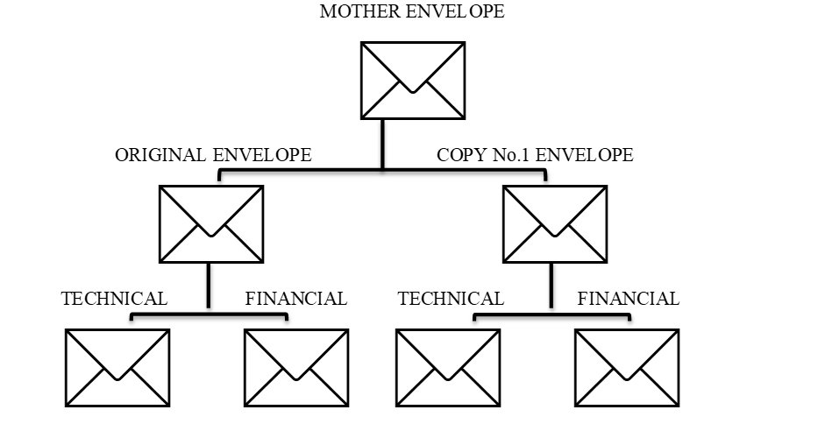
16.1 | The address for submission of bids is:  CHARITO S. FERNANDO or MARICHU Y. FERRER  SMWD BAC Secretariat  Procurement Office, 3rd Flr., SMWD Bldg.  No. 302 J.P. Rizal St., Poblacion  Santa Maria, Bulacan  The deadline for submission of bids is: February 19, 2024 at 12:00PM
17.1 | The place of bid opening is: 4th Flr. SMWD Bldg., No. 302 J.P. Rizal St.,  Poblacion, Santa Maria, Bulacan  The date and time of bid opening is: February 19, 2024 @ 1:00 PM
19.4 | One Project having two lots that shall be awarded to one (1) or two (2) bidders.
20.2 | Latest income and business tax returns filed and paid through the BIR electronic Filing and Payment System (eFPS)
21.2 | [List here any additional contract documents relevant to the Project that may be required by existing laws and/or the Procuring Entity.]  To be submitted together with the bidding documents or during post-qualification stage  - General Condition and Special Condition of the contract duly signed by the bidder.  - Manufacturer’s Certificate, if applicable  - Certificate of Dealership, if applicable  - Certificate of sole or authorized distributorship, if applicable  - Certificate of Warranty

Section IV. General Conditions of Contract

Scope of Contract

This Contract shall include all such items, although not specifically mentioned, that can be reasonably inferred as being required for its completion as if such items were expressly mentioned herein. All the provisions of RA No. 9184 and its 2016 revised IRR, including the Generic Procurement Manual, and associated issuances, constitute the primary source for the terms and conditions of the Contract, and thus, applicable in contract implementation. Herein clauses shall serve as the secondary source for the terms and conditions of the Contract.

This is without prejudice to Sections 74.1 and 74.2 of the 2016 revised IRR of RA No. 9184 allowing the GPPB to amend the IRR, which shall be applied to all procurement activities, the advertisement, posting, or invitation of which were issued after the effectivity of the said amendment.

Additional requirements for the completion of this Contract shall be provided in the Special Conditions of Contract (SCC).

Advance Payment and Terms of Payment

  - Advance payment of the contract amount is provided under Annex “D” of the revised 2016 IRR of RA No. 9184.

  - The Procuring Entity is allowed to determine the terms of payment on the partial or staggered delivery of the Goods procured, provided such partial payment shall correspond to the value of the goods delivered and accepted in accordance with prevailing accounting and auditing rules and regulations. The terms of payment are indicated in the SCC.

[Include the following clauses if Framework Agreement will be used:]

  - For a single-year Framework Agreement, prices charged by the Supplier for Goods delivered and/or services performed under a Call-Off shall not vary from the prices quoted by the Supplier in its bid.

  - For multi-year Framework Agreement, prices charged by the Supplier for Goods delivered and/or services performed under a Call-Off shall not vary from the prices quoted by the Supplier during conduct of Mini-Competition.

Performance Security

Within ten (10) calendar days from receipt of the Notice of Award by the Bidder from the Procuring Entity but in no case later than prior to the signing of the Contract by both parties, the successful Bidder shall furnish the performance security in any of the forms prescribed in Section 39 of the 2016 revised IRR of RA No. 9184

Inspection and Tests

The Procuring Entity or its representative shall have the right to inspect and/or to test the Goods to confirm their conformity to the Project specifications at no extra cost to the Procuring Entity in accordance with the Generic Procurement Manual. In addition to tests in the SCC, Section IV (Technical Specifications) shall specify what inspections and/or tests the Procuring Entity requires, and where they are to be conducted. The Procuring Entity shall notify the Supplier in writing, in a timely manner, of the identity of any representatives retained for these purposes.

All reasonable facilities and assistance for the inspection and testing of Goods, including access to drawings and production data, shall be provided by the Supplier to the authorized inspectors at no charge to the Procuring Entity.

Warranty

  - In order to assure that manufacturing defects shall be corrected by the Supplier, a warranty shall be required from the Supplier as provided under Section 62.1 of the 2016 revised IRR of RA No. 9184.

  - The Procuring Entity shall promptly notify the Supplier in writing of any claims arising under this warranty. Upon receipt of such notice, the Supplier shall, repair or replace the defective Goods or parts thereof without cost to the Procuring Entity, pursuant to the Generic Procurement Manual.

Liability of the Supplier

The Supplier’s liability under this Contract shall be as provided by the laws of the Republic of the Philippines.

If the Supplier is a joint venture, all partners to the joint venture shall be jointly and severally liable to the Procuring Entity.

Section V. Special Conditions of Contract

Notes on the Special Conditions of Contract

Similar to the BDS, the clauses in this Section are intended to assist the Procuring Entity in providing contract-specific information in relation to corresponding clauses in the GCC found in Section IV.

The Special Conditions of Contract (SCC) complement the GCC, specifying contractual requirements linked to the special circumstances of the Procuring Entity, the Procuring Entity’s country, the sector, and the Goods purchased. In preparing this Section, the following aspects should be checked:

  - Information that complements provisions of the GCC must be incorporated.

  - Amendments and/or supplements to provisions of the GCC as necessitated by the circumstances of the specific purchase, must also be incorporated.

However, no special condition which defeats or negates the general intent and purpose of the provisions of the GCC should be incorporated herein.

Special Conditions of Contract
GCC Clause
1 | [List here any additional requirements for the completion of this Contract. The following requirements and the corresponding provisions may be deleted, amended, or retained depending on its applicability to this Contract:]
 | Delivery and Documents –
 | For purposes of the Contract, “EXW,” “FOB,” “FCA,” “CIF,” “CIP,” “DDP” and other trade terms used to describe the obligations of the parties shall have the meanings assigned to them by the current edition of INCOTERMS published by the International Chamber of Commerce, Paris. The Delivery terms of this Contract shall be as follows:
 | [For Goods supplied from abroad, state:] “The delivery terms applicable to the Contract are DDP delivered at Santa Maria Water District, No. 301 J.P. Rizal St., Poblacion, Santa Maria, Bulacan. In accordance with INCOTERMS.”
 | [For Goods supplied from within the Philippines, state:] “The delivery terms applicable to this Contract are delivered, Santa Maria Water District, No. 301 J.P. Rizal St., Poblacion, Santa Maria, Bulacan. Risk and title will pass from the Supplier to the Procuring Entity upon receipt and final acceptance of the Goods at their final destination.”
 | Delivery of the Goods shall be made by the Supplier in accordance with the terms specified in Section VI (Schedule of Requirements).
 | For purposes of this Clause the Procuring Entity’s Representative at the Project Site is the storekeeper.
 | Incidental Services –
 | The Supplier is required to provide all of the following services, including additional services, if any, specified in Section VI. Schedule of Requirements:
 | - furnishing of a detailed operations and maintenance manual for each appropriate unit of the supplied Goods;
 | The Contract price for the Goods shall include the prices charged by the Supplier for incidental services and shall not exceed the prevailing rates charged to other parties by the Supplier for similar services.
 | Spare Parts –
 | The Supplier is required to provide all of the following materials, notifications, and information pertaining to spare parts manufactured or distributed by the Supplier:
 | Select appropriate requirements and delete the rest.
 | - such spare parts as the Procuring Entity may elect to purchase from the Supplier, provided that this election shall not relieve the Supplier of any warranty obligations under this Contract; and
 | - in the event of termination of production of the spare parts:
 | - advance notification to the Procuring Entity of the pending termination, in sufficient time to permit the Procuring Entity to procure needed requirements; and
 | - following such termination, furnishing at no cost to the Procuring Entity, the blueprints, drawings, and specifications of the spare parts, if requested.
 | The spare parts and other components required are listed in Section VI (Schedule of Requirements) and the cost thereof are included in the contract price.
 | The Supplier shall carry sufficient inventories to assure ex-stock supply of consumable spare parts or components for the Goods for a period of [indicate here the time period specified. If not used indicate a time period of three times the warranty period].
 | Spare parts or components shall be supplied as promptly as possible, but in any case, within [insert appropriate time period] months of placing the order.
Packaging –

The Supplier shall provide such packaging of the Goods as is required to prevent their damage or deterioration during transit to their final destination, as indicated in this Contract. The packaging shall be sufficient to withstand, without limitation, rough handling during transit and exposure to extreme temperatures, salt and precipitation during transit, and open storage. Packaging case size and weights shall take into consideration, where appropriate, the remoteness of the Goods’ final destination and the absence of heavy handling facilities at all points in transit.

 | The packaging, marking, and documentation within and outside the packages shall comply strictly with such special requirements as shall be expressly provided for in the Contract, including additional requirements, if any, specified below, and in any subsequent instructions ordered by the Procuring Entity.
 | The outer packaging must be clearly marked on at least four (4) sides as follows:
 | Name of the Procuring Entity
 | Name of the Supplier
 | Contract Description
 | Final Destination
 | Gross weight
 | Any special lifting instructions
 | Any special handling instructions
 | Any relevant HAZCHEM classifications
 | A packaging list identifying the contents and quantities of the package is to be placed on an accessible point of the outer packaging if practical. If not practical the packaging list is to be placed inside the outer packaging but outside the secondary packaging.
 | Transportation –
 | Where the Supplier is required under Contract to deliver the Goods CIF, CIP, or DDP, transport of the Goods to the port of destination or such other named place of destination in the Philippines, as shall be specified in this Contract, shall be arranged and paid for by the Supplier, and the cost thereof shall be included in the Contract Price.
 | Where the Supplier is required under this Contract to transport the Goods to a specified place of destination within the Philippines, defined as the Project Site, transport to such place of destination in the Philippines, including insurance and storage, as shall be specified in this Contract, shall be arranged by the Supplier, and related costs shall be included in the contract price.
 | Where the Supplier is required under Contract to deliver the Goods CIF, CIP or DDP, Goods are to be transported on carriers of Philippine registry. In the event that no carrier of Philippine registry is available, Goods may be shipped by a carrier which is not of Philippine registry provided that the Supplier obtains and presents to the Procuring Entity certification to this effect from the nearest Philippine consulate to the port of dispatch. In the event that carriers of Philippine registry are available but their schedule delays the Supplier in its performance of this Contract the period from when the Goods were first ready for shipment and the actual date of shipment the period of delay will be considered force majeure.
 | The Procuring Entity accepts no liability for the damage of Goods during transit other than those prescribed by INCOTERMS for DDP deliveries. In the case of Goods supplied from within the Philippines or supplied by domestic Suppliers risk and title will not be deemed to have passed to the Procuring Entity until their receipt and final acceptance at the final destination.
 | Intellectual Property Rights –
 | The Supplier shall indemnify the Procuring Entity against all third-party claims of infringement of patent, trademark, or industrial design rights arising from use of the Goods or any part thereof.
2.1 | No advance payment shall be made by the Procuring Entity to the winning bidder
2.2 | For partial or staggered delivery of the Goods procured. “The terms of payment shall be as follows:  Payment shall be based on complete delivery of goods requested to be delivered and only upon presentation of an Inspection and Acceptance Report by the General Services Division to the effect that the goods have been ordered and delivered in accordance with the terms of this contract and have been duly inspected and accepted.  Payment shall be made within thirty (30) days upon delivery.
3 | The Performance Security will be released by the SMWD after the issuance of the “Certificate of Completion” subject to the following condition:  - there is no pending claims against the supplier or surety company filed by the SMWD;  - the Supplier has no pending claims for labor and materials filed against it; and  (c) upon submission of a letter by the Supplier requesting for the release of the Performance Security.
4 | The inspections and tests that will be conducted are:  Delivery Inspection:  Upon notification from the General Services Division of Santa Maria Water District that the delivery is made, the inspectorate team which is consist of Storekeeper, End-User and supplier’s representative shall randomly inspect goods delivered in conformity to required specifications.  If in case a non-compliance of some provision in the specifications, the applicable test for HDPE and Plastic Fittings such as Burst, Leakage and Durability test shall be conducted while such discrepancies are rectified by the supplier at no cost to the procuring entity not to exceed thirty 30 calendar days.
5.1 | Warranty period is Three (3) months for HDPE and One (1) Year for Plastic Fittings after acceptance by the Procuring Entity of the delivered Goods.  In accordance with Section 62.1 of the 2016 revised IRR of RA No. 9184, the obligations of the warranty shall be covered by either retention money in an amount equivalent to one percent (1%) of each payment, or special bank guarantee equivalent to one percent (1%) of the total contract price. The said amounts shall only be released after the lapse of the warranty period.
5.2 | The period for correction of defects in the warranty period is within thirty (30) calendar days upon receipt of the notice for replacement. If the supplier failed to replace the defective items, the Procuring Entity will charged/billed the total amount to the supplier, the amount of replacement shall be the amount of the items as bought.
6.1 | This contract maybe amended when deemed necessary to modify the terms agreed upon, provided that it is a mutual written agreement executed and approved by both parties concerned

Section VI. Schedule of Requirements

The delivery schedule expressed as weeks/months stipulates hereafter a delivery date which is the date of delivery to the project site.

 | Items/Description |  | Qty. | Unit | Delivered,
 |  |  |  |  | days/weeks/months
 | FOR LOT NO. 1 – HDPE TUBING |  |  |  | Delivery is required within 15 days upon receipt of P.O
01 | HDPE TUBING 1/2"Ø / SDR11 / BLUE |  | 15,266 | meter
02 | HDPE TUBING 3/4"Ø / SDR11 / BLUE |  | 18 | meter
03 | HDPE TUBING 1 SDR 11 - BLUE |  | 2,091 | meter
 | FOR LOT NO. 2 PLASTIC FITTINGS
01 | PLASTIC ADAPTOR 1/2 |  | 3,600 | pc
02 | PLASTIC ADAPTOR 3/4 |  | 22 | pc
03 | PLASTIC ADAPTOR 1 |  | 712 | pc
04 | PLASTIC FEMALE ELBOW 1/2 x 90 (20mm) |  | 200 | pc
05 | PLASTIC FEMALE ELBOW 3/4 x 90 |  | 6 | pc
06 | PLASTIC FEMALE ELBOW 1 x 90 (32mm) |  | 95 | pc
07 | PLASTIC SADDLE CLAMP 2 x 1 with TAPPING FERRULE |  | 198 | set
08 | PLASTIC SADDLE CLAMP 3 x 1 with TAPPING FERRULE |  | 198 | set
09 | PLASTIC SADDLE CLAMP 4 x 1 with TAPPING FERRULE |  | 240 | set
10 | PLASTIC SADDLE CLAMP 6 x 1 with TAPPING FERRULE |  | 114 | set
11 | PLASTIC SADDLE CLAMP 8 x 1 with TAPPING FERRULE |  | 35 | set
12 | UPVC UNION COUPLING 1/2 |  | 930 | pc
13 | UPVC UNION COUPLING 3/4 |  | 10 | pc
14 | UPVC UNION COUPLING 1 |  | 140 | pc
 | ***nothing follows***

[Use this form for Framework Agreement:]

Framework Agreement List

Limited to repeatedly required goods and services that are identified to be necessary and desirable, but, by its nature, use or characteristic, the quantity and/ or exact time of need cannot be accurately pre-determined and are not advisable to be carried in stock.

Prepared by the End-User, attached to the APP and submitted to the BAC for the approval of the HOPE.

FRAMEWORK AGREEMENT LIST
(AGENCY)
Item / Service  Type and nature of each item/service |  | Cost per item or service | Maximum Quantity |  | Total Cost per Item
TOTAL
(Approved Budget for the Contract)
Expected delivery timeframe after receipt of a Call-Off. |  | Within [no. of days] calendar days upon issuance of Call-off .
Remarks |  | Indicate here any other appropriate information as may be necessary.
SIGNATURE OVER PRINTED NAME |  | POSITION |  | DEPARTMENT/DIVISION

Section VII. Technical Specifications

Notes for Preparing the Technical Specifications

A set of precise and clear specifications is a prerequisite for Bidders to respond realistically and competitively to the requirements of the Procuring Entity without qualifying their Bids. In the context of Competitive Bidding, the specifications (e.g. production/delivery schedule, manpower requirements, and after-sales service/parts, descriptions of the lots or items) must be prepared to permit the widest possible competition and, at the same time, present a clear statement of the required standards of workmanship, materials, and performance of the goods and services to be procured. Only if this is done will the objectives of transparency, equity, efficiency, fairness , and economy in procurement be realized, responsiveness of bids be ensured, and the subsequent task of bid evaluation and post-qualification facilitated. The specifications should require that all items, materials and accessories to be included or incorporated in the goods be new, unused, and of the most recent or current models, and that they include or incorporate all recent improvements in design and materials unless otherwise provided in the Contract.

Samples of specifications from previous similar procurements are useful in this respect. The use of metric units is encouraged. Depending on the complexity of the goods and the repetitiveness of the type of procurement, it may be advantageous to standardize the General Technical Specifications and incorporate them in a separate subsection. The General Technical Specifications should cover all classes of workmanship, materials, and equipment commonly involved in manufacturing similar goods. Deletions or addenda should then adapt the General Technical Specifications to the particular procurement.

Care must be taken in drafting specifications to ensure that they are not restrictive. In the specification of standards for equipment, materials, and workmanship, recognized Philippine and international standards should be used as much as possible. Where other particular standards are used, whether national standards or other standards, the specifications should state that equipment, materials, and workmanship that meet other authoritative standards, and which ensure at least a substantially equal quality than the standards mentioned, will also be acceptable. The following clause may be inserted in the Special Conditions of Contract or the Technical Specifications.

Sample Clause: Equivalency of Standards and Codes

Wherever reference is made in the Technical Specifications to specific standards and codes to be met by the goods and materials to be furnished or tested, the provisions of the latest edition or revision of the relevant standards and codes shall apply, unless otherwise expressly stated in the Contract. Where such standards and codes are national or relate to a particular country or region, other authoritative standards that ensure substantial equivalence to the standards and codes specified will be acceptable.

Reference to brand name and catalogue number should be avoided as far as possible; where unavoidable they should always be followed by the words “or at least equivalent.” References to brand names cannot be used when the funding source is the GOP.

Where appropriate, drawings, including site plans as required, may be furnished by the Procuring Entity with the Bidding Documents. Similarly, the Supplier may be requested to provide drawings or samples either with its Bid or for prior review by the Procuring Entity during contract execution.

Bidders are also required, as part of the technical specifications, to complete their statement of compliance demonstrating how the items comply with the specification.

Technical Specifications
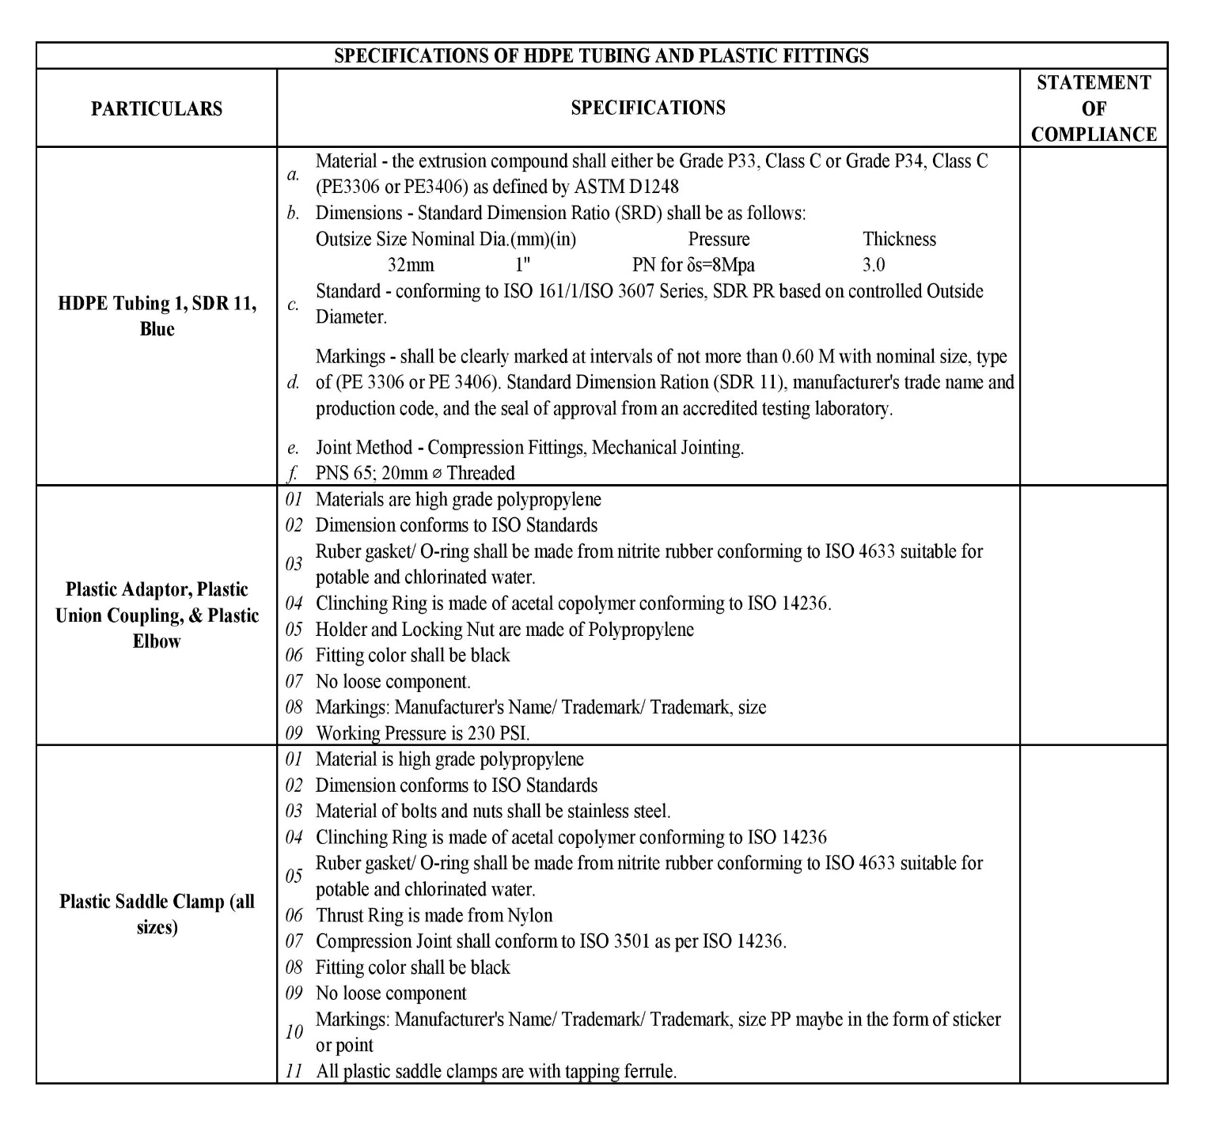

NOTE:

The bidder shall submit applicable Certification (Burst, Leakage and Durability Test) or Material
Test Results for HDPE and Plastic fittings.

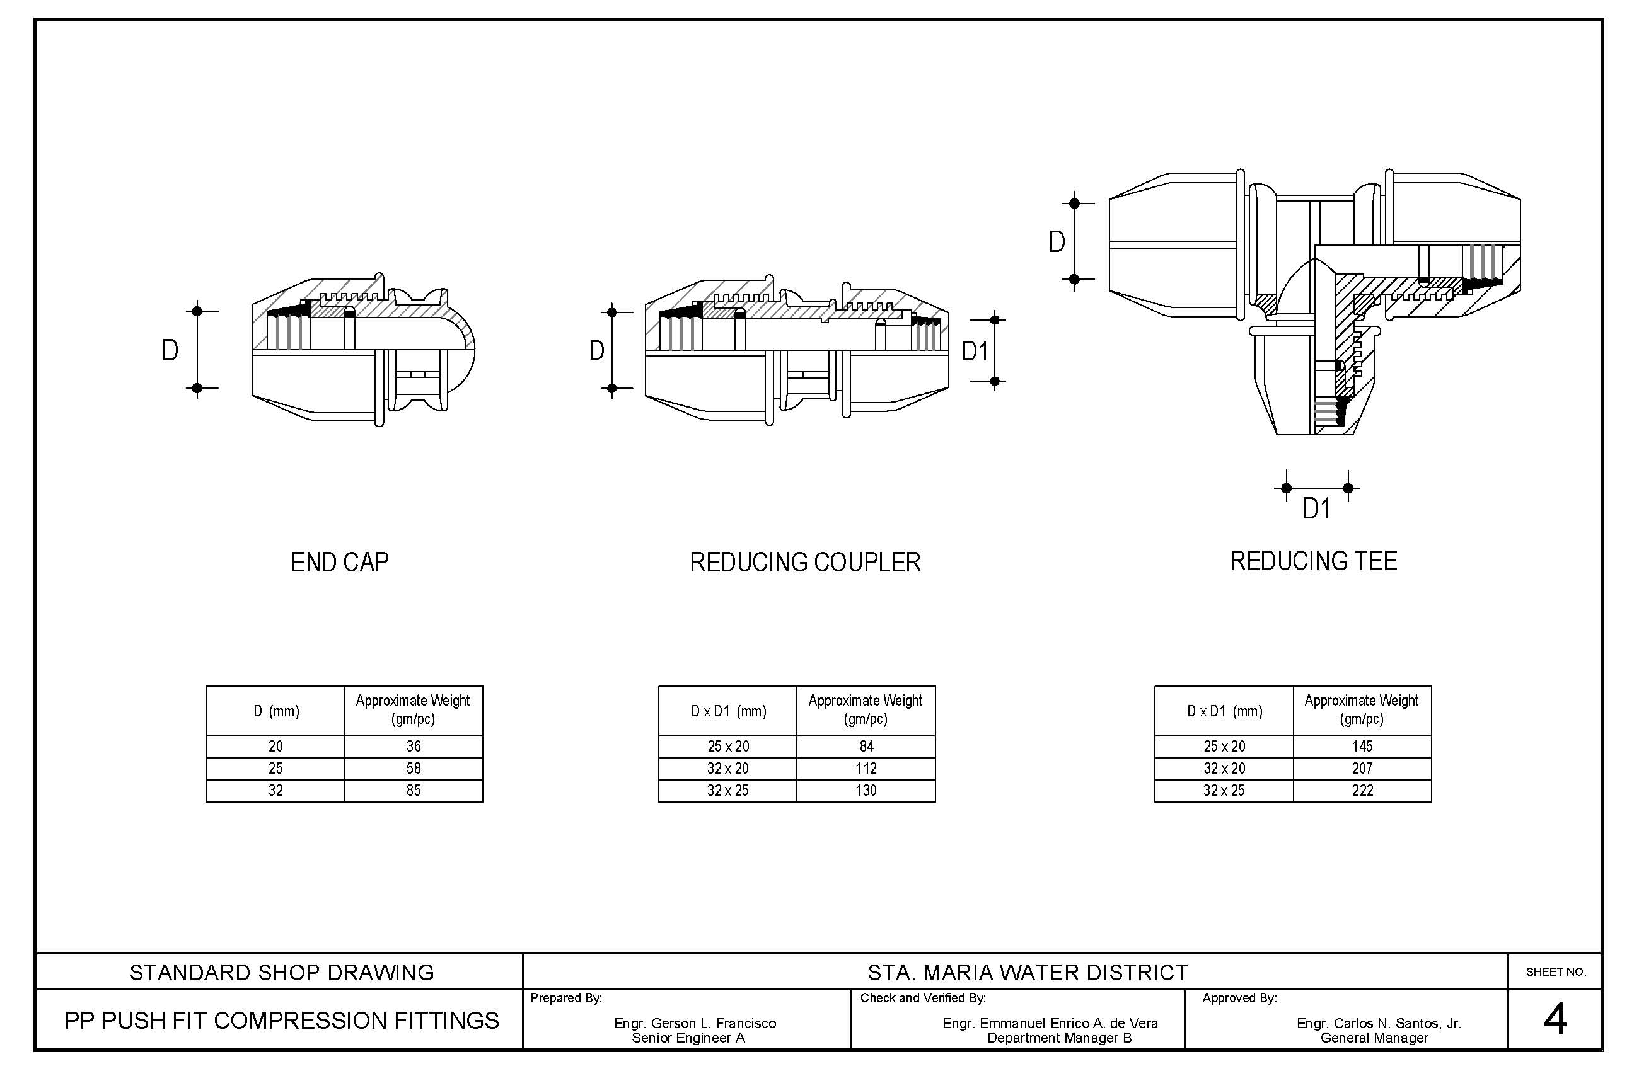 | DRAWINGS

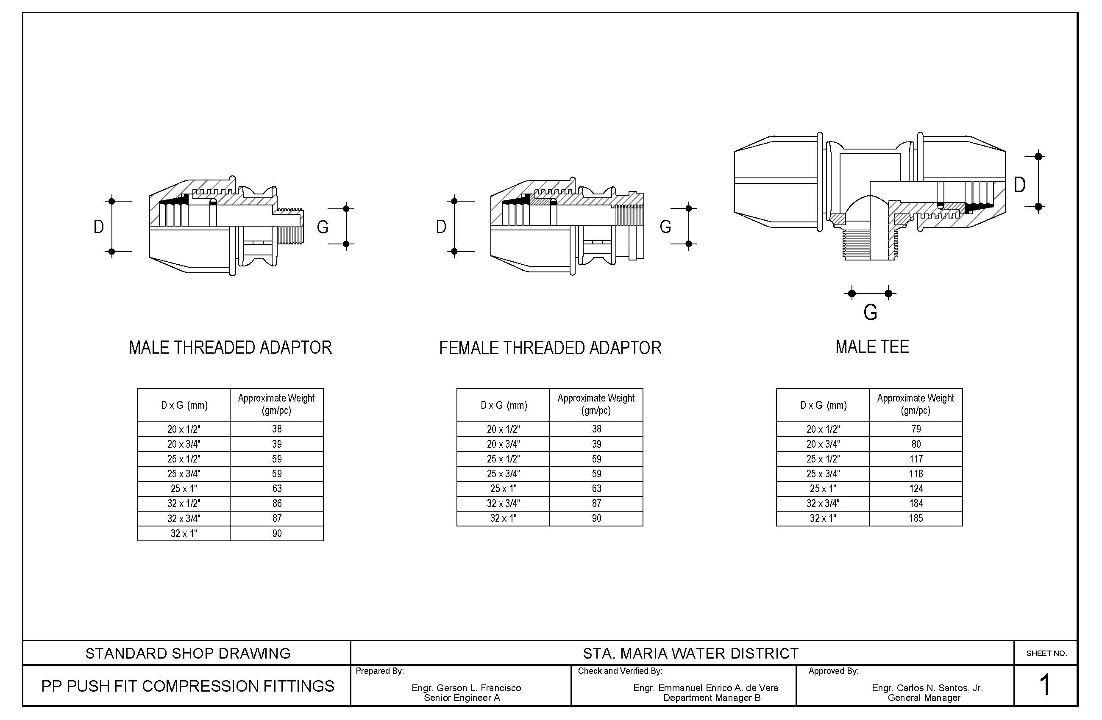

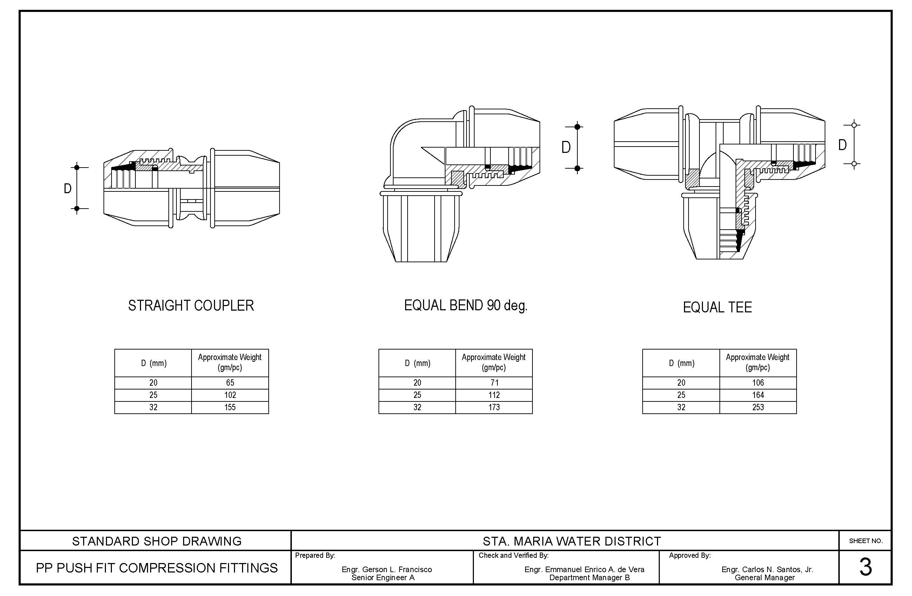
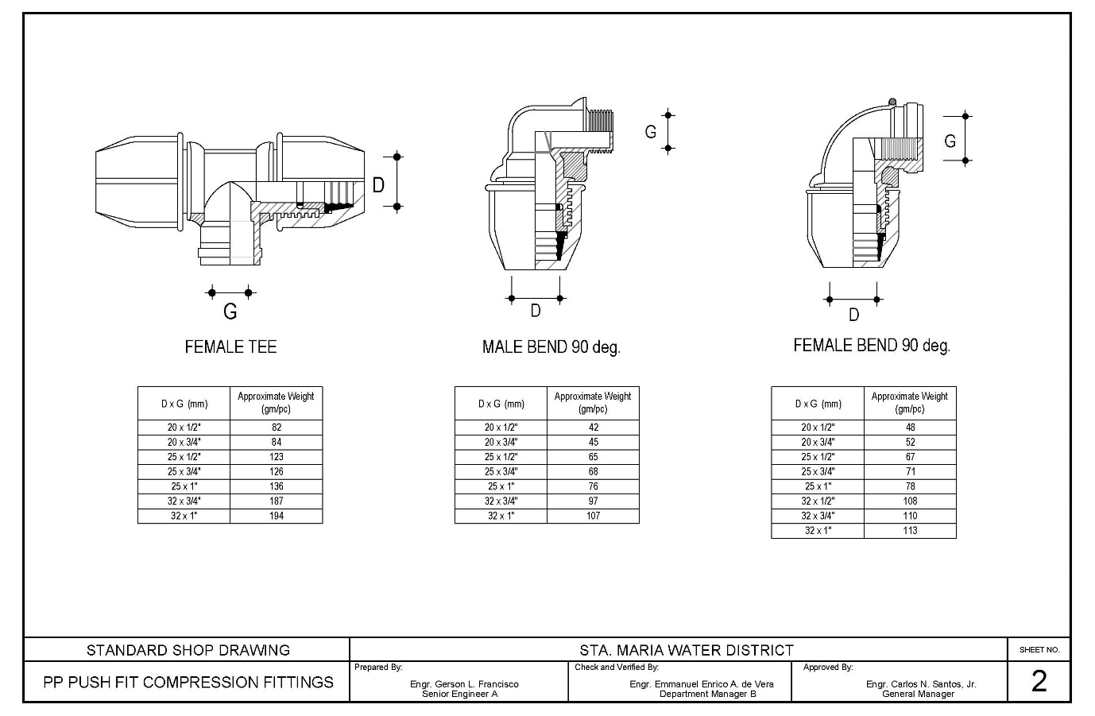

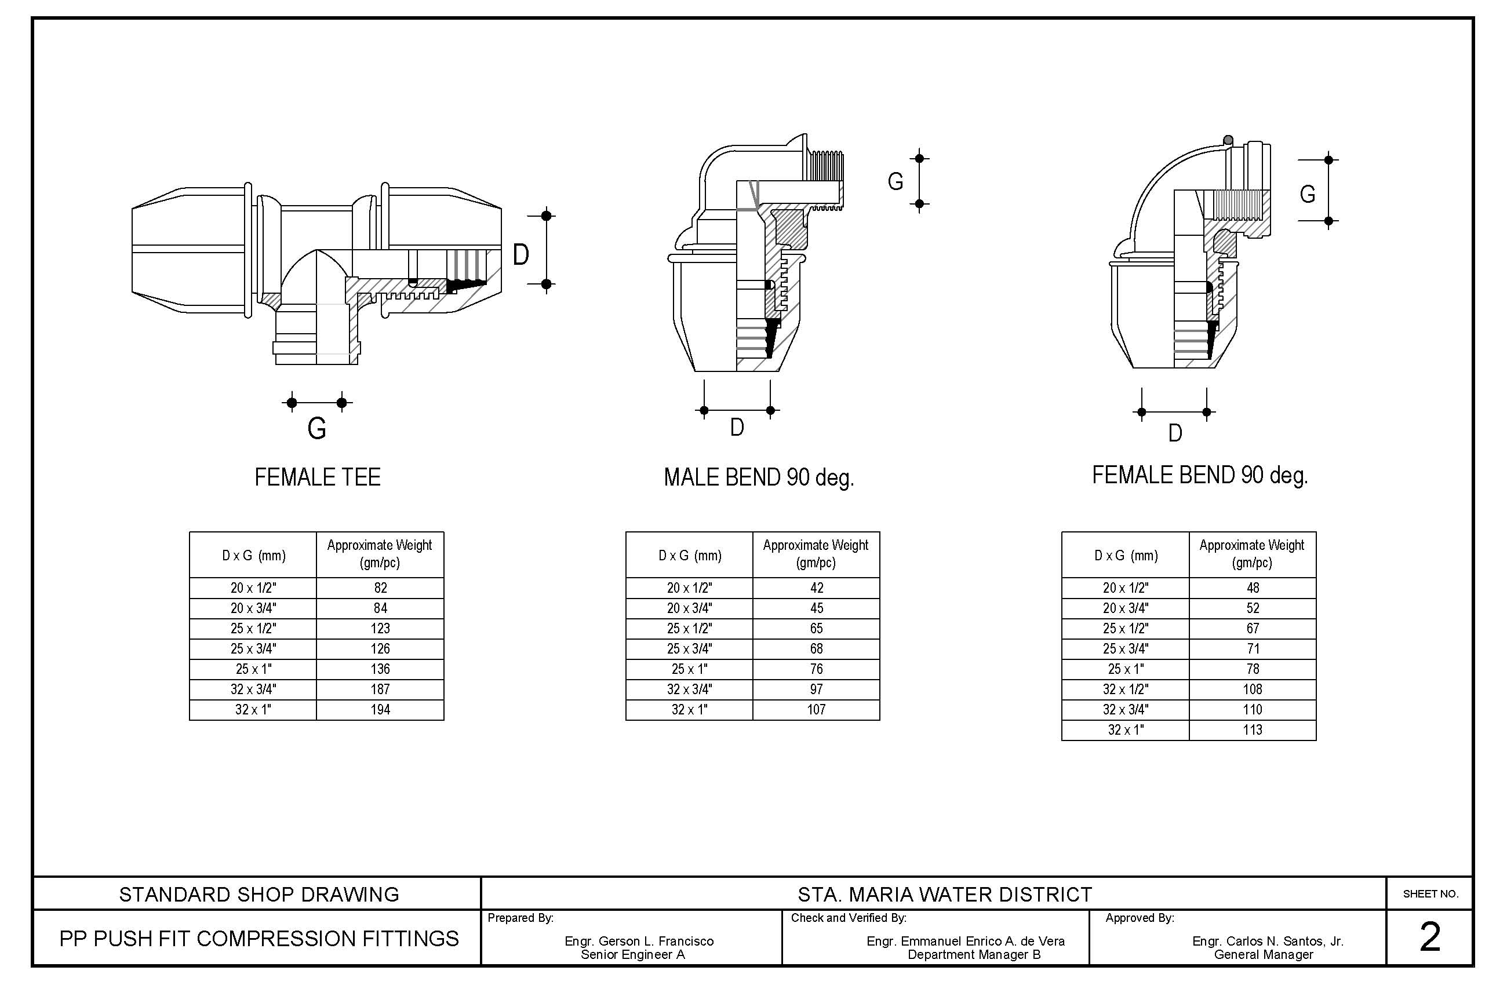

Note: As part of technical specifications, bidders shall bring sample of plastic fittings 1 pc. of each kind (no need to bring all sizes). Samples shall be submitted together with the bidding documents

Section VIII. Checklist of Technical and Financial Documents

Checklist of Technical and Financial Documents

- TECHNICAL COMPONENT ENVELOPE

Class “A” Documents
Legal Documents
⬜ | - Valid PhilGEPS Registration Certificate (Platinum Membership) (all pages);  or
⬜ | - Registration certificate from Securities and Exchange Commission (SEC), Department of Trade and Industry (DTI) for sole proprietorship, or Cooperative Development Authority (CDA) for cooperatives or its equivalent document,  and
⬜ | - Mayor’s or Business permit issued by the city or municipality where the principal place of business of the prospective bidder is located, or the equivalent document for Exclusive Economic Zones or Areas;  and
⬜ | - Tax clearance per E.O. No. 398, s. 2005, as finally reviewed and approved by the Bureau of Internal Revenue (BIR).
Technical Documents
⬜ | - Statement of the prospective bidder of all its ongoing government and private contracts, including contracts awarded but not yet started, if any, whether similar or not similar in nature and complexity to the contract to be bid; and
⬜ | - Statement of the bidder’s Single Largest Completed Contract (SLCC) similar to the contract to be bid, except under conditions provided for in Sections 23.4.1.3 and 23.4.2.4 of the 2016 revised IRR of RA No. 9184, within the relevant period as provided in the Bidding Documents; and
⬜ | - Original copy of Bid Security. If in the form of a Surety Bond, submit also a certification issued by the Insurance Commission;  or  Original copy of Notarized Bid Securing Declaration; and
⬜ | - Conformity with the Technical Specifications, which may include production/delivery schedule, manpower requirements, and/or after-sales/parts, if applicable; and
⬜ | - Original duly signed Omnibus Sworn Statement (OSS);  and if applicable, Original Notarized Secretary’s Certificate in case of a corporation, partnership, or cooperative; or Original Special Power of Attorney of all members of the joint venture giving full power and authority to its officer to sign the OSS and do acts to represent the Bidder.
⬜ | - Manufacturer’s Certificate (for HDPE Tubing).
⬜ | - Certificate of Exclusive Distributorship for Plastic Fittings
⬜  ⬜ - Certificate of Warranty. | - Certificate of Warranty.  - ISO Certification of the Product
Financial Documents
⬜ | - The Supplier’s audited financial statements, showing, among others, the Supplier’s total and current assets and liabilities, stamped “received” by the BIR or its duly accredited and authorized institutions, for the preceding calendar year which should not be earlier than two (2) years from the date of bid submission; and
⬜ | - The prospective bidder’s computation of Net Financial Contracting Capacity (NFCC);  or  A committed Line of Credit from a Universal or Commercial Bank in lieu of its NFCC computation.
Class “B” Documents
⬜ | - If applicable, a duly signed joint venture agreement (JVA) in case the joint venture is already in existence;  or  duly notarized statements from all the potential joint venture partners stating that they will enter into and abide by the provisions of the JVA in the instance that the bid is successful.
- FINANCIAL COMPONENT ENVELOPE
⬜ | - Original of duly signed and accomplished Financial Bid Form; and
⬜ | - Original of duly signed and accomplished Price Schedule(s).
Other documentary requirements under RA No. 9184 (as applicable)
⬜ | - [For foreign bidders claiming by reason of their country’s extension of reciprocal rights to Filipinos] Certification from the relevant government office of their country stating that Filipinos are allowed to participate in government procurement activities for the same item or product.
⬜ | - Certification from the DTI if the Bidder claims preference as a Domestic Bidder or Domestic Entity.

Omnibus Sworn Statement (Revised)
[shall be submitted with the Bid]
_________________________________________________________________________

REPUBLIC OF THE PHILIPPINES )
CITY/MUNICIPALITY OF ______ ) S.S.
AFFIDAVIT
I, [Name of Affiant], of legal age, [Civil Status], [Nationality], and residing at [Address of Affiant], after having been duly sworn in accordance with law, do hereby depose and state that:

- [Select one, delete the other:]
[If a sole proprietorship:] I am the sole proprietor or authorized representative of [Name of Bidder] with office address at [address of Bidder];
[If a partnership, corporation, cooperative, or joint venture:] I am the duly authorized and designated representative of [Name of Bidder] with office address at [address of Bidder];

- [Select one, delete the other:]
[If a sole proprietorship:] As the owner and sole proprietor, or authorized representative of [Name of Bidder], I have full power and authority to do, execute and perform any and all acts necessary to participate, submit the bid, and to sign and execute the ensuing contract for [Name of the Project] of the [Name of the Procuring Entity], as shown in the attached duly notarized Special Power of Attorney;
[If a partnership, corporation, cooperative, or joint venture:] I am granted full power and authority to do, execute and perform any and all acts necessary to participate, submit the bid, and to sign and execute the ensuing contract for [Name of the Project] of the [Name of the Procuring Entity], as shown in the attached [state title of attached document showing proof of authorization (e.g., duly notarized Secretary’s Certificate, Board/Partnership Resolution, or Special Power of Attorney, whichever is applicable;)];

- [Name of Bidder] is not “blacklisted” or barred from bidding by the Government of the Philippines or any of its agencies, offices, corporations, or Local Government Units, foreign government/foreign or international financing institution whose blacklisting rules have been recognized by the Government Procurement Policy Board, by itself or by relation, membership, association, affiliation, or controlling interest with another blacklisted person or entity as defined and provided for in the Uniform Guidelines on Blacklisting;

- Each of the documents submitted in satisfaction of the bidding requirements is an authentic copy of the original, complete, and all statements and information provided therein are true and correct;

- [Name of Bidder] is authorizing the Head of the Procuring Entity or its duly authorized representative(s) to verify all the documents submitted;

- [Select one, delete the rest:]
[If a sole proprietorship:] The owner or sole proprietor is not related to the Head of the Procuring Entity, members of the Bids and Awards Committee (BAC), the Technical Working Group, and the BAC Secretariat, the head of the Project Management Office or the end-user unit, and the project consultants by consanguinity or affinity up to the third civil degree;
[If a partnership or cooperative:] None of the officers and members of [Name of Bidder] is related to the Head of the Procuring Entity, members of the Bids and Awards Committee (BAC), the Technical Working Group, and the BAC Secretariat, the head of the Project Management Office or the end-user unit, and the project consultants by consanguinity or affinity up to the third civil degree;
[If a corporation or joint venture:] None of the officers, directors, and controlling stockholders of [Name of Bidder] is related to the Head of the Procuring Entity, members of the Bids and Awards Committee (BAC), the Technical Working Group, and the BAC Secretariat, the head of the Project Management Office or the end-user unit, and the project consultants by consanguinity or affinity up to the third civil degree;

- [Name of Bidder] complies with existing labor laws and standards; and

- [Name of Bidder] is aware of and has undertaken the responsibilities as a Bidder in compliance with the Philippine Bidding Documents, which includes:

  - Carefully examining all of the Bidding Documents;
  - Acknowledging all conditions, local or otherwise, affecting the implementation of the Contract;
  - Making an estimate of the facilities available and needed for the contract to be bid, if any; and
  - Inquiring or securing Supplemental/Bid Bulletin(s) issued for the [Name of the Project].

- [Name of Bidder] did not give or pay directly or indirectly, any commission, amount, fee, or any form of consideration, pecuniary or otherwise, to any person or official, personnel or representative of the government in relation to any procurement project or activity.

- In case advance payment was made or given, failure to perform or deliver any of the obligations and undertakings in the contract shall be sufficient grounds to constitute criminal liability for Swindling (Estafa) or the commission of fraud with unfaithfulness or abuse of confidence through misappropriating or converting any payment received by a person or entity under an obligation involving the duty to deliver certain goods or services, to the prejudice of the public and the government of the Philippines pursuant to Article 315 of Act No. 3815 s. 1930, as amended, or the Revised Penal Code.
IN WITNESS WHEREOF, I have hereunto set my hand this __ day of ___, 20__ at ____________, Philippines.
[Insert NAME OF BIDDER OR ITS AUTHORIZED REPRESENTATIVE]
[Insert signatory’s legal capacity]
Affiant

[Jurat]

In the case of Framework Agreement, the undertaking shall refer to entering into contract with the Procuring Entity and furnishing of the performance security or the performance securing declaration within ten (10) calendar days from receipt of Notice to Execute Framework Agreement.

