Philippine Bidding Documents

PROCUREMENT OF JANITORIAL SERVICES OF THE SMWD FOR CY 2025

Reference No. SMWD-PB2025-S-04-005

Government of the Republic of the Philippines

Sixth Edition
July 2020

TABLE OF CONTENTS

Section I. Invitation to Bid | 2
Section II. Instructions to Bidders | 4
- Scope of Bid | 5
- Funding Information | 5
- Bidding Requirements | 5
- Corrupt, Fraudulent, Collusive, and Obstructive Practices | 5
- Eligible Bidders | 6
- Origin of Goods | 6
- Subcontracts | 6
- Pre-Bid Conference | 6
- Clarification and Amendment of Bidding Documents | 6
- Documents Comprising the Bid Eligibility and Technical Documents | 6
- Documents Comprising the Bid Financial Component | 7
- Bid Prices | 7
- Bid and Payment Currencies | 8
- Bid Security | 8
- Sealing and Marking of Bids | 8
- Deadline of Submission of Bids | 8
- Opening and Preliminary Examination of Bids | 9
- Domestic Preference | 9
- Detailed Evaluation and Comparison of Bids | 9
- Post-Qualification | 10
- Signing of the Contract | 10
Section III. Bid Data Sheet | 12
Section IV. General Conditions of Contract | 16
- Scope of Contract | 16
- Advance Payment and Terms of Payment | 16
- Performance Security | 16
- Inspection and Tests | 16
- Warranty | 17
- Liability and Supplier | 17
Section V. Special Conditions of Contract | 18
Section Vl. Schedule of Requirements | 19
Section VII. Technical Specifications/Terms of Reference | 20
Section Vlll. Checklist of Technical and Financial Documents | 36
Bid Form for Procurement of Goods | 38
Bid Proposal Form | 40
Bid Securing Declaration Form | 41
Contract Agreement Form for the Procurement of Goods | 42
Omnibus Sworn Statement | 44

Section I. Invitation to Bid
Invitation to Bid for:
PROCUREMENT OF JANITORIAL SERVICES OF THE SMWD FOR CY 2025

- The Santa Maria Water District (SMWD), through the Corporate Operating Fund for the Year 2025 intends to apply the sum of One Million Seven Hundred Forty-One Thousand Eight Hundred Thirty Pesos (Php1,741,830.00) being the ABC to payments under the contract for the Procurement of Janitorial Services of the SMWD FOR CY 2025 with Identification No. SMWD-PB2025-S-04-005. Bids received in excess of the ABC shall be automatically rejected at bid opening.

- The Santa Maria Water District now invites bids for the procurement of Janitorial Services for the period June 2025 to January 2026, adjusted the period of coverage as stated in the Terms of Reference (TOR), May to December 2025. Bidders should have completed, within five (5) years from the date of submission and receipt of bids, a contract similar to the Project which is at least fifty percent (50%) of the ABC. The description of an eligible bidder is contained in the Bidding Documents, particularly, in Section II (Instructions to Bidders).

- Bidding will be conducted through open competitive bidding procedures using a non-discretionary “pass/fail” criterion as specified in the 2016 revised Implementing Rules and Regulations (IRR) of Republic Act (RA) No. 9184.

Bidding is restricted to Filipino citizens/sole proprietorships, partnerships, or organizations with at least sixty percent (60%) interest or outstanding capital stock belonging to citizens of the Philippines, and to citizens or organizations of a country the laws or regulations of which grant similar rights or privileges to Filipino citizens, pursuant to RA No. 5183.

- Prospective Bidders may obtain further information from SMWD-Bids and Awards Committee (BAC) Secretariat and may view and inspect the Bidding Documents as posted in the websites of the SMWD and the Philippine Government Electronic Procurement System (PhilGEPS).

- A complete set of Bidding Documents may be acquired by interested Bidders on April 14, 2025 to May 7, 2025 from the given address and upon payment of a non-refundable fee of Three Thousand Pesos (Php3,000.00) not later than the submission of their bids. The Procuring Entity shall allow the bidder to present its proof of payment for the fees through email indicated below.

- The Santa Maria Water District will hold a Pre-Bid Conference on April 25, 2025 at 1:00 PM face to face which shall be open to all prospective bidders. The address for pre-bid conference is:

3rd floor – BAC Room, SMWD Building
No. 302 J.P. Rizal St., Poblacion, Santa Maria, Bulacan

- Bids must be duly received by the BAC Secretariat through manual submission, LBC or any Freight Service at the office address indicated below on or before 12:00 PM on May 7, 2025. The official time is the one reflected in the biometrics located in the ground floor of the SMWD’s building. Late bids shall not be accepted.

- All Bids must be accompanied by a bid security in any of the acceptable forms and in the amount stated in ITB Clause 14.

- Bid opening shall be on May 7, 2025 3:00 PM at the given address below. Bid opening shall be held manually and face to face. Bids will be opened in the presence of the bidders’ representatives who choose to attend the activity.

- The summary of the bidding activities is as follows:

Advertisement/posting of Invitation to Bid | April 14-21, 2025
Issuance and Availability of Bid Documents | April 14, 2025 to May 7, 2025
Pre-Bid Conference | April 25, 2025 @1:00P.M
Last day of Submission of Written Clarification | April 27, 2025
Last day of Issuance of Bid Bulletin (if any) | April 30, 2025
Deadline for Submission of Bids | May 7, 2025 @ 12:00 P.M
Opening of Bids | May 7, 2025 @ 3:00 P.M.

- The Santa Maria Water District reserves the right to reject any and all bids, declare a failure of bidding, or not award the contract at any time prior to contract award in accordance with Sections 35.6 and 41 of the 2016 revised IRR of RA No. 9184, without thereby incurring any liability to the affected bidder or bidders.

- For further information, please refer to:

Charito S. Fernando
BAC Secretariat – 3rd Floor, SMWD Building
No. 302 J.P Rizal St., Poblacion,
Santa Maria, Bulacan
CP# 0917-138-8683 or (044)815-3238
Email Address: smwdbulacan@yahoo.com
Website: smwdbulacan.gov.ph

- For viewing and downloading of Bidding Documents you may visit: http://notices.philgeps.gov.ph
https://smwdbulacan.gov.ph

Date of issuance of Bidding Documents: April 14, 2025

sgd
MARIA LEONORA S. ROMARATE
Chairperson, SMWD Bids and Awards Committee

Section II. Instructions to Bidders

Scope of Bid

    - The procuring entity Santa Maria Water District (SMWD) hereinafter referred to as the “Procuring Entity” wishes to receive bids for the PROCUREMENT OF JANITORIAL SERVICES OF THE SMWD FOR CY 2025 as described in Section VII Technical Specifications (hereinafter referred to as the “Goods”).
    - The name, identification, and number of lots specific to this bidding are provided in the BDS. The contracting strategy and basis of evaluation of lots is described in ITB Clause 28.

Funding Information

- The GOP through the source of funding as indicated below for the year 2025 in the amount of One Million Seven Hundred Forty-One Thousand Eight Hundred Thirty Pesos (Php1,741,830.00).

- The source of funding is GOCC, the proposed Corporate Operating Budget for the Year 2025

Bidding Requirements

The Bidding for the Project shall be governed by all the provisions of RA No. 9184 and its 2016 revised IRR, including its Generic Procurement Manuals and associated policies, rules and regulations as the primary source thereof, while the herein clauses shall serve as the secondary source thereof.

Any amendments made to the IRR and other GPPB issuances shall be applicable only to the ongoing posting, advertisement, or IB by the BAC through the issuance of a supplemental or bid bulletin.

The Bidder, by the act of submitting its Bid, shall be deemed to have verified and accepted the general requirements of this Project, including other factors that may affect the cost, duration and execution or implementation of the contract, project, or work and examine all instructions, forms, terms, and project requirements in the Bidding Documents.

Corrupt, Fraudulent, Collusive, and Coercive Practices

The Procuring Entity, as well as the Bidders and Suppliers, shall observe the highest standard of ethics during the procurement and execution of the contract. They or through an agent shall not engage in corrupt, fraudulent, collusive, coercive, and obstructive practices defined under Annex “I” of the 2016 revised IRR of RA No. 9184 or other integrity violations in competing for the Project.

Eligible Bidders

5.1. Only Bids of Bidders found to be legally, technically, and financially capable will be evaluated.

5.2. Foreign ownership limited to those allowed under the rules may participate in this Project.

5.3. Pursuant to Section 23.4.1.3 of the 2016 revised IRR of RA No.9184, the Bidder shall have an SLCC that is at least one (1) contract similar to the Project the value of which, adjusted to current prices using the PSA’s CPI, must be at least equivalent to:

- For the procurement of Expendable Supplies: The Bidder must have completed a single contract that is similar to this Project, equivalent to at least twenty-five percent (25%) of the ABC.

5.4. The Bidders shall comply with the eligibility criteria under Section 23.4.1 of the 2016 IRR of RA No. 9184.

Origin of Goods

There is no restriction on the origin of goods other than those prohibited by a decision of the UN Security Council taken under Chapter VII of the Charter of the UN, subject to Domestic Preference requirements under ITB Clause 18.

Subcontracts

7.1 The Procuring Entity has prescribed that: Subcontracting is not allowed.

Pre-Bid Conference

The Procuring Entity will hold a pre-bid conference for this Project on the specified date and time and either at its physical address at BAC Room 3rd Flr. SMWD Bldg., No. 302 J.P. Rizal St., Poblacion, Santa Maria, Bulacan face to face as indicated in paragraph 6 of the IB.

Clarification and Amendment of Bidding Documents

Prospective bidders may request for clarification on and/or interpretation of any part of the Bidding Documents. Such requests must be in writing and received by the Procuring Entity, either at its given address or through electronic mail indicated in the IB, at least ten (10) calendar days before the deadline set for the submission and receipt of Bids.

Documents comprising the Bid: Eligibility and Technical Components

    - The first envelope shall contain the eligibility and technical documents of the Bid as specified in Section VIII (Checklist of Technical and Financial Documents).

    - The Bidder’s SLCC as indicated in ITB Clause 5.3 should have been completed within two (2) years prior to the deadline for the submission and receipt of bids.

    - If the eligibility requirements or statements, the bids, and all other documents for submission to the BAC are in foreign language other than English, it must be accompanied by a translation in English, which shall be authenticated by the appropriate Philippine foreign service establishment, post, or the equivalent office having jurisdiction over the foreign bidder’s affairs in the Philippines. Similar to the required authentication above, for Contracting Parties to the Apostille Convention, only the translated documents shall be authenticated through an apostille pursuant to GPPB Resolution No. 13-2019 dated 23 May 2019. The English translation shall govern, for purposes of interpretation of the bid.

Documents comprising the Bid: Financial Component

  - The second bid envelope shall contain the financial documents for the Bid as specified in Section VIII (Checklist of Technical and Financial Documents).

  - If the Bidder claims preference as a Domestic Bidder or Domestic Entity, a certification issued by DTI shall be provided by the Bidder in accordance with Section 43.1.3 of the 2016 revised IRR of RA No. 9184.

  - Any bid exceeding the ABC indicated in paragraph 1 of the IB shall not be accepted.

  - For Foreign-funded Procurement, a ceiling may be applied to bid prices provided the conditions are met under Section 31.2 of the 2016 revised IRR of RA No. 9184.

Bid Prices

12.1. Prices indicated on the Price Schedule shall be entered separately in the following manner:

      - For Goods offered from within the Procuring Entity’s country:

- The price of the Goods quoted EXW (ex-works, ex-factory, ex-warehouse, ex-showroom, or off-the-shelf, as applicable);

- The cost of all customs duties and sales and other taxes already paid or payable;

- The cost of transportation, insurance, and other costs incidental to delivery of the Goods to their final destination; and

- The price of other (incidental) services, if any, listed in e.

      - For Goods offered from abroad:

- Unless otherwise stated in the BDS, the price of the Goods shall be quoted delivered duty paid (DDP) with the place of destination in the Philippines as specified in the BDS. In quoting the price, the Bidder shall be free to use transportation through carriers registered in any eligible country. Similarly, the Bidder may obtain insurance services from any eligible source country.

- The price of other (incidental) services, if any, as listed in Section VII (Technical Specifications).

Bid and Payment Currencies

    - For Goods that the Bidder will supply from outside the Philippines, the bid prices may be quoted in the local currency or tradeable currency accepted by the BSP at the discretion of the Bidder. However, for purposes of bid evaluation, Bids denominated in foreign currencies, shall be converted to Philippine currency based on the exchange rate as published in the BSP reference rate bulletin on the day of the bid opening.

    - Payment of the contract price shall be made in: Philippine Pesos.

Bid Security

  - The Bidder shall submit a Bid Securing Declaration or any form of Bid Security in the amount indicated in the BDS, which shall be not less than the percentage of the ABC in accordance with the schedule in the BDS.

  - The Bid and bid security shall be valid within one hundred twenty (120) calendar days from bid opening. Any Bid not accompanied by an acceptable bid security shall be rejected by the Procuring Entity as non-responsive.

Sealing and Marking of Bids

Each Bidder shall submit one copy of the first and second components of its Bid.

The Procuring Entity may request additional hard copies and/or electronic copies of the Bid. However, failure of the Bidders to comply with the said request shall not be a ground for disqualification.

If the Procuring Entity allows the submission of bids through online submission or any other electronic means, the Bidder shall submit an electronic copy of its Bid, which must be digitally signed. An electronic copy that cannot be opened or is corrupted shall be considered non-responsive and, thus, automatically disqualified.

Deadline for Submission of Bids

16.1. The Bidders shall submit on the specified date and time and either at its physical address or through online submission as indicated in paragraph 7 of the IB.

Opening and Preliminary Examination of Bids

  - The BAC shall open the Bids in public at the time, on the date, and at the place specified in paragraph 9 of the IB. The Bidders’ representatives who are present shall sign a register evidencing their attendance. In case videoconferencing, webcasting or other similar technologies will be used, attendance of participants shall likewise be recorded by the BAC Secretariat.

In case the Bids cannot be opened as scheduled due to justifiable reasons, the rescheduling requirements under Section 29 of the 2016 revised IRR of RA No. 9184 shall prevail.

  - The preliminary examination of bids shall be governed by Section 30 of the 2016 revised IRR of RA No. 9184.

Domestic Preference

18.1. The Procuring Entity will grant a margin of preference for the purpose of comparison of Bids in accordance with Section 43.1.2 of the 2016 revised IRR of RA No. 9184.

Detailed Evaluation and Comparison of Bids

  - The Procuring BAC shall immediately conduct a detailed evaluation of all Bids rated “passed,” using non-discretionary pass/fail criteria. The BAC shall consider the conditions in the evaluation of Bids under Section 32.2 of the 2016 revised IRR of RA No. 9184.

  - If the Project allows partial bids, bidders may submit a proposal on any of the lots or items, and evaluation will be undertaken on a per lot or item basis, as the case maybe. In this case, the Bid Security as required by ITB Clause 15 shall be submitted for each lot or item separately.

  - The descriptions of the lots or items shall be indicated in Section VII (Technical Specifications), although the ABCs of these lots or items are indicated in the BDS for purposes of the NFCC computation pursuant to Section 23.4.2.6 of the 2016 revised IRR of RA No. 9184. The NFCC must be sufficient for the total of the ABCs for all the lots or items participated in by the prospective Bidder.

  - The Project shall be awarded as one (1) contract

  - Except for bidders submitting a committed Line of Credit from a Universal or Commercial Bank in lieu of its NFCC computation, all Bids must include the NFCC computation pursuant to Section 23.4.1.4 of the 2016 revised IRR of RA No. 9184, which must be sufficient for the total of the ABCs for all the lots or items participated in by the prospective Bidder. For bidders submitting the committed Line of Credit, it must be at least equal to ten percent (10%) of the ABCs for all the lots or items participated in by the prospective Bidder.

Post-Qualification

20.1. Within a non-extendible period of five (5) calendar days from receipt by the Bidder of the notice from the BAC that it submitted the Lowest Calculated Bid, the Bidder shall submit its latest income and business tax returns filed and paid through the BIR Electronic Filing and Payment System (eFPS) and other appropriate licenses and permits required by law and stated in the BDS.

Signing of the Contract

21.1. The documents required in Section 37.2 of the 2016 revised IRR of RA No. 9184 shall form part of the Contract. Additional Contract documents are indicated in the BDS.

Section III.

Bid Data Sheet
ITB Clause
2.1 | The Funding Source is:  The Government of the Philippines (GOP) through 2025 Corporate Operating Budget in the amount of One Million Seven Hundred Forty-One Thousand Eight Hundred Thirty Pesos (P1,741,830.00).  The name of the Project is: Procurement of Janitorial Services of the SMWD for CY 2025  Project Contract No. SMWD-PB2025-S-04-005
 | Foreign Bidders are not allowed
5.3 | For the Procurement of Janitorial Services, the Bidder must have completed, within five (5) years from the date of submission and receipt of bids, a contract similar to this Project with a value of at least fifty percent (50%) of the ABC.  For this purpose, similar contracts shall refer to “Procurement of Janitorial Services”
7.1 | Sub-contracting is not allowed.
8 | The Procuring Entity will hold a pre-bid conference face to face for this Project on April 25, 2025 at 1:00PM.  Address for Pre-bid Conference  3rd Floor, BAC Room, SMWD Bldg.  302 J.P. Rizal St., Poblacion  Santa Maria, Bulacan  The minutes of the pre-bid conference shall be made available to prospective bidders not later than five (5) days upon submission of a written request and settlement of corresponding fee.  The anticipated participants are the BAC, BAC Secretariat, Bidder’s Representatives and Observers from COA.
10.1 | The bidder or its duly authorized representative shall submit copy of the following documents with signature as part of the ELIGIBILITY, TECHNICAL and FINANCIAL documents:  LEGAL DOCUMENTS:  1. Valid PhilGEPS Registration Certificate (Platinum)  2. SEC/DTI Registration  3. Valid/Current Mayor’s Permit  4. Latest Tax Clearance  TECHNICAL DOCUMENTS:  5. Statement of all its on-going government and private contracts  Whether similar or not similar to the project to be bid whether on-  going or not yet started. The name of the contact person and contact  numbers of the concerned agency/company shall be included in the  statement.  6.. Statement of the bidder’s Single Largest Completed Contract (SLCC) similar to the contract to be bid. The name of the contact person and contact numbers of the agency/company concerned shall be included in the statement  7. Original Copy of Bid Security, if in form of Surety Bond submit also a certification issued by the Insurance Commission, or Original Notarized Copy of Bid Securing Declaration.  8. Original duly signed and notarized Omnibus Sworn Statement  9. Conformity with the Specification  FINANCIAL DOCUMENTS:  11. The Supplier’s Audited Financial Statements for the last two  (2) years from the date of bid submission.  12. Bidder’s computation of Net Financial Contracting Capacity  Or a Committed Line of Credit from Universal or Commercial  Bank.  Please take note that financial documents differ from Financial Component Envelope. Financial Component Envelope contains the duly signed and accomplished Financial Bid form, pls. see the checklist of Technical and Financial Documents)  The BAC shall check the submitted documents of each Bidder against the Eligibility/Technical checklist to ascertain if they are all present, using a non-discretionary “pass/fail” criterion pursuant to Section 30 of the 2016 revised IRR of RA No. 9184.
10.2 | The bidder’s Single Largest Completed Contract (SLCC) shall be within five (5) years from the date and receipt of bids similar to the project which is at least 50% of the ABC.  The name of the contact person and contact numbers of the agency/company concerned shall be included in the statement
11.3 | Any bid exceeding the ABC shall not be accepted
12 | The Bid prices for Goods supplied from outside of the Philippines shall be quoted in Philippine Pesos.
14.1 | The bid security shall be in the form of a Bid Securing Declaration, or any of the following forms and amounts:
 | - The amount of not less than P 34,836.60 (2%) of ABC], if bid security is in cash, cashier’s/manager’s check, bank draft/guarantee or irrevocable letter of credit; or
 | - The amount of not less than P87,091.50 (5%) of ABC] if bid security is in Surety Bond. The Certificate of the Insurance Commission or the CIC shall be attached together with the Surety Bond.
15 | Each Bidder shall submit ONE (1) Mother Envelope Containing Two (2) Envelopes, which are as follows:  Envelope No. 1– “Original” Documents: with Two (2) Sub envelopes for the ff:  - Technical (including eligibility documents)  - Financial Documents  Envelope No. 2- “Copy 1” : with Two (2) Sub envelopes for the ff:  - Technical (including eligibility documents)  - Financial Documents  TOTAL NUMBER OF ENVELOPES = 7 ENVELOPES  MOTHER ENVELOPE……………… ……………… 1 envelope  ORIGINAL COPY ………………………………….... 1 envelope  Sub-envelope – Eligibility & Technical Component.. 1 envelope  Sub-envelope – Financial Component......................... 1 envelope  COPY 1…………………….………………… ……… 1 envelope  Sub-envelope – Eligibility & Technical Component.. 1 envelope  Sub-envelope – Financial Component......................... 1 envelope  TOTAL ENVELOPES……………………………… 7 envelopes  “All envelopes must be sealed and properly labeled”  Provide table of contents and each bid documents must be properly labelled/tabbed  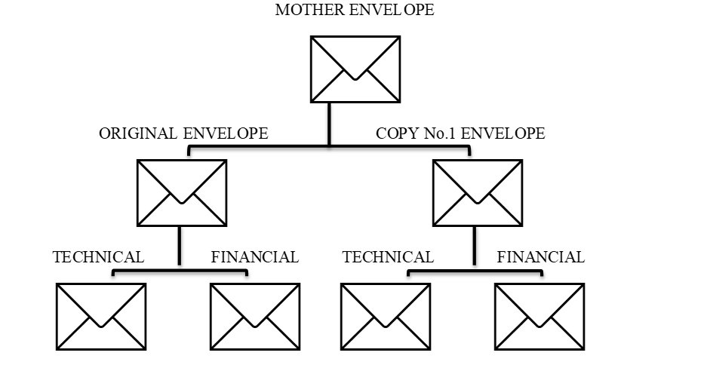  All documents along with any attachments must be originally signed and certified as true copies by the bidder and/or authorized representative.
16.1 | The address for submission of bids is:  CHARITO S. FERNANDO or MARICHU Y. FERRER  SMWD BAC Secretariat  Procurement Office, 3rd Floor  SMWD Bldg., No. 302 J.P. Rizal St.  Poblacion, Santa Maria, Bulacan  The deadline for submission of bids is: May 7, 2025 at 12:00PM
17.1 | The place of bid opening is: BAC Room 3rd Floor SMWD Building  No. 302 J.P. Rizal St., Poblacion  Santa Maria, Bulacan  The date and time of bid opening is May 7, 2025 at 3:00PM
19.3 | Partial bid is not allowed. The goods are grouped in a single lot and the lot shall not be divided into sub-lots for the purpose of bidding, evaluation, and contract award.
20.2 | Latest income and business tax returns filed and paid through the BIR electronic Filing and Payment System (eFPS)
21.2 | [List here any additional contract documents relevant to the Project that may be  required by existing laws and/or the Procuring Entity.]  To be submitted during post qualification stage:  - 1. General Condition and Special Condition of the contract duly signed by the bidder.  2. Valid DOLE Registration  3. Membership/Registration Certificate from Social Security Services (SSS), Pag-Ibig  Fund, and Philippine Health Insurance Commission (Philhealth)  4. Five years experience presenting written and duly notarized documents showing  therein the following but shall not be limited to:  a. Record of previous engagements and quality of performance:  1. Name of Client  II. Contract details (duration and amount)  III. Manpower Count  5. Organizational Set-up  6. Resources:  a. Quantity and type of equipment and supplies available  b. Total number of Head Housekeeper and janitors  7. Recruitment and selection process. The janitorial agency shall submit brief  profile of the janitors to be deployed to SMWD upon receipt of Notice of Award  (NOA)  8. I.D and Uniform Design  9. Sample of Official/Service Invoice  10. Copy of BIR Form 2303

Section IV. General Conditions of Contract

Scope of Contract

This Contract shall include all such items, although not specifically mentioned, that can be reasonably inferred as being required for its completion as if such items were expressly mentioned herein. All the provisions of RA No. 9184 and its 2016 revised IRR, including the Generic Procurement Manual, and associated issuances, constitute the primary source for the terms and conditions of the Contract, and thus, applicable in contract implementation. Herein clauses shall serve as the secondary source for the terms and conditions of the Contract.

This is without prejudice to Sections 74.1 and 74.2 of the 2016 revised IRR of RA No. 9184 allowing the GPPB to amend the IRR, which shall be applied to all procurement activities, the advertisement, posting, or invitation of which were issued after the effectivity of the said amendment.

Additional requirements for the completion of this Contract shall be provided in the Special Conditions of Contract (SCC).

Advance Payment and Terms of Payment

  - Advance payment of the contract amount is provided under Annex “D” of the revised 2016 IRR of RA No. 9184.

  - The Procuring Entity is allowed to determine the terms of payment on the partial or staggered delivery of the Goods procured, provided such partial payment shall correspond to the value of the goods delivered and accepted in accordance with prevailing accounting and auditing rules and regulations. The terms of payment are indicated in the SCC.

Performance Security

Within ten (10) calendar days from receipt of the Notice of Award by the Bidder from the Procuring Entity but in no case later than prior to the signing of the Contract by both parties, the successful Bidder shall furnish the performance security in any of the forms prescribed in Section 39 of the 2016 revised IRR of RA No. 9184

Inspection and Tests

The Procuring Entity or its representative shall have the right to inspect and/or to test the Goods to confirm their conformity to the Project specifications at no extra cost to the Procuring Entity in accordance with the Generic Procurement Manual. In addition to tests in the SCC, Section IV (Technical Specifications) shall specify what inspections and/or tests the Procuring Entity requires, and where they are to be conducted. The Procuring Entity shall notify the Supplier in writing, in a timely manner, of the identity of any representatives retained for these purposes.

All reasonable facilities and assistance for the inspection and testing of Goods, including access to drawings and production data, shall be provided by the Supplier to the authorized inspectors at no charge to the Procuring Entity.

Warranty

  - In order to assure that manufacturing defects shall be corrected by the Supplier, a warranty shall be required from the Supplier as provided under Section 62.1 of the 2016 revised IRR of RA No. 9184.

  - The Procuring Entity shall promptly notify the Supplier in writing of any claims arising under this warranty. Upon receipt of such notice, the Supplier shall, repair or replace the defective Goods or parts thereof without cost to the Procuring Entity, pursuant to the Generic Procurement Manual.

Liability of the Supplier

The Supplier’s liability under this Contract shall be as provided by the laws of the Republic of the Philippines.

If the Supplier is a joint venture, all partners to the joint venture shall be jointly and severally liable to the Procuring Entity.
Section V. Special Conditions of Contract

GCC Clause
1 | Refer to Terms of Reference (TOR)
2 | Refer to Terms of Reference (TOR)
3 | No further instruction
4 | The Contractor shall maintain a satisfactory level of performance throughout the contract period based on the following set of performance criteria:  - Conformity to Technical Specifications (Terms of Reference)  - Timelines in the Delivery of Services  - Behavior of Personnel (Courteousness, Professionalism and being knowledgeable).  - Response to Complaints  - Compliance with office rules and policies  If SMWD finds or believes that the performance of the janitorial personnel is unsatisfactory, replacement of personnel may be demanded.
5.1 | No further instruction
5.2 | No further instruction
6.1 | This contract maybe amended when deemed necessary to modify the terms agreed upon, provided that it is a mutual written agreement executed and approved by both parties concerned

Section VI. Schedule of Requirements

REFER TO THE TERMS OF REFERENCE – SECTION IV – MANPOWER REQUIREMENTS

Section VII. Technical Specifications
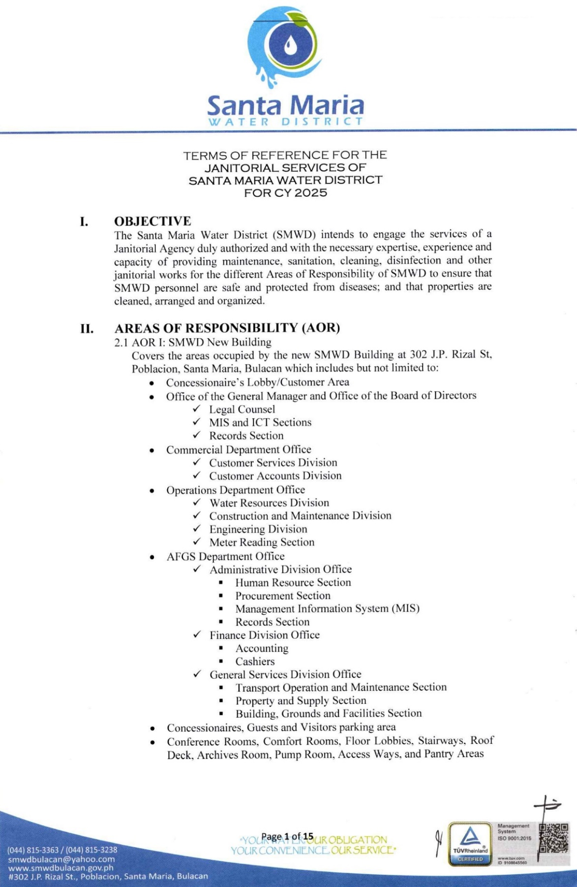

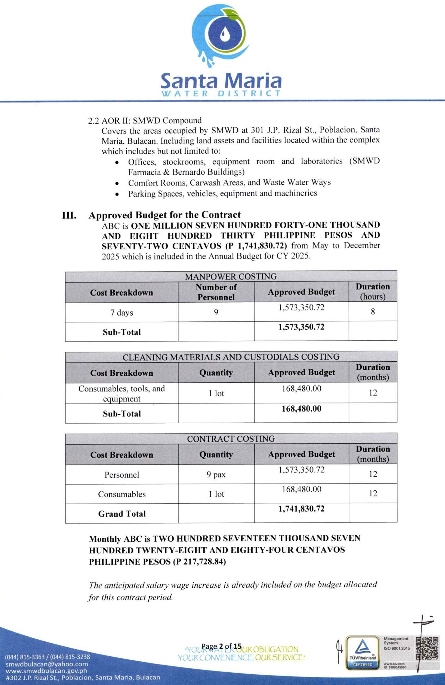

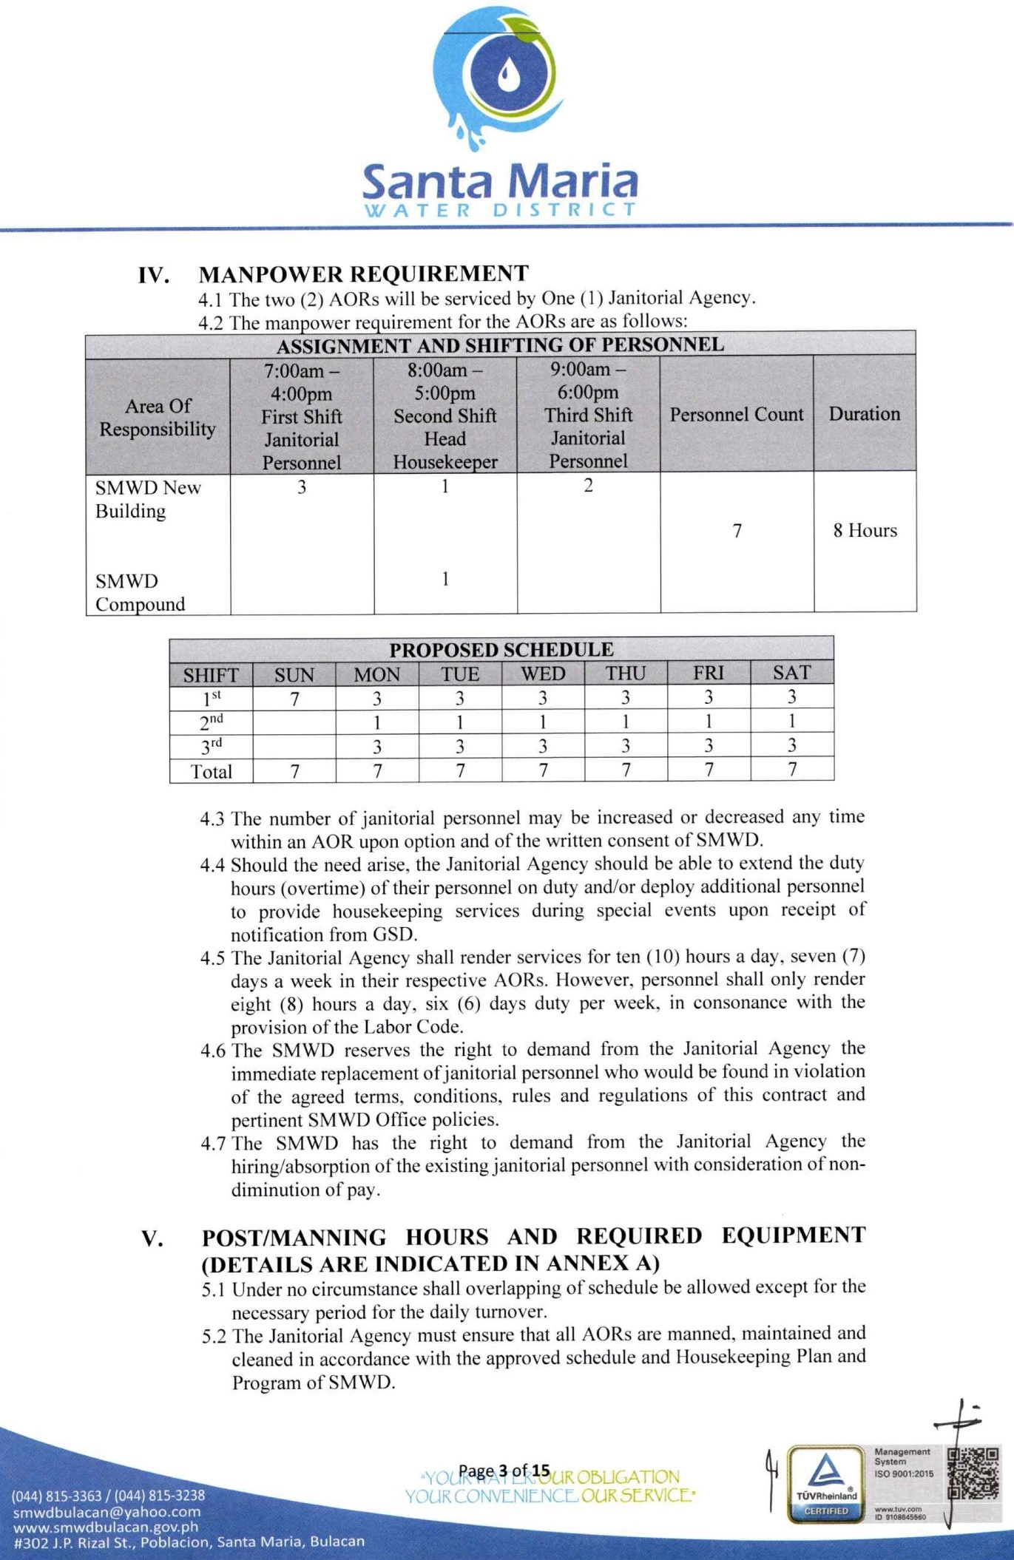

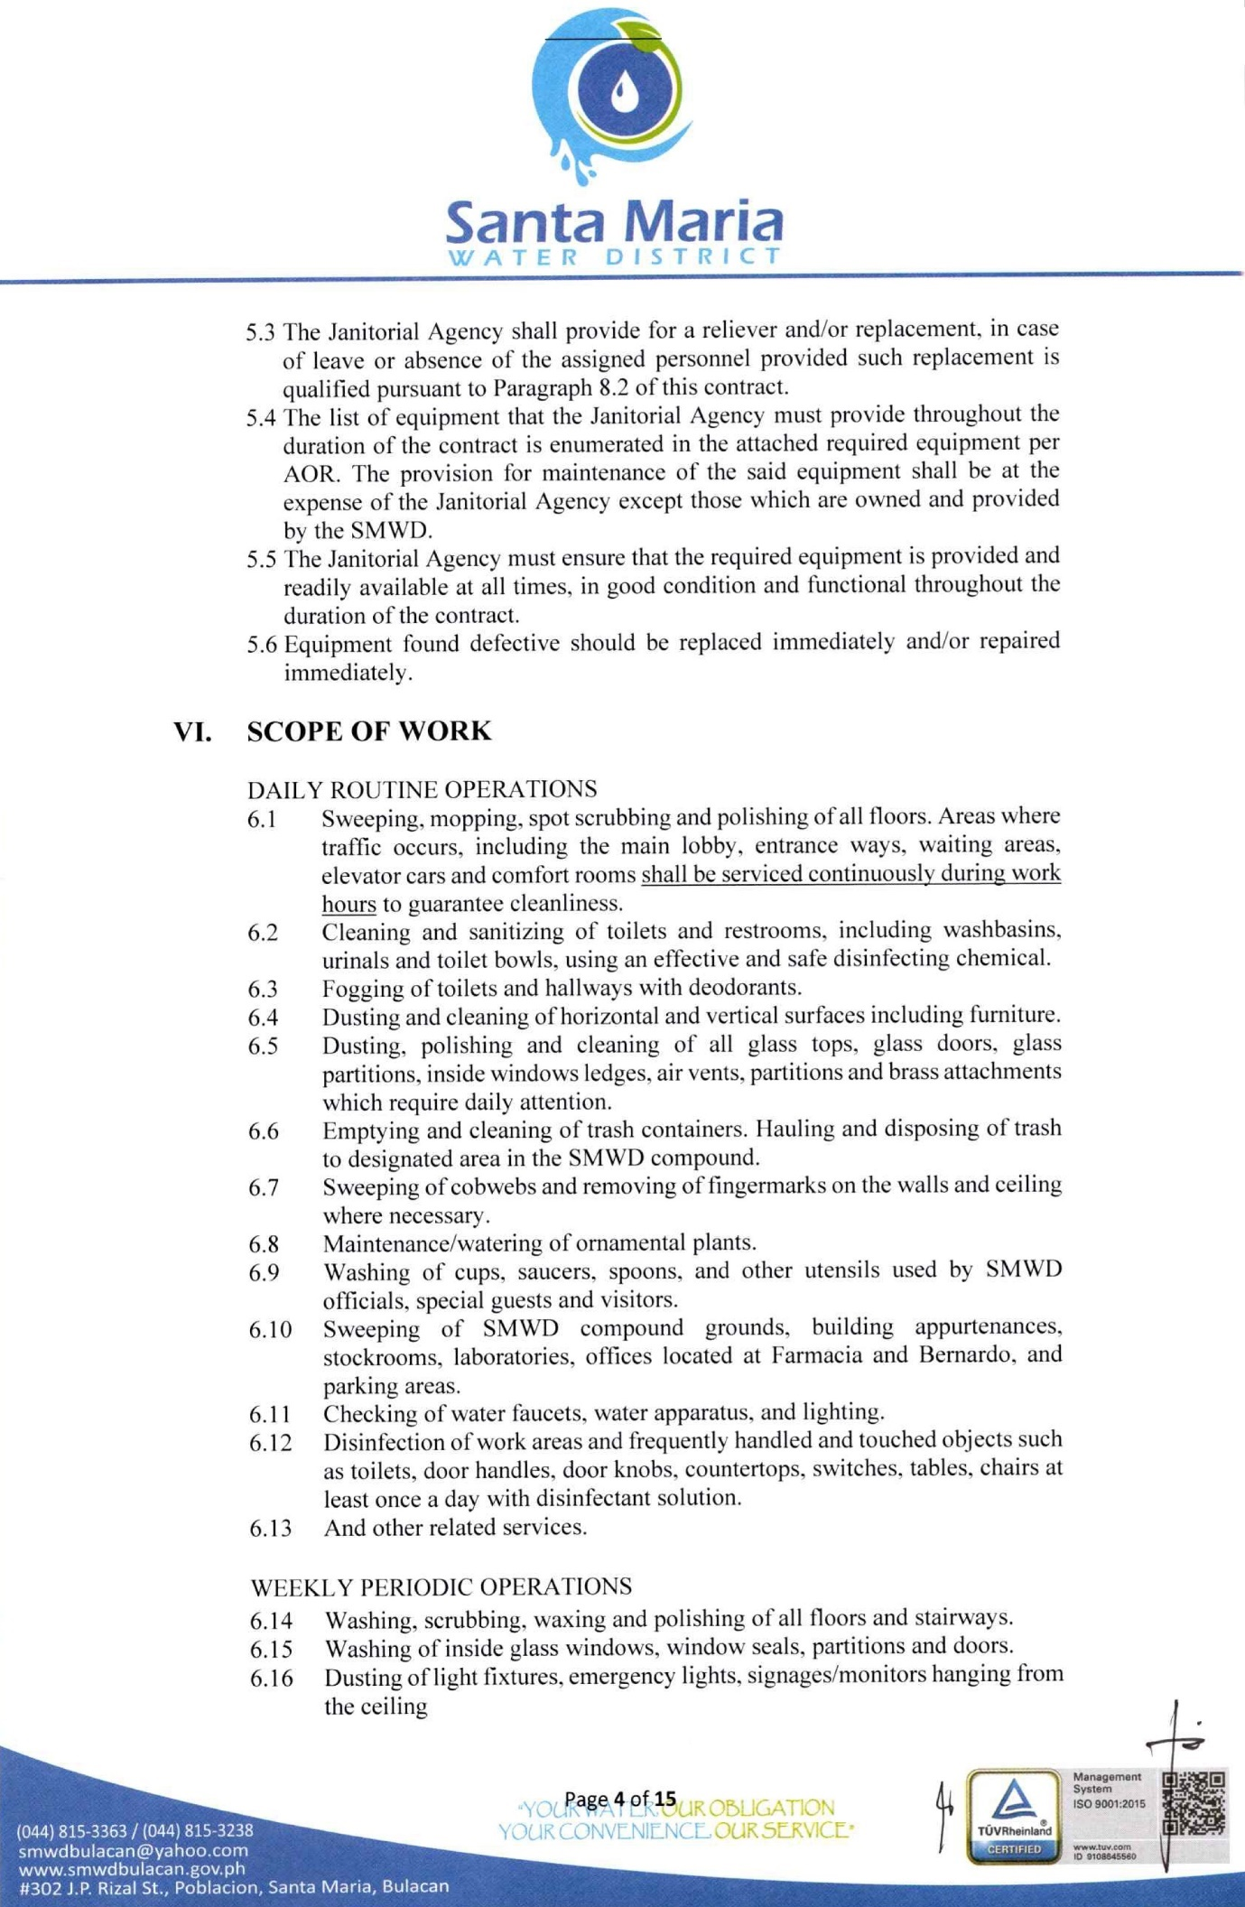

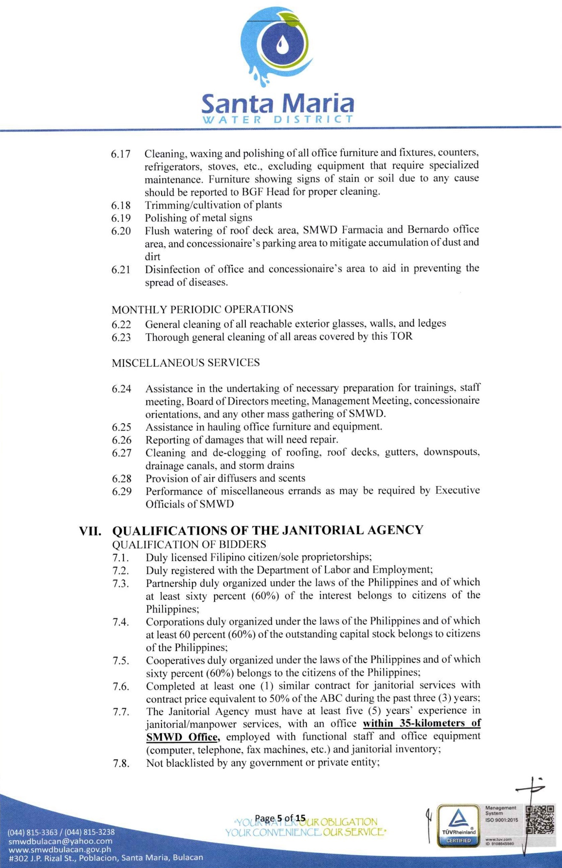

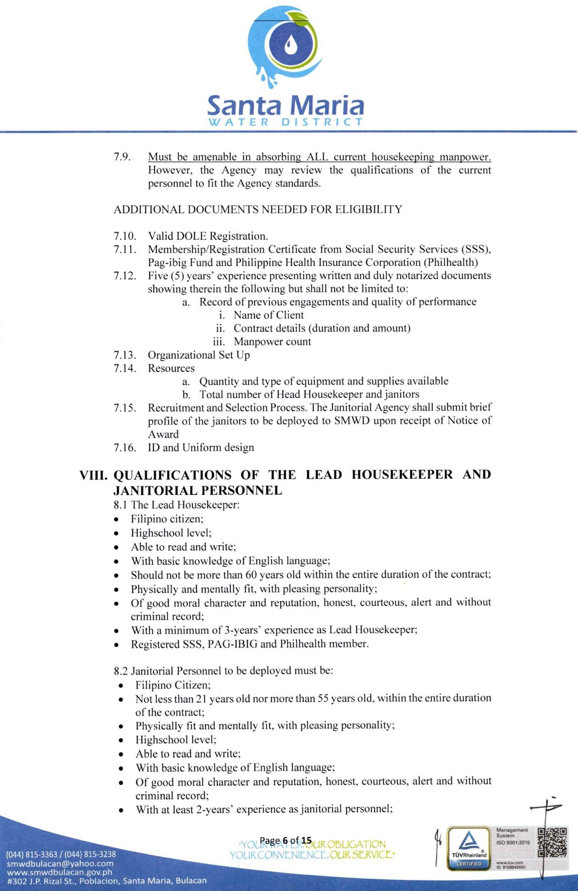

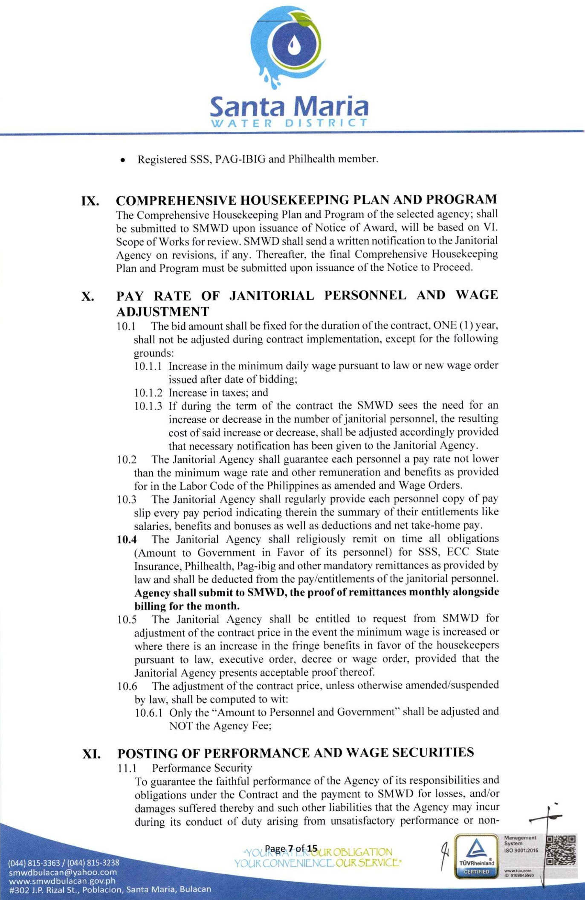

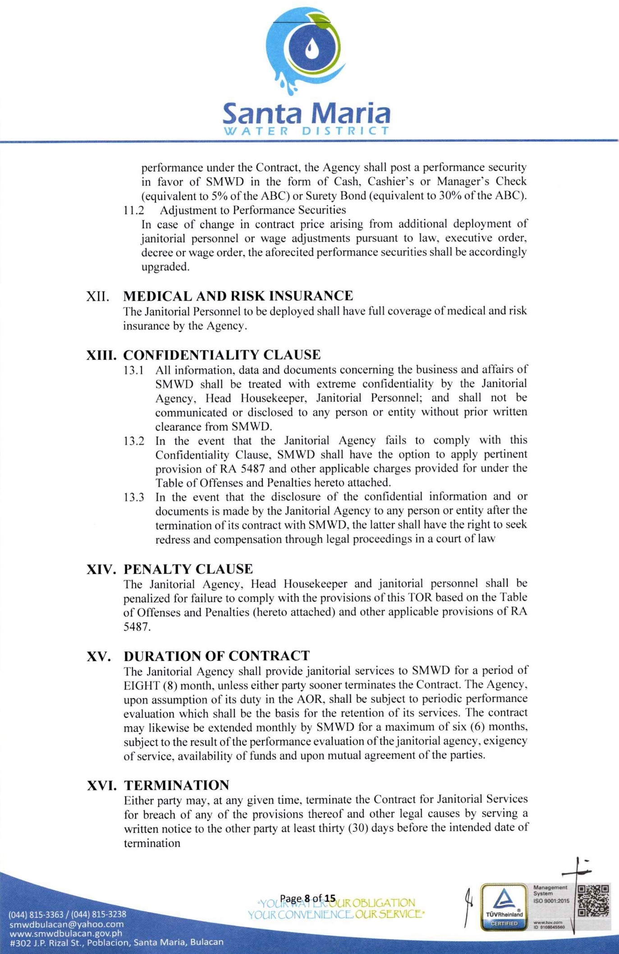

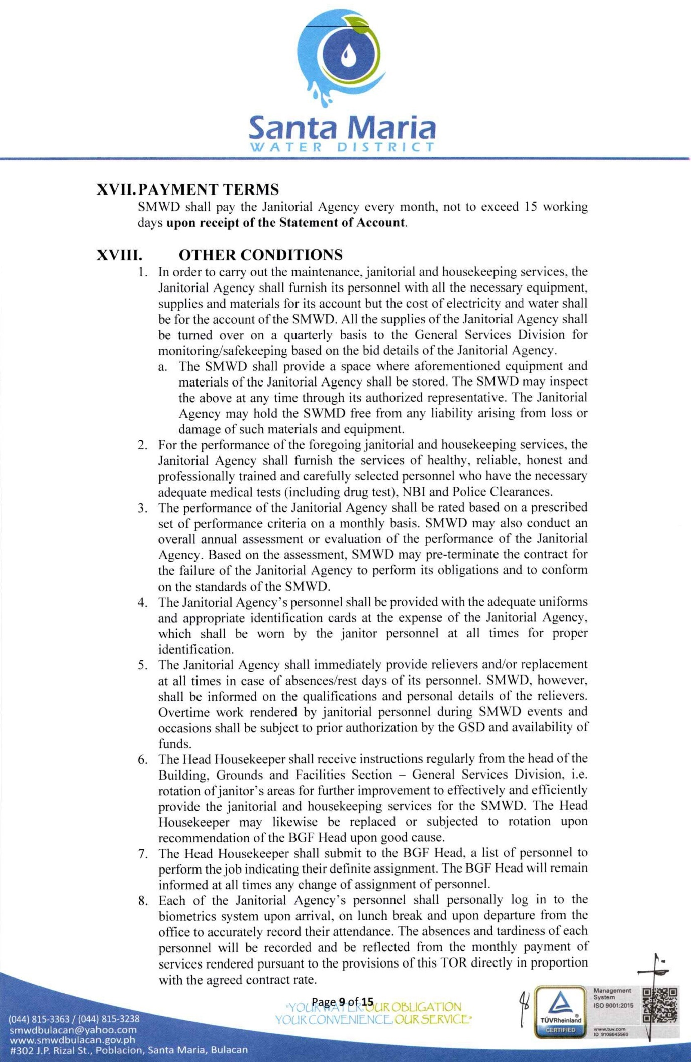

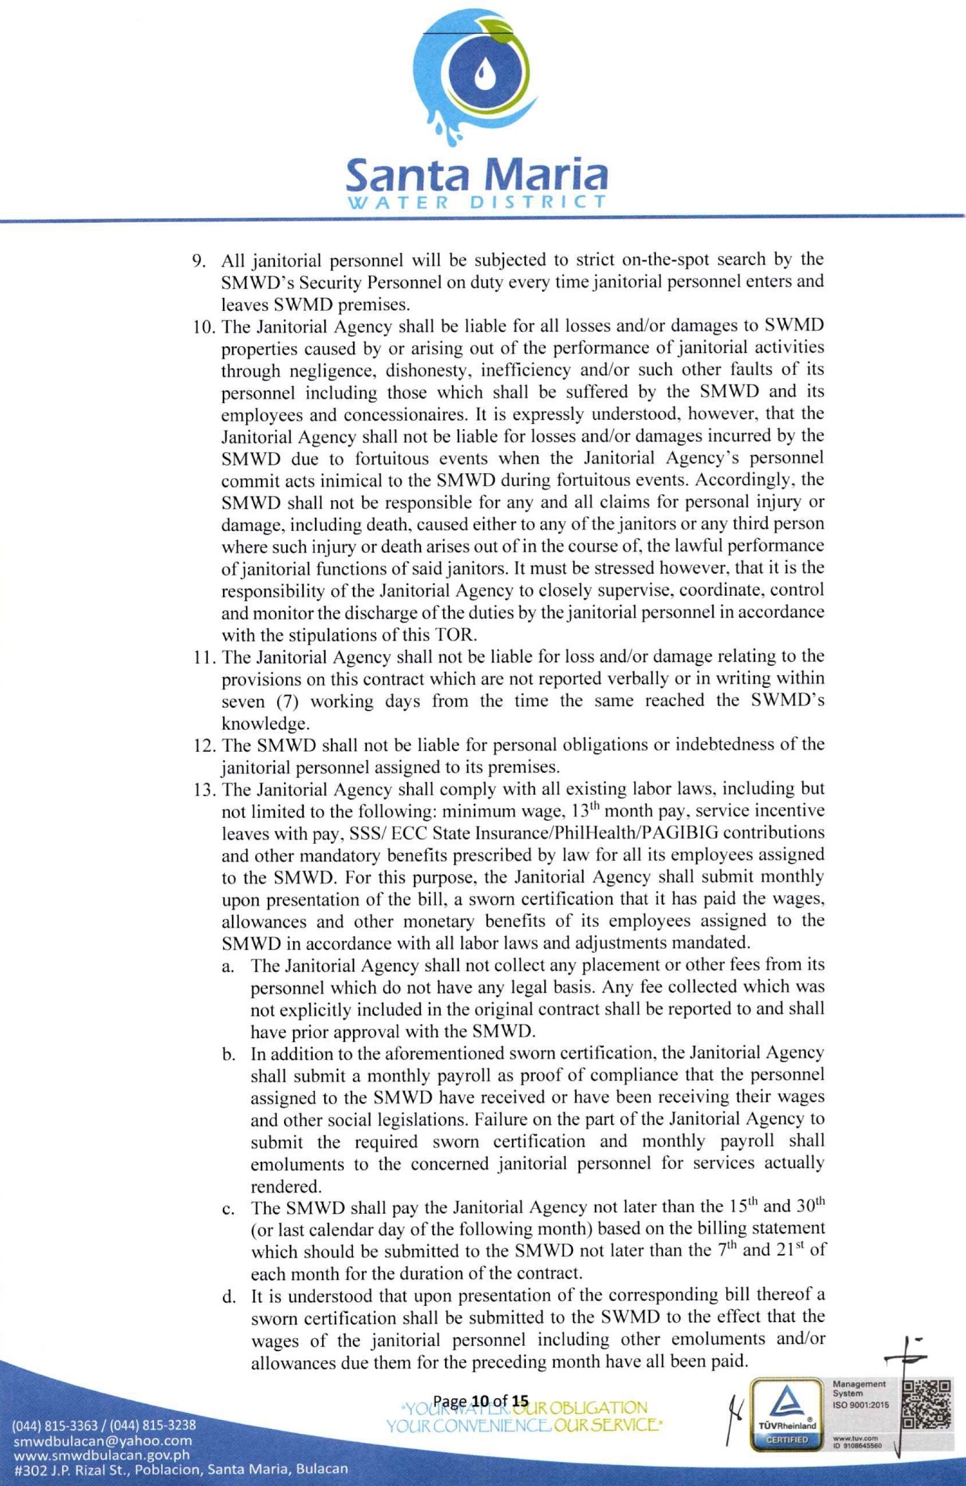

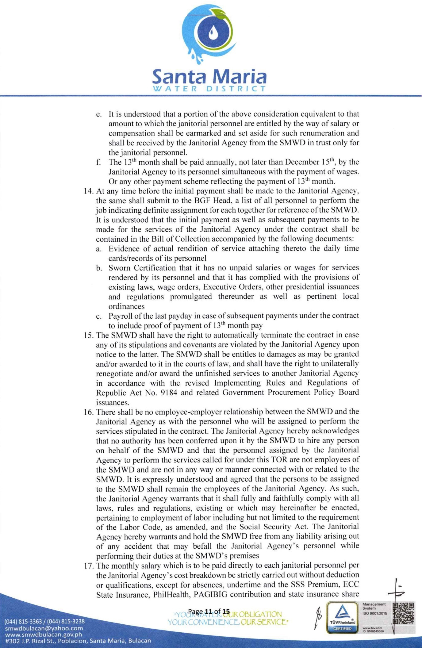

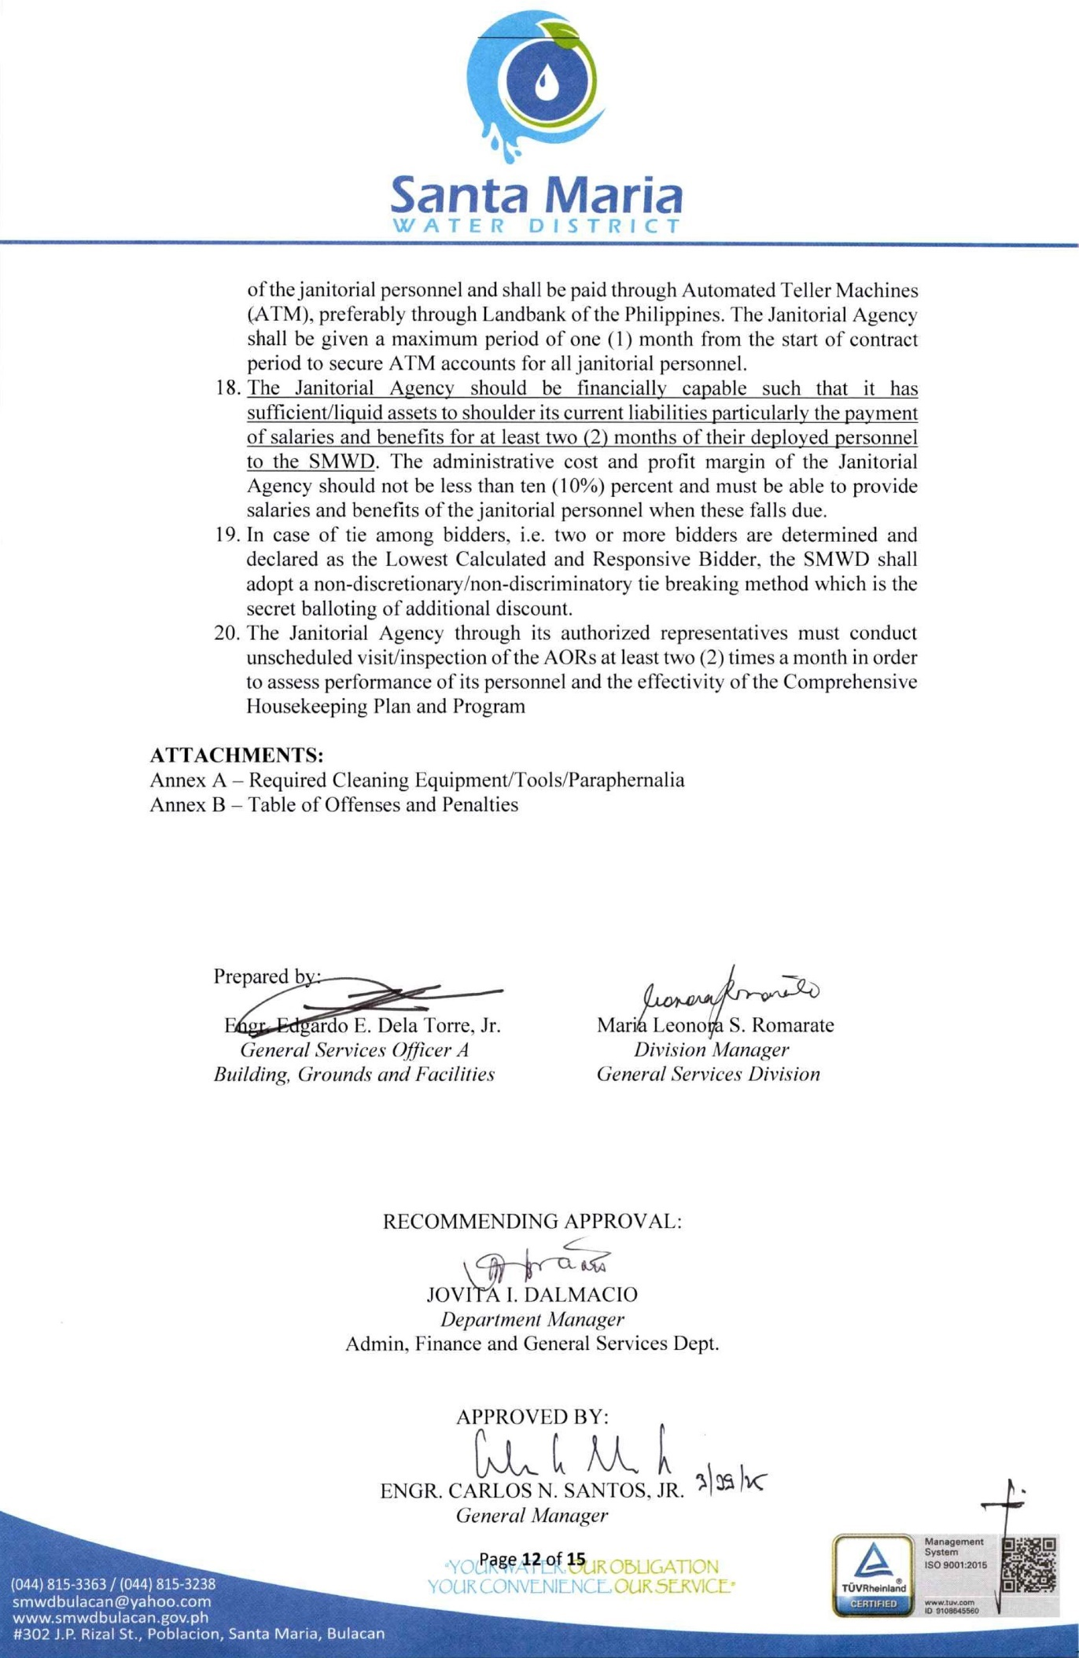

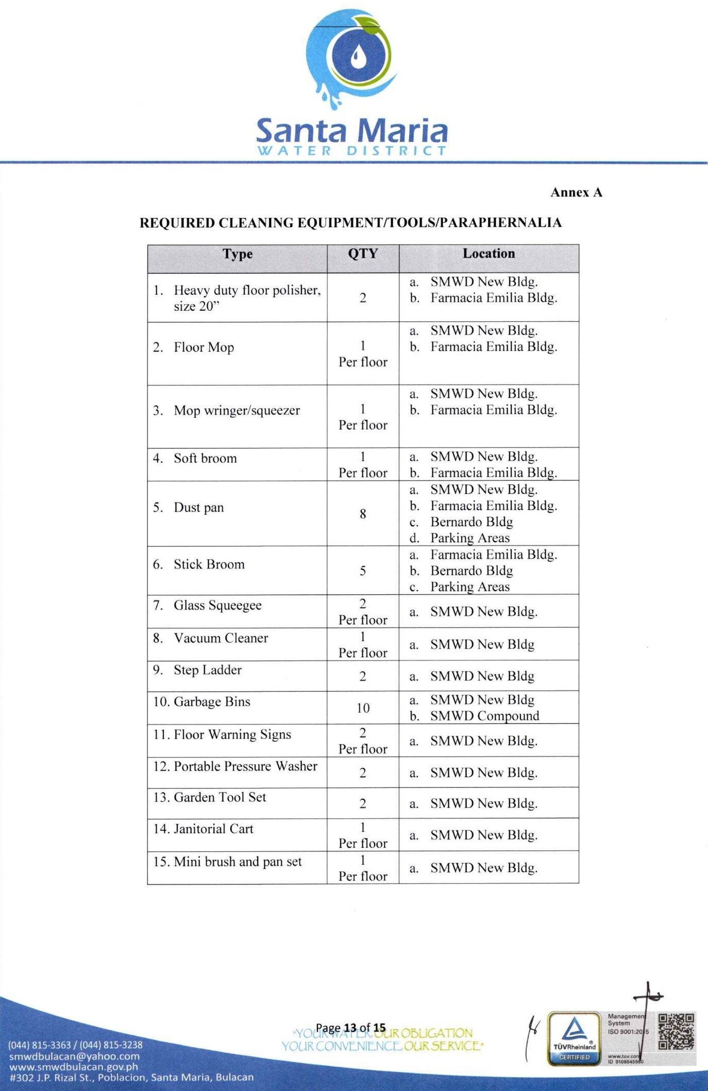

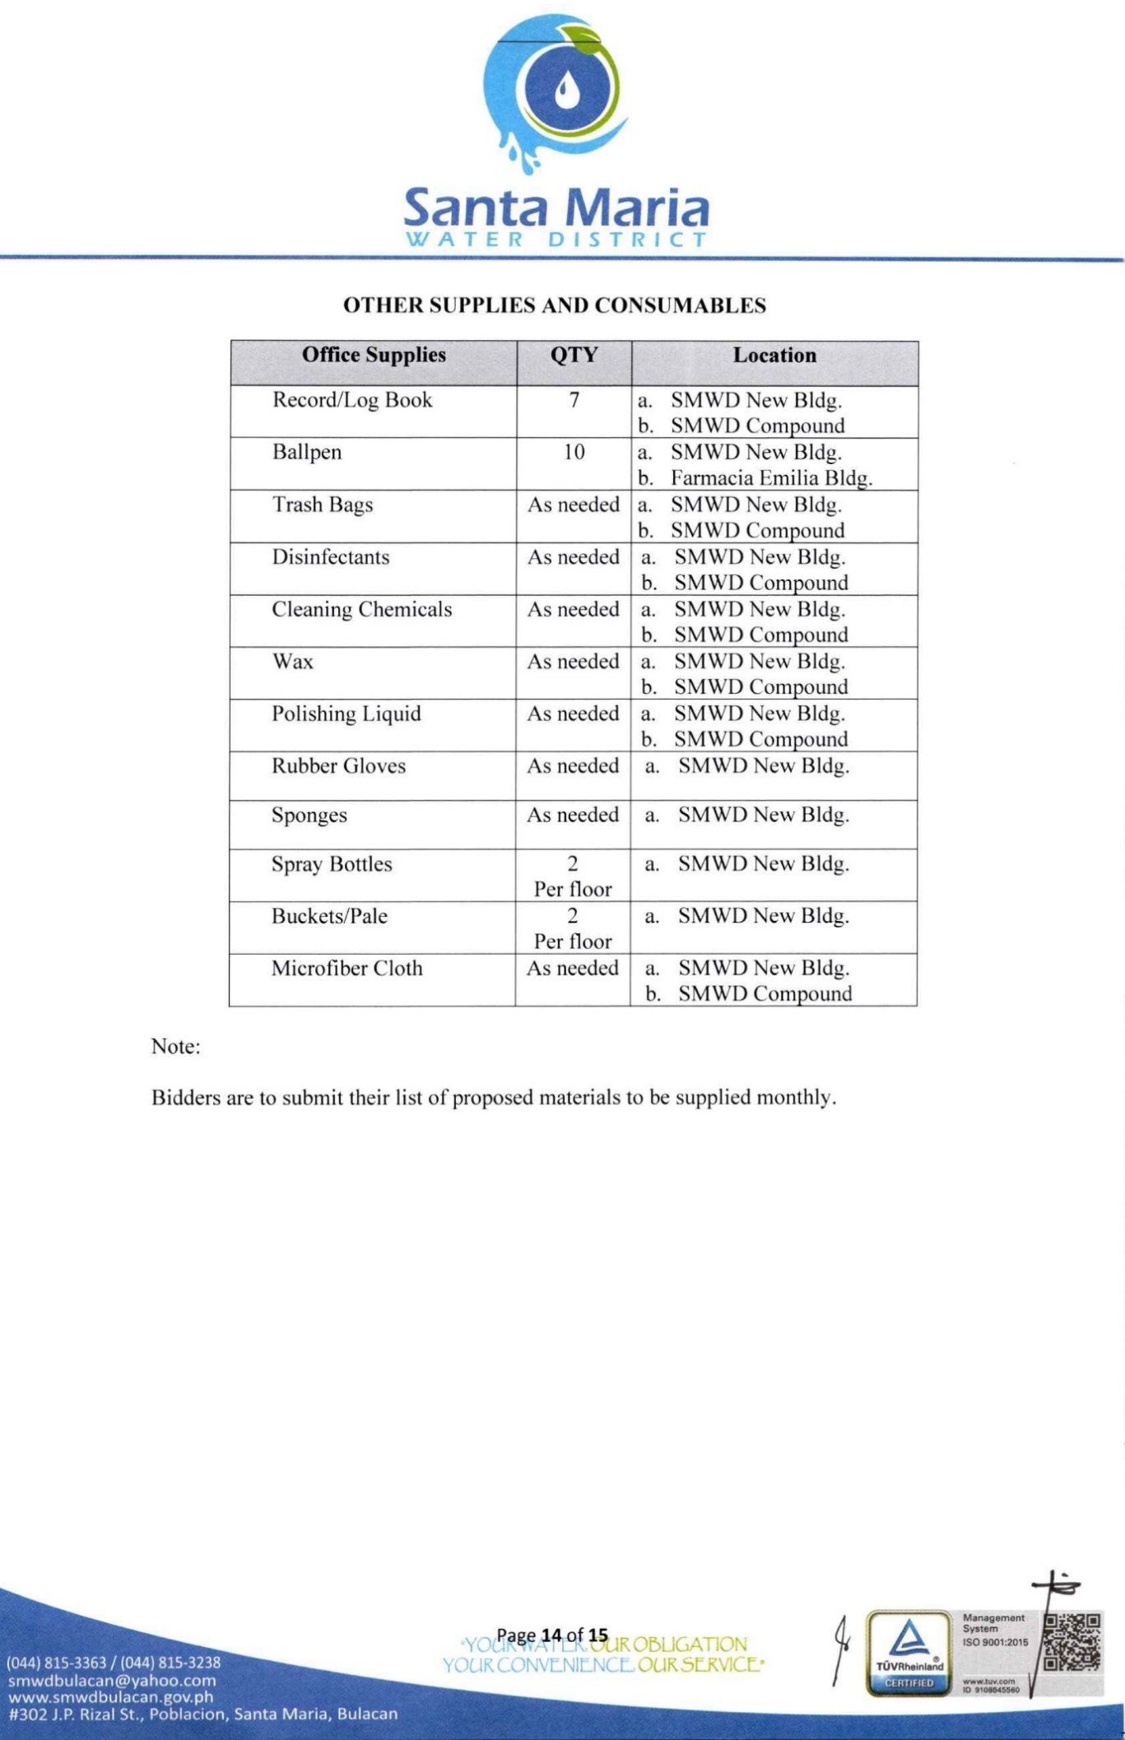

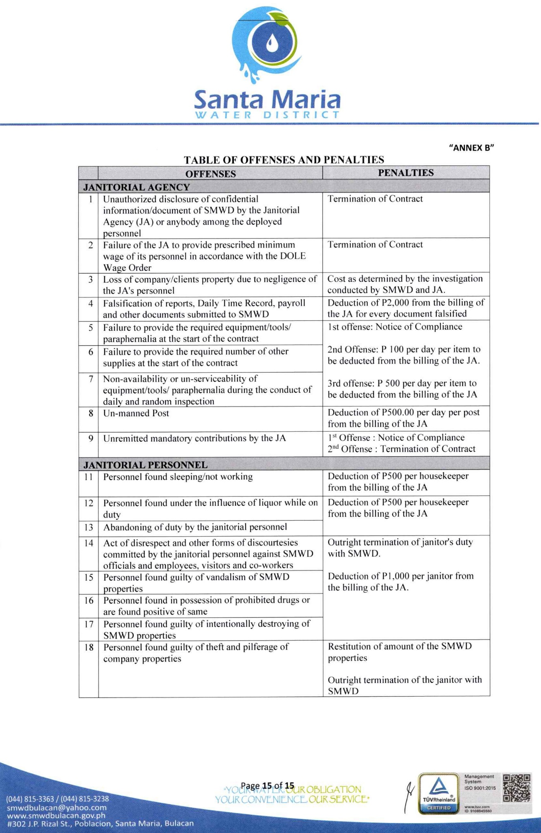

Technical Specifications

Item | Specification | Statement of Compliance
 | State if compliance to the Terms of Reference (TOR)
.

Section VIII. Checklist of Technical and Financial Documents

Notes on the Checklist of Technical and Financial Documents

The prescribed documents in the checklist are mandatory to be submitted in the Bid, but shall be subject to the following:

- GPPB Resolution No. 09-2020 on the efficient procurement measures during a State of Calamity or other similar issuances that shall allow the use of alternate documents in lieu of the mandated requirements; or

- Any subsequent GPPB issuances adjusting the documentary requirements after the effectivity of the adoption of the PBDs.

The BAC shall be checking the submitted documents of each Bidder against this checklist to ascertain if they are all present, using a non-discretionary “pass/fail” criterion pursuant to Section 30 of the 2016 revised IRR of RA No. 9184.

Checklist of Technical and Financial Documents

- TECHNICAL COMPONENT ENVELOPE

Class “A” Documents
Legal Documents
⬜ | - Valid PhilGEPS Registration Certificate (Platinum Membership) (all pages);  or
⬜ | - Registration certificate from Securities and Exchange Commission (SEC), Department of Trade and Industry (DTI) for sole proprietorship, or Cooperative Development Authority (CDA) for cooperatives or its equivalent document,  and
⬜ | - Mayor’s or Business permit issued by the city or municipality where the principal place of business of the prospective bidder is located, or the equivalent document for Exclusive Economic Zones or Areas;  and
⬜ | - Tax clearance per E.O. No. 398, s. 2005, as finally reviewed and approved by the Bureau of Internal Revenue (BIR).
Technical Documents
⬜ | - Statement of the prospective bidder of all its ongoing government and private contracts, including contracts awarded but not yet started, if any, whether similar or not similar in nature and complexity to the contract to be bid; and
⬜ | - Statement of the bidder’s Single Largest Completed Contract (SLCC) similar to the contract to be bid, except under conditions provided for in Sections 23.4.1.3 and 23.4.2.4 of the 2016 revised IRR of RA No. 9184, within the relevant period as provided in the Bidding Documents; and
⬜ | - Original copy of Bid Security. If in the form of a Surety Bond, submit also a certification issued by the Insurance Commission;  or  Original copy of Notarized Bid Securing Declaration; and
⬜ | - Conformity with the Technical Specifications, which may include production/delivery schedule, manpower requirements, and/or after-sales/parts, if applicable; and
⬜ | - Original duly signed Omnibus Sworn Statement (OSS);  and if applicable, Original Notarized Secretary’s Certificate in case of a corporation, partnership, or cooperative; or Original Special Power of Attorney of all members of the joint venture giving full power and authority to its officer to sign the OSS and do acts to represent the Bidder.
Financial Documents
⬜ | - The Supplier’s audited financial statements, showing, among others, the Supplier’s total and current assets and liabilities, stamped “received” by the BIR or its duly accredited and authorized institutions, for the preceding calendar year which should not be earlier than two (2) years from the date of bid submission; and
⬜ | - The prospective bidder’s computation of Net Financial Contracting Capacity (NFCC);  or  A committed Line of Credit from a Universal or Commercial Bank in lieu of its NFCC computation.
Class “B” Documents
⬜ | - If applicable, a duly signed joint venture agreement (JVA) in case the joint venture is already in existence;  or  duly notarized statements from all the potential joint venture partners stating that they will enter into and abide by the provisions of the JVA in the instance that the bid is successful.
- FINANCIAL COMPONENT ENVELOPE
⬜ |  | - Original of duly signed and accomplished Financial Bid Form; and
⬜ |  | - Original of duly signed and accomplished Price Schedule(s).
Other documentary requirements under RA No. 9184 (as applicable)
⬜ | - [For foreign bidders claiming by reason of their country’s extension of reciprocal rights to Filipinos] Certification from the relevant government office of their country stating that Filipinos are allowed to participate in government procurement activities for the same item or product.
⬜ | - Certification from the DTI if the Bidder claims preference as a Domestic Bidder or Domestic Entity.

Bid Form for the Procurement of Goods
[shall be submitted with the Bid] _________________________________________________________________________

BID FORM
Date : _________________
Project Identification No. : _________________

To: SANTA MARIA WATER DISTRICT

Gentlemen and/or Ladies:

Having examined the Philippine Bidding Documents (PBDs) including the Supplemental or Bid Bulletin Numbers [insert numbers], the receipt of which is hereby duly acknowledged, we, the undersigned, offer to _______________________________________________________________ in conformity with the said PBDs for the sum of [amount in words (amount in numbers)], inclusive of VAT or the total calculated bid price, as evaluated and corrected for computational errors, and other bid modifications in accordance with the Price Schedules attached herewith and made part of this Bid. The total bid price includes the cost of all taxes, such as, but not limited to: [specify the applicable taxes, e.g. (i) value added tax (VAT), (ii) income tax, (iii) local taxes, and (iv) other fiscal levies and duties], which are itemized herein or in the Price Schedules,

If our Bid is accepted, we undertake:

a. to deliver the goods in accordance with the delivery schedule specified in the Schedule of
Requirements of the Philippine Bidding Documents (PBDs);

b. to provide a performance security in the form, amounts, and within the times prescribed in the
PBDs;

c. to abide by the Bid Validity Period specified in the PBDs and it shall remain binding upon us at
any time before the expiration of that period.

[Insert this paragraph if Foreign-Assisted Project with the Development Partner:
Commissions or gratuities, if any, paid or to be paid by us to agents relating to this Bid,
and to contract execution if we are awarded the contract, are listed below:

Name and address Amount and Purpose of
of agent Currency Commission or gratuity
________________________________________________
________________________________________________
________________________________________________
(if none, state “None”) ]

Until a formal Contract is prepared and executed, this Bid, together with your written
acceptance thereof and your Notice of Award, shall be binding upon us.

We understand that you are not bound to accept the Lowest Calculated Bid or any Bid
you may receive.

We certify/confirm that we comply with the eligibility requirements pursuant to the
PBDs.

The undersigned is authorized to submit the bid on behalf of [name of the bidder] as
evidenced by the attached [state the written authority].

We acknowledge that failure to sign each and every page of this Bid Form, including the
attached Schedule of Prices, shall be a ground for the rejection of our bid

Name: ___________________________________________________________________
Legal capacity: _____________________________________________________________
Signature: ________________________________________________________________
Duly authorized to sign the Bid for and in behalf of: __________________________________
Date: _________________

BID PROPOSAL FORM

Name of Company:_________________________________________________________
Address:_________________________________________________________________

Lot No. | Description | Quantity  (a) | Unit Cost  (VAT Inclusive) (b) | Total Cost  (VAT Inclusive)  (a x b)
1 | Chlorine Dioxide Liquid | 2913 set
Total

Certified Correct:

____________________________________
Name and Signature of Bidder Representative

Bid Securing Declaration Form
[shall be submitted with the Bid if bidder opts to provide this form of bid security]
_________________________________________________________________________

REPUBLIC OF THE PHILIPPINES)
CITY OF _______________________) S.S.

BID SECURING DECLARATION
Project Identification No.: [Insert number]

To: [Insert name and address of the Procuring Entity]

I/We, the undersigned, declare that:

1. I/We understand that, according to your conditions, bids must be supported by a Bid Security,
which may be in the form of a Bid Securing Declaration.

2. I/We accept that: (a) I/we will be automatically disqualified from bidding for any
procurement contract with any procuring entity for a period of two (2) years upon receipt of
your Blacklisting Order; and, (b) I/we will pay the applicable fine provided under Section 6
of the Guidelines on the Use of Bid Securing Declaration, within fifteen (15) days from
receipt of the written demand by the procuring entity for the commission of acts resulting to
the enforcement of the bid securing declaration under Sections 23.1(b), 34.2, 40.1 and 69.1,
except 69.1(f),of the IRR of RA No. 9184; without prejudice to other legal action the
government may undertake.

3. I/We understand that this Bid Securing Declaration shall cease to be valid on the following
circumstances:

a. Upon expiration of the bid validity period, or any extension thereof pursuant to your
request;

b. I am/we are declared ineligible or post-disqualified upon receipt of your notice to such
effect, and (i) I/we failed to timely file a request for reconsideration or (ii) I/we filed a
waiver to avail of said right; and

c. I am/we are declared the bidder with the Lowest Calculated Responsive Bid, and I/we
have furnished the performance security and signed the Contract.

IN WITNESS WHEREOF, I/We have hereunto set my/our hand/s this ____ day of [month]
[year] at [place of execution].

[Insert NAME OF BIDDER OR ITS AUTHORIZED
REPRESENTATIVE]
[Insert signatory’s legal capacity]
Affiant

[Jurat]
[Format shall be based on the latest Rules on Notarial Practice]

Contract Agreement Form for the Procurement of Goods (Revised)
[Not required to be submitted with the Bid, but it shall be submitted within ten (10) days after receiving the Notice of Award]
__________________________________________________________________________________

CONTRACT AGREEMENT

THIS AGREEMENT made the _____ day of __________ 20_____ between [name of
PROCURING ENTITY] of the Philippines (hereinafter called “the Entity”) of the one part and [name of Supplier] of [city and country of Supplier] (hereinafter called “the Supplier”) of the other part;

WHEREAS, the Entity invited Bids for certain goods and ancillary services, particularly [brief description of goods and services] and has accepted a Bid by the Supplier for the supply ofthose goods and services in the sum of [contract price in words and figures in specified currency] (hereinafter called “the Contract Price”).
NOW THIS AGREEMENT WITNESSETH AS FOLLOWS:

1. In this Agreement words and expressions shall have the same meanings as are
respectively assigned to them in the Conditions of Contract referred to.

2. The following documents as required by the 2016 revised Implementing Rules and
Regulations of Republic Act No. 9184 shall be deemed to form and be read and
construed as integral part of this Agreement, viz.:

i. Philippine Bidding Documents (PBDs);
i. Schedule of Requirements;
ii. Technical Specifications;
iii. General and Special Conditions of Contract; and
iv. Supplemental or Bid Bulletins, if any
ii. Winning bidder’s bid, including the Eligibility requirements, Technical and
Financial Proposals, and all other documents or statements submitted;

Bid form, including all the documents/statements contained in the Bidder’s
bidding envelopes, as annexes, and all other documents submitted (e.g.,
Bidder’s response to request for clarifications on the bid), including
corrections to the bid, if any, resulting from the Procuring Entity’s bid
evaluation;
iii. Performance Security;

iv. Notice of Award of Contract; and the Bidder’s conforme thereto; and

v. Other contract documents that may be required by existing laws and/or the
Procuring Entity concerned in the PBDs. Winning bidder agrees that
additional contract documents or information prescribed by the GPPB
that are subsequently required for submission after the contract
execution, such as the Notice to Proceed, Variation Orders, and Warranty
Security, shall likewise form part of the Contract.
3. In consideration for the sum of [total contract price in words and figures] or such
other sums as may be ascertained, [Named of the bidder] agrees to [state the object
of the contract] in accordance with his/her/its Bid.

4. The [Name of the procuring entity] agrees to pay the above-mentioned sum in
accordance with the terms of the Bidding.
IN WITNESS whereof the parties hereto have caused this Agreement to be executed in
accordance with the laws of the Republic of the Philippines on the day and year first above
written.

[Insert Name and Signature] [Insert Name and Signature]

[Insert Signatory’s Legal Capacity] [Insert Signatory’s Legal Capacity]

for: for:

[Insert Procuring Entity] [Insert Name of Supplier

Acknowledgment
[Format shall be based on the latest Rules on Notarial Practice]

Omnibus Sworn Statement (Revised)
[shall be submitted with the Bid]
________________________________________________________________________________

REPUBLIC OF THE PHILIPPINES )
CITY/MUNICIPALITY OF ______ ) S.S

AFFIDAVIT

I, [Name of Affiant], of legal age, [Civil Status], [Nationality], and residing at [Address of
Affiant], after having been duly sworn in accordance with law, do hereby depose and state that:

1. [Select one, delete the other:]

[If a sole proprietorship:] I am the sole proprietor or authorized representative of [Name of
Bidder] with office address at [address of Bidder];

[If a partnership, corporation, cooperative, or joint venture:] I am the duly authorized and
designated representative of [Name of Bidder] with office address at [address of Bidder];

  - [Select one, delete the other:]

[If a sole proprietorship:] As the owner and sole proprietor, or authorized representative of
[Name of Bidder], I have full power and authority to do, execute and perform any and all acts
necessary to participate, submit the bid, and to sign and execute the ensuing contract for
[Name of the Project] of the [Name of the Procuring Entity], as shown in the attached duly
notarized Special Power of Attorney;

[If a partnership, corporation, cooperative, or joint venture:] I am granted full power and
authority to do, execute and perform any and all acts necessary to participate, submit the bid,
and to sign and execute the ensuing contract for [Name of the Project] of the [Name of the
Procuring Entity], as shown in the attached [state title of attached document showing proof of
authorization (e.g., duly notarized Secretary’s Certificate, Board/Partnership Resolution, or
Special Power of Attorney, whichever is applicable;)];

3. [Name of Bidder] is not “blacklisted” or barred from bidding by the Government of the
Philippines or any of its agencies, offices, corporations, or Local Government Units,
foreign government/foreign or international financing institution whose blacklisting rules
have been recognized by the Government Procurement Policy Board, by itself or by
relation, membership, association, affiliation, or controlling interest with another
blacklisted person or entity as defined and provided for in the Uniform Guidelines
on Blacklisting;
4. Each of the documents submitted in satisfaction of the bidding requirements is an authentic
copy of the original, complete, and all statements and information provided therein are true
and correct;

5. [Name of Bidder] is authorizing the Head of the Procuring Entity or its duly authorized
representative(s) to verify all the documents submitted;

6. [Select one, delete the rest:]

[If a sole proprietorship:] The owner or sole proprietor is not related to the Head of the
Procuring Entity, members of the Bids and Awards Committee (BAC), the Technical
Working Group, and the BAC Secretariat, the head of the Project Management Office or the
end-user unit, and the project consultants by consanguinity or affinity up to the third civil
degree;

[If a partnership or cooperative:] None of the officers and members of [Name of Bidder] is
related to the Head of the Procuring Entity, members of the Bids and Awards Committee
(BAC), the Technical Working Group, and the BAC Secretariat, the head of the Project
Management Office or the end-user unit, and the project consultants by consanguinity or
affinity up to the third civil degree;

[If a corporation or joint venture:] None of the officers, directors, and controlling
stockholders of [Name of Bidder] is related to the Head of the Procuring Entity, members of
the Bids and Awards Committee (BAC), the Technical Working Group, and the BAC
Secretariat, the head of the Project Management Office or the end-user unit, and the project
consultants by consanguinity or affinity up to the third civil degree;

7. [Name of Bidder] complies with existing labor laws and standards; and

8. [Name of Bidder] is aware of and has undertaken the responsibilities as a Bidder in
compliance with the Philippine Bidding Documents, which includes:

a. Carefully examining all of the Bidding Documents;
b. Acknowledging all conditions, local or otherwise, affecting the implementation of the
Contract;
c. Making an estimate of the facilities available and needed for the contract to be bid, if
any; and
d. Inquiring or securing Supplemental/Bid Bulletin(s) issued for the [Name of the Project].

9. [Name of Bidder] did not give or pay directly or indirectly, any commission, amount, fee, or
any form of consideration, pecuniary or otherwise, to any person or official, personnel or
representative of the government in relation to any procurement project or activity.
10. In case advance payment was made or given, failure to perform or deliver any of the
obligations and undertakings in the contract shall be sufficient grounds to constitute
criminal liability for Swindling (Estafa) or the commission of fraud with unfaithfulness
or abuse of confidence through misappropriating or converting any payment received
by a person or entity under an obligation involving the duty to deliver certain goods or
services, to the prejudice of the public and the government of the Philippines pursuant
to Article 315 of Act No. 3815 s. 1930, as amended, or the Revised Penal Code.

IN WITNESS WHEREOF, I have hereunto set my hand this __ day of ___, 20__ at
____________, Philippines.

[Insert NAME OF BIDDER OR ITS AUTHORIZED
REPRESENTATIVE]
[Insert signatory’s legal capacity]
Affiant

[Jurat]



