Philippine Bidding Documents

Procurement of:

CONSTRUCTION OF PUMP HOUSE, PERIMETER FENCE, AND SITE DEVELOPMENT OF GLENWOODS PUMP STATION AT BRGY. CAYSIO
REF. NO. SMWD-PB2025-IF-06-009

Government of the Republic of the Philippines

Sixth Edition
July 2020

Preface

These Philippine Bidding Documents (PBDs) for the procurement of Infrastructure Projects (hereinafter referred to also as the “Works”) through Competitive Bidding have been prepared by the Government of the Philippines for use by all branches, agencies, departments, bureaus, offices, or instrumentalities of the government, including government-owned and/or -controlled corporations, government financial institutions, state universities and colleges, local government units, and autonomous regional government. The procedures and practices presented in this document have been developed through broad experience, and are for mandatory use in projects that are financed in whole or in part by the Government of the Philippines or any foreign government/foreign or international financing institution in accordance with the provisions of the 2016 revised Implementing Rules and Regulations (IRR) of Republic Act (RA) No. 9184.
The PBDs are intended as a model for admeasurements (unit prices or unit rates in a bill of quantities) types of contract, which are the most common in Works contracting.
The Bidding Documents shall clearly and adequately define, among others: (i) the objectives, scope, and expected outputs and/or results of the proposed contract; (ii) the eligibility requirements of Bidders; (iii) the expected contract duration; and (iv)the obligations, duties, and/or functions of the winning Bidder.
Care should be taken to check the relevance of the provisions of the PBDs against the requirements of the specific Works to be procured. If duplication of a subject is inevitable in other sections of the document prepared by the Procuring Entity, care must be exercised to avoid contradictions between clauses dealing with the same matter.
Moreover, each section is prepared with notes intended only as information for the Procuring Entity or the person drafting the Bidding Documents. They shall not be included in the final documents. The following general directions should be observed when using the documents:
- All the documents listed in the Table of Contents are normally required for the procurement of Infrastructure Projects. However, they should be adapted as necessary to the circumstances of the particular Project.
- Specific details, such as the “name of the Procuring Entity” and “address for bid submission,” should be furnished in the Instructions to Bidders, Bid Data Sheet, and Special Conditions of Contract. The final documents should contain neither blank spaces nor options.
- This Preface and the footnotes or notes in italics included in the Invitation to Bid, BDS, General Conditions of Contract, Special Conditions of Contract, Specifications, Drawings, and Bill of Quantities are not part of the text of the final document, although they contain instructions that the Procuring Entity should strictly follow.
- The cover should be modified as required to identify the Bidding Documents as to the names of the Project, Contract, and Procuring Entity, in addition to date of issue.
- Modifications for specific Procurement Project details should be provided in the Special Conditions of Contract as amendments to the Conditions of Contract. For easy completion, whenever reference has to be made to specific clauses in the Bid Data Sheet or Special Conditions of Contract, these terms shall be printed in bold typeface on Sections I (Instructions to Bidders) and III (General Conditions of Contract), respectively.
- For guidelines on the use of Bidding Forms and the procurement of Foreign-Assisted Projects, these will be covered by a separate issuance of the Government Procurement Policy Board.

TABLE OF CONTENTS

Glossary of Terms, Abbreviations, and Acronyms 5
Section I. Invitation to Bid 8
Section II. Instructions to Bidders 11
1. Scope of Bid 11
2. Funding Information 11
3. Bidding Requirements 11
4. Corrupt, Fraudulent, Collusive, Coercive, and Obstructive Practices 11
5. Eligible Bidders 12
6. Origin of Associated Goods 12
7. Subcontracts 12
8. Pre-Bid Conference 13
9. Clarification and Amendment of Bidding Documents 13
10. Documents Comprising the Bid: Eligibility and Technical Components 13
11. Documents Comprising the Bid: Financial Component 14
12. Alternative Bids 14
13. Bid Prices 14
14. Bid and Payment Currencies 14
15. Bid Security 15
16. Sealing and Marking of Bids 15
17. Deadline for Submission of Bids 15
18. Opening and Preliminary Examination of Bids 15
19. Detailed Evaluation and Comparison of Bids 16
20. Post Qualification 16
21. Signing of the Contract 16
Section III. Bid Data Sheet 17
Section IV. General Conditions of Contract 21
1. Scope of Contract 22
2. Sectional Completion of Works 22
3. Possession of Site 22
4. The Contractor’s Obligations 22
5. Performance Security 23
6. Site Investigation Reports 23
7. Warranty 23
8. Liability of the Contractor 23
9. Termination for Other Causes 23
10. Dayworks 24
11. Program of Work 24
12. Instructions, Inspections and Audits 24
13. Advance Payment 24
14. Progress Payments 24
15. Operating and Maintenance Manuals 24
Section V. Special Conditions of Contract 26
Section VI. Specifications 28
Section VII. Drawings 33
Section VIII. Bill of Quantities 36
Section IX. Checklist of Technical and Financial Documents 39

Glossary of

Terms, Abbreviations, and Acronyms

ABC – Approved Budget for the Contract.
ARCC – Allowable Range of Contract Cost.
BAC – Bids and Awards Committee.
Bid – A signed offer or proposal to undertake a contract submitted by a bidder in response to and in consonance with the requirements of the bidding documents. Also referred to as Proposal and Tender. (2016 revised IRR, Section 5[c])
Bidder – Refers to a contractor, manufacturer, supplier, distributor and/or consultant who submits a bid in response to the requirements of the Bidding Documents. (2016 revised IRR, Section 5[d])
Bidding Documents – The documents issued by the Procuring Entity as the bases for bids, furnishing all information necessary for a prospective bidder to prepare a bid for the Goods, Infrastructure Projects, and/or Consulting Services required by the Procuring Entity. (2016 revised IRR, Section 5[e])
BIR – Bureau of Internal Revenue.
BSP – Bangko Sentral ng Pilipinas.
CDA – Cooperative Development Authority.
Consulting Services – Refer to services for Infrastructure Projects and other types of projects or activities of the GOP requiring adequate external technical and professional expertise that are beyond the capability and/or capacity of the GOP to undertake such as, but not limited to: (i) advisory and review services; (ii) pre-investment or feasibility studies; (iii) design; (iv) construction supervision; (v) management and related services; and (vi) other technical services or special studies. (2016 revised IRR, Section 5[i])
Contract – Refers to the agreement entered into between the Procuring Entity and the Supplier or Manufacturer or Distributor or Service Provider for procurement of Goods and Services; Contractor for Procurement of Infrastructure Projects; or Consultant or Consulting Firm for Procurement of Consulting Services; as the case may be, as recorded in the Contract Form signed by the parties, including all attachments and appendices thereto and all documents incorporated by reference therein.
Contractor – is a natural or juridical entity whose proposal was accepted by the Procuring Entity and to whom the Contract to execute the Work was awarded. Contractor as used in these Bidding Documents may likewise refer to a supplier, distributor, manufacturer, or consultant.
CPI – Consumer Price Index.
DOLE – Department of Labor and Employment.
DTI – Department of Trade and Industry.
Foreign-funded Procurement or Foreign-Assisted Project – Refers to procurement whose funding source is from a foreign government, foreign or international financing institution as specified in the Treaty or International or Executive Agreement. (2016 revised IRR, Section 5[b]).
GFI – Government Financial Institution.
GOCC – Government-owned and/or –controlled corporation.
Goods – Refer to all items, supplies, materials and general support services, except Consulting Services and Infrastructure Projects, which may be needed in the transaction of public businesses or in the pursuit of any government undertaking, project or activity, whether in the nature of equipment, furniture, stationery, materials for construction, or personal property of any kind, including non-personal or contractual services such as the repair and maintenance of equipment and furniture, as well as trucking, hauling, janitorial, security, and related or analogous services, as well as procurement of materials and supplies provided by the Procuring Entity for such services. The term “related” or “analogous services” shall include, but is not limited to, lease or purchase of office space, media advertisements, health maintenance services, and other services essential to the operation of the Procuring Entity. (2016 revised IRR, Section 5[r])
GOP – Government of the Philippines.
Infrastructure Projects – Include the construction, improvement, rehabilitation, demolition, repair, restoration or maintenance of roads and bridges, railways, airports, seaports, communication facilities, civil works components of information technology projects, irrigation, flood control and drainage, water supply, sanitation, sewerage and solid waste management systems, shore protection, energy/power and electrification facilities, national buildings, school buildings, hospital buildings, and other related construction projects of the government. Also referred to as civil works or works. (2016 revised IRR, Section 5[u])
LGUs – Local Government Units.
NFCC – Net Financial Contracting Capacity.
NGA – National Government Agency.
PCAB – Philippine Contractors Accreditation Board.
PhilGEPS - Philippine Government Electronic Procurement System.
Procurement Project – refers to a specific or identified procurement covering goods, infrastructure project or consulting services. A Procurement Project shall be described, detailed, and scheduled in the Project Procurement Management Plan prepared by the agency which shall be consolidated in the procuring entity's Annual Procurement Plan. (GPPB Circular No. 06-2019 dated 17 July 2019)
PSA – Philippine Statistics Authority.
SEC – Securities and Exchange Commission.
SLCC – Single Largest Completed Contract.
UN – United Nations.

Section I. Invitation to Bid

Notes on the Invitation to Bid

The Invitation to Bid (IB) provides information that enables potential Bidders to decide whether to participate in the procurement at hand. The IB shall be posted in accordance with Section 21.2 of the 2016 revised IRR of RA No. 9184.

Apart from the essential items listed in the Bidding Documents, the IB should also indicate the following:

- The date of availability of the Bidding Documents, which shall be from the time the IB is first advertised/posted until the deadline for the submission and receipt of bids;

- The place where the Bidding Documents may be acquired or the website where it may be downloaded;

- The deadline for the submission and receipt of bids; and

- Any important bid evaluation criteria.

The IB should be incorporated into the Bidding Documents. The information contained in the IB must conform to the Bidding Documents and in particular to the relevant information in the Bid Data Sheet.

Invitation to bid for the
CONSTRUCTION OF PUMP HOUSE, PERIMETER FENCE, AND SITE DEVELOPMENT OF GLENWOODS PUMP STATION AT BRGY. CAYSIO

- The Santa Maria Water District, through the Corporate Operating Budget for the Year 2025 approved by the Board of Directors intends to apply the sum of One Million Nine Hundred Eighty-Eight Thousand Pesos (Php1,988,000.00) being the Approved Budget for the Contract (ABC) to payments under the contract for the Construction of Pump House, Perimeter Fence, and Site Development of Glenwoods Pump Station at Brgy. Caysio with Identification No. SMWD-PB2025-IF-06-009. Bids received in excess of the ABC shall be automatically rejected at bid opening.

- The Santa Maria Water District now invites bids for the above Procurement Project. Completion of the Works is required within one hundred twenty (120) calendar days from receipt of the Notice to Proceed. Bidders should have completed, within three (3) years from the date of submission and receipt of bids, a contract similar to the Project. The description of an eligible bidder is contained in the Bidding Documents, particularly, in Section II (Instructions to Bidders).

- Bidding will be conducted through open competitive bidding procedures using non-discretionary “pass/fail” criterion as specified in the 2016 revised Implementing Rules and Regulations (IRR) of Republic Act (RA) No. 9184.

- Interested bidders may obtain further information from the Santa Maria Water District, the Procuring Entity, and view and inspect the Bidding Documents in PhilGEPs and Santa Maria Water District’s website at wwwsmwdbulacan.gov.ph

- A complete set of Bidding Documents may be acquired by interested bidders on June 18, 2025 to July 8, 2025 from the given address below and downloadable from Philgeps and our website at www.smwdbulacan.gov.ph. Only soft copies will be issued by the Procuring Entity. The amount of the bidding documents is Three Thousand Pesos (Php3,000.00) in pursuant to the latest guidelines issued by the GPPB. The amount shall be paid by the prospective bidder to the SMWD’s cashier prior to bid submission. The proof of payment, official receipt, shall be presented to the BAC Secretariat upon submission of bidding documents or send through electronic means prior to bid submission.

- The Santa Maria Water District through its Bids and Awards Committee will hold a Pre-Bid Conference on June 26, 2025, 10:00 AM at the BAC Room, 3rd Floor SMWD Building located at No. 302 J.P Rizal St., Poblacion, Santa Maria, Bulacan, which shall be open to prospective bidders.

- Bids must be duly received by the BAC Secretariat through manual submission, LBC or any Freight Service at the office address indicated below on or before 12:00 PM on July 8, 2025. The official time is the one reflected in the biometrics located at the ground floor of the SMWD’s building. Late bids shall not be accepted.

- All Bids must be accompanied by a bid security in any of the acceptable forms and in the amount stated in ITB Clause 14.

- Bid opening shall be on July 8, 2025, 1:00 PM at the given address below. Bid opening will be held manually and face to face. Bids will be opened in the presence of the bidders’ representatives who choose to attend the activity.

- The summary of the bidding activities is as follows:

Advertisement/posting of Invitation to Bid | June 18 - 25, 2025
Issuance and Availability of Bid Documents | June 18, 2025 to July 8, 2025
Pre-Bid Conference | June 26, 2025 @10:00 A.M
Last day of Submission of Written Clarification | June 29, 2025
Last day of Issuance of Bid Bulletin (if any) | July 1, 2025
Deadline for Submission of Bids | July 8, 2025 @12:00 P.M
Opening of Bids | July 8, 2025 @ 1:00 P.M.

- The Santa Maria Water District reserves the right to reject any and all bids, declare a failure of bidding, or not award the contract at any time prior to contract award in accordance with Sections 35.6 and 41 of the 2016 revised IRR of RA No. 9184, without thereby incurring any liability to the affected bidder or bidders.

- For further information, please refer to:

Maria Lourdes V. German
BAC Secretariat
3rd Floor SMWD Building, No. 302 J.P Rizal St.,
Poblacion, Santa Maria, Bulacan
CP# 0917-138-8683
Landline: (044) 815-3238
Email Address: smwdbulacan@yahoo.com
Website: smwdbulacan.gov.ph

- For viewing and downloading of Bidding Documents you may visit: http://notices.philgeps.gov.ph
https://smwdbulacan.gov.ph

Date of Issuance of Bidding Documents: June 18, 2025

sgd
MARIA LEONORA S. ROMARATE
BAC Chairperson

Section II. Instructions to Bidders

Scope of Bid

The Procuring Entity, Santa Maria Water District invites Bids for the Procurement Project, “Construction of Pump House, Perimeter Fence, and Site Development of Glenwoods Pump Station at Brgy Caysio, with Project Identification Number SMWD-PB2025-IF-06-009.

The Procurement Project (referred to herein as “Project”) is for the construction of Works, as described in Section VI (Specifications).

Funding Information

- The GOP through the source of funding as indicated below for the year 2025 in the amount of One Million Nine Hundred Eighty-Eight Thousand Pesos Pesos (Php1,988,000.00).

- The source of funding is:

GOCC and GFIs, the proposed Corporate Operating Budget.

Bidding Requirements

The Bidding for the Project shall be governed by all the provisions of RA No. 9184 and its 2016 revised IRR, including its Generic Procurement Manual and associated policies, rules and regulations as the primary source thereof, while the herein clauses shall serve as the secondary source thereof.

Any amendments made to the IRR and other GPPB issuances shall be applicable only to the ongoing posting, advertisement, or invitation to bid by the BAC through the issuance of a supplemental or bid bulletin.

The Bidder, by the act of submitting its Bid, shall be deemed to have inspected the site, determined the general characteristics of the contracted Works and the conditions for this Project, such as the location and the nature of the work; (b) climatic conditions; (c) transportation facilities; (c) nature and condition of the terrain, geological conditions at the site communication facilities, requirements, location and availability of construction aggregates and other materials, labor, water, electric power and access roads; and (d) other factors that may affect the cost, duration and execution or implementation of the contract, project, or work and examine all instructions, forms, terms, and project requirements in the Bidding Documents.

Corrupt, Fraudulent, Collusive, Coercive, and Obstructive Practices

The Procuring Entity, as well as the Bidders and Contractors, shall observe the highest standard of ethics during the procurement and execution of the contract. They or through an agent shall not engage in corrupt, fraudulent, collusive, coercive, and obstructive practices defined under Annex “I” of the 2016 revised IRR of RA No. 9184 or other integrity violations in competing for the Project.

Eligible Bidders

- Only Bids of Bidders found to be legally, technically, and financially capable will be evaluated.

- The Bidder must have an experience of having completed a Single Largest Completed Contract (SLCC) that is similar to this Project, equivalent to at least fifty percent (50%) of the ABC adjusted, if necessary, by the Bidder to current prices using the PSA’s CPI, except under conditions provided for in Section 23.4.2.4 of the 2016 revised IRR of RA No. 9184.

A contract is considered to be “similar” to the contract to be bid if it has the major categories of work stated in the BDS.

- For Foreign-funded Procurement, the Procuring Entity and the foreign government/foreign or international financing institution may agree on another track record requirement, as specified in the Bidding Document prepared for this purpose.

- The Bidders shall comply with the eligibility criteria under Section 23.4.2 of the 2016 IRR of RA No. 9184.

Origin of Associated Goods

There is no restriction on the origin of Goods other than those prohibited by a decision of the UN Security Council taken under Chapter VII of the Charter of the UN.

Subcontracts

- The Bidder may subcontract portions of the Project to the extent allowed by the Procuring Entity as stated herein, but in no case more than fifty percent (50%) of the Project.

The Procuring Entity has prescribed that:
[Select one, delete other/s]

- Subcontracting is allowed. The portions of Project and the maximum percentage allowed to be subcontracted are indicated in the BDS, which shall not exceed fifty percent (50%) of the contracted Works.

- Subcontracting is not allowed.

Pre-Bid Conference
The Procuring Entity will hold a pre-bid conference for this Project on the specified date and time and either at its physical address {[insert if applicable] and/or through videoconferencing/webcasting} as indicated in paragraph 6 of the IB.

Clarification and Amendment of Bidding Documents

Prospective bidders may request for clarification on and/or interpretation of any part of the Bidding Documents. Such requests must be in writing and received by the Procuring Entity, either at its given address or through electronic mail indicated in the IB, at least ten (10) calendar days before the deadline set for the submission and receipt of Bids.

Documents Comprising the Bid: Eligibility and Technical Components

- The first envelope shall contain the eligibility and technical documents of the Bid as specified in Section IX. Checklist of Technical and Financial Documents.

- If the eligibility requirements or statements, the bids, and all other documents for submission to the BAC are in foreign language other than English, it must be accompanied by a translation in English, which shall be authenticated by the appropriate Philippine foreign service establishment, post, or the equivalent office having jurisdiction over the foreign bidder’s affairs in the Philippines. For Contracting Parties to the Apostille Convention, only the translated documents shall be authenticated through an apostille pursuant to GPPB Resolution No. 13-2019 dated 23 May 2019. The English translation shall govern, for purposes of interpretation of the bid.

- A valid PCAB License is required, and in case of joint ventures, a valid special PCAB License, and registration for the type and cost of the contract for this Project. Any additional type of Contractor license or permit shall be indicated in the BDS.

- A List of Contractor’s key personnel (e.g., Project Manager, Project Engineers, Materials Engineers, and Foremen) assigned to the contract to be bid, with their complete qualification and experience data shall be provided. These key personnel must meet the required minimum years of experience set in the BDS.

- A List of Contractor’s major equipment units, which are owned, leased, and/or under purchase agreements, supported by proof of ownership, certification of availability of equipment from the equipment lessor/vendor for the duration of the project, as the case may be, must meet the minimum requirements for the contract set in the BDS.

Documents Comprising the Bid: Financial Component

- The second bid envelope shall contain the financial documents for the Bid as specified in Section IX. Checklist of Technical and Financial Documents.

- Any bid exceeding the ABC indicated in paragraph 1 of the IB shall not be accepted.

- For Foreign-funded procurement, a ceiling may be applied to bid prices provided the conditions are met under Section 31.2 of the 2016 revised IRR of RA No. 9184.

Alternative Bids

Bidders shall submit offers that comply with the requirements of the Bidding Documents, including the basic technical design as indicated in the drawings and specifications. Unless there is a value engineering clause in the BDS, alternative Bids shall not be accepted.

Bid Prices

All bid prices for the given scope of work in the Project as awarded shall be considered as fixed prices, and therefore not subject to price escalation during contract implementation, except under extraordinary circumstances as determined by the NEDA and approved by the GPPB pursuant to the revised Guidelines for Contract Price Escalation guidelines.

Bid and Payment Currencies

  - Bid prices may be quoted in the local currency or tradeable currency accepted by the BSP at the discretion of the Bidder. However, for purposes of bid evaluation, Bids denominated in foreign currencies shall be converted to Philippine currency based on the exchange rate as published in the BSP reference rate bulletin on the day of the bid opening.

  - Payment of the contract price shall be made in:

- Philippine Pesos.

Bid Security

- The Bidder shall submit a Bid Securing Declaration or any form of Bid Security in the amount indicated in the BDS, which shall be not less than the percentage of the ABC in accordance with the schedule in the BDS.

- The Bid and bid security shall be valid until [indicate date]. Any bid not accompanied by an acceptable bid security shall be rejected by the Procuring Entity as non-responsive.

Sealing and Marking of Bids

Each Bidder shall submit one copy of the first and second components of its Bid.

The Procuring Entity may request additional hard copies and/or electronic copies of the Bid. However, failure of the Bidders to comply with the said request shall not be a ground for disqualification.

If the Procuring Entity allows the submission of bids through online submission to the given website or any other electronic means, the Bidder shall submit an electronic copy of its Bid, which must be digitally signed. An electronic copy that cannot be opened or is corrupted shall be considered non-responsive and, thus, automatically disqualified.

Deadline for Submission of Bids

The Bidders shall submit on the specified date and time and either at its physical address or through online submission as indicated in paragraph 7 of the IB.

Opening and Preliminary Examination of Bids

- The BAC shall open the Bids in public at the time, on the date, and at the place specified in paragraph 9 of the IB. The Bidders’ representatives who are present shall sign a register evidencing their attendance. In case videoconferencing, webcasting or other similar technologies will be used, attendance of participants shall likewise be recorded by the BAC Secretariat.

In case the Bids cannot be opened as scheduled due to justifiable reasons, the rescheduling requirements under Section 29 of the 2016 revised IRR of RA No. 9184 shall prevail.

- The preliminary examination of Bids shall be governed by Section 30 of the 2016 revised IRR of RA No. 9184.

Detailed Evaluation and Comparison of Bids

- The Procuring Entity’s BAC shall immediately conduct a detailed evaluation of all Bids rated “passed” using non-discretionary pass/fail criteria. The BAC shall consider the conditions in the evaluation of Bids under Section 32.2 of 2016 revised IRR of RA No. 9184.

- If the Project allows partial bids, all Bids and combinations of Bids as indicated in the BDS shall be received by the same deadline and opened and evaluated simultaneously so as to determine the Bid or combination of Bids offering the lowest calculated cost to the Procuring Entity. Bid Security as required by ITB Clause 15 shall be submitted for each contract (lot) separately.

- In all cases, the NFCC computation pursuant to Section 23.4.2.6 of the 2016 revised IRR of RA No. 9184 must be sufficient for the total of the ABCs for all the lots participated in by the prospective Bidder.

Post Qualification

Within a non-extendible period of five (5) calendar days from receipt by the Bidder of the notice from the BAC that it submitted the Lowest Calculated Bid, the Bidder shall submit its latest income and business tax returns filed and paid through the BIR Electronic Filing and Payment System (eFPS), and other appropriate licenses and permits required by law and stated in the BDS.

Signing of the Contract

The documents required in Section 37.2 of the 2016 revised IRR of RA No. 9184 shall form part of the Contract. Additional Contract documents are indicated in the BDS.

Section III. Bid Data Sheet

Notes on the Bid Data Sheet (BDS)

The Bid Data Sheet (BDS) consists of provisions that supplement, amend, or specify in detail, information, or requirements included in the ITB found in Section II, which are specific to each procurement.

This Section is intended to assist the Procuring Entity in providing the specific information in relation to corresponding clauses in the ITB and has to be prepared for each specific procurement.

The Procuring Entity should specify in the BDS information and requirements specific to the circumstances of the Procuring Entity, the processing of the procurement, and the bid evaluation criteria that will apply to the Bids. In preparing the BDS, the following aspects should be checked:

    - Information that specifies and complements provisions of the ITB must be incorporated.

    - Amendments and/or supplements, if any, to provisions of the ITB as necessitated by the circumstances of the specific procurement, must also be incorporated.

Bid Data Sheet
ITB Clause
5.2 | For this purpose, Bidder/s should have completed a Single Largest Completed Contract (SLCC) within three (3) years from the date of submission and receipt of bids a contract similar to the project equivalent to at least fifty percent (50%) of the ABC.
7.1 | Subcontracting is not allowed
8.1 | The Procuring Entity will hold a face-to-face pre-bid conference for this Project on June 26, 2025 at 10:00 AM.  The address for pre-bid conference is as follows:  3rd Floor, BAC Room, SMWD Bldg.  No. 302 J.P. Rizal St., Poblacion  Santa Maria, Bulacan  The minutes of the pre-bid conference shall be made available to prospective bidders not later than five (5) days upon submission of a written request and settlement of corresponding fee.  The anticipated participants are the BAC, BAC Secretariat, Bidder’s Representatives and Observers from COA and Philippine Institute of Certified Engineers (PICE)
10.1 | The bidder or its duly authorized representative shall submit copy of the following documents with signature as part of the ELIGIBILITY, TECHNICAL, and FINANCIAL documents:  LEGAL DOCUMENTS:  1. Valid PhilGEPS Registration Certificate  2. SEC/DTI Registration  3. Valid/Current Mayor’s Permit  4. Latest Tax Clearance  TECHNICAL DOCUMENTS:  5. Statement of all its ongoing government and private contracts  Whether similar or not similar to the project to be bid whether on-  going or not yet started.  . 6. Statement of the bidder’s Single Largest Completed Contract  (SLCC) similar to the contract to be bid.  7. Original Copy of Bid Security, if in form of Bid Securing  Declaration submits also a certification issued by the Insurance  Commission, or Original Notarized Copy of Bid Securing  Declaration.  8. Original duly signed and notarized Omnibus Sworn Statement  11. Certificate of Warranty  12. PCAB License  FINANCIAL DOCUMENTS:  11. The bidder’s Audited Financial Statements for the last two  (2) years from the date of bid submission.  12. Bidder’s computation of Net Financial Contracting Capacity  Or a Committed Line of Credit from Universal or Commercial  Bank.  Please take note that financial documents differ from Financial Component Envelope. Financial Component Envelope contains the duly signed and accomplished Financial Bid from, pls. see the checklist of Technical and Financial Documents)  The BAC shall check the submitted documents of each Bidder against the Eligibility/Technical checklist to ascertain if they are all present, using a non-discretionary “pass/fail” criterion pursuant to Section 30 of the 2016 revised IRR of RA No. 9184.
10.3 | Must be a licensee of the Philippine Contractors Accreditation Board  Classification: Water Supply  Category: A  Size Range: Medium A  The PCAB license must be valid at the time of the deadline for the submission and opening of bids. The submission of a PCAB License with validity period after the date of the opening of bids is a ground for disqualification of the prospective bidders.
10.4 | The following key personnel shall be present during the implementation of the project and must meet the required minimum years of experience set below:
Key Personnel Relevant Experience
Project Engineer minimum of 5 years
Architect minimum of 5 years
Foreman minimum of 5 years

“List down other personnel for the project. “
10.5 | The minimum major equipment requirements are the following:  Equipment Capacity Number of Units  “List down major and minor equipment to be used in the project.
11.2 | Any bid exceeding the ABC indicated in paragraph 1 of the IB shall not be accepted.
12 | Alternative Bids shall not be accepted
14.2 | Payment of the contract price shall be in Philippine Peso
15.1 | The bid security shall be in the form of a Bid Securing Declaration or any of the following forms and amounts:  - The amount of not less than P39,760.00 [Insert two percent (2%) of ABC], if bid security is in cash, cashier’s/manager’s check, bank draft/guarantee or irrevocable letter of credit;  - The amount of not less than P99,400.00 [Insert five percent (5%) of ABC] if bid security is in Surety Bond.
17 | Bid submission is on July 8, 2025 on or before 12:00 PM. Manual Submission. Late bids shall not be accepted.  The address for submission of bid is:  Maria Lourdes V. German  BAC Secretariat  Santa Maria Water District  No. 302 J.P. Rizal St., Poblacion  Santa Maria, Bulacan  For authentication purposes, all pages of the bidding documents for submission must be certified by the authorized signatory of the participating Bidder/Company.  The bidders are also reminded to PUT PROPER TAB ON EACH BIDDING DOCUMENTS.  Bid envelopes that are not properly sealed and marked shall be accepted, provided that the bidder or its duly authorized representative shall acknowledge such condition of the bid as submitted. The BAC shall assume no responsibility for the misplacement of the contents of the improperly sealed bid envelopes.
18.1 | Bid opening will be on July 8, 2025 1:00 PM at:  BAC Room 3rd Floor  SMWD Building  No. 302 J.P Rizal Street  Poblacion, Santa Maria, Bulcan
19.2 | Partial bids are not allowed
20 | [List licenses and permits relevant to the Project and the corresponding law requiring it, e.g. Certificate, Certification that the project site is not within a geohazard zone, etc.]  ***The contractor shall secure all necessary permits and ensure compliance with all applicable regulations and requirements throughout the project. The cost shall be at the expense of the winning bidder.***
21 | [List here any additional contract documents relevant to the Project that may be required by existing laws and/or the Procuring Entity.]  - Certification of Availability of Spare Parts for Major equipment  - General Conditions of the contract  - Special Conditions of the Contract  - construction schedule and S-curve, manpower schedule, construction methods, equipment utilization schedule, construction safety and health program approved by the Department of Labor and Employment, and PERT/CPM or other acceptable tools of project scheduling  - Contractor’s All Risk Insurance (CARI).

Section IV. General Conditions of Contract

Notes on the General Conditions of Contract

The General Conditions of Contract (GCC) in this Section, read in conjunction with the Special Conditions of Contract in Section V and other documents listed therein, should be a complete document expressing all the rights and obligations of the parties.

Matters governing performance of the Contractor, payments under the contract, or matters affecting the risks, rights, and obligations of the parties under the contract are included in the GCC and Special Conditions of Contract.

Any complementary information, which may be needed, shall be introduced only through the Special Conditions of Contract.

Scope of Contract

This Contract shall include all such items, although not specifically mentioned, that can be reasonably inferred as being required for its completion as if such items were expressly mentioned herein. All the provisions of RA No. 9184 and its 2016 revised IRR, including the Generic Procurement Manual, and associated issuances, constitute the primary source for the terms and conditions of the Contract, and thus, applicable in contract implementation. Herein clauses shall serve as the secondary source for the terms and conditions of the Contract.

This is without prejudice to Sections 74.1 and 74.2 of the 2016 revised IRR of RA No. 9184 allowing the GPPB to amend the IRR, which shall be applied to all procurement activities, the advertisement, posting, or invitation of which were issued after the effectivity of the said amendment.

Sectional Completion of Works

If sectional completion is specified in the Special Conditions of Contract (SCC), references in the Conditions of Contract to the Works, the Completion Date, and the Intended Completion Date shall apply to any Section of the Works (other than references to the Completion Date and Intended Completion Date for the whole of the Works).

Possession of Site

  - The Procuring Entity shall give possession of all or parts of the Site to the Contractor based on the schedule of delivery indicated in the SCC, which corresponds to the execution of the Works. If the Contractor suffers delay or incurs cost from failure on the part of the Procuring Entity to give possession in accordance with the terms of this clause, the Procuring Entity’s Representative shall give the Contractor a Contract Time Extension and certify such sum as fair to cover the cost incurred, which sum shall be paid by Procuring Entity.

  - If possession of a portion is not given by the above date, the Procuring Entity will be deemed to have delayed the start of the relevant activities. The resulting adjustments in contract time to address such delay may be addressed through contract extension provided under Annex “E” of the 2016 revised IRR of RA No. 9184.

The Contractor’s Obligations

The Contractor shall employ the key personnel named in the Schedule of Key Personnel indicating their designation, in accordance with ITB Clause 10.3 and specified in the BDS, to carry out the supervision of the Works.

The Procuring Entity will approve any proposed replacement of key personnel only if their relevant qualifications and abilities are equal to or better than those of the personnel listed in the Schedule.

Performance Security

- Within ten (10) calendar days from receipt of the Notice of Award from the Procuring Entity but in no case later than the signing of the contract by both parties, the successful Bidder shall furnish the performance security in any of the forms prescribed in Section 39 of the 2016 revised IRR.

- The Contractor, by entering into the Contract with the Procuring Entity, acknowledges the right of the Procuring Entity to institute action pursuant to RA No. 3688 against any subcontractor be they an individual, firm, partnership, corporation, or association supplying the Contractor with labor, materials and/or equipment for the performance of this Contract.

Site Investigation Reports

The Contractor, in preparing the Bid, shall rely on any Site Investigation Reports referred to in the SCC supplemented by any information obtained by the Contractor.

Warranty

- In case the Contractor fails to undertake the repair works under Section 62.2.2 of the 2016 revised IRR, the Procuring Entity shall forfeit its performance security, subject its property(ies) to attachment or garnishment proceedings, and perpetually disqualify it from participating in any public bidding. All payables of the GOP in his favor shall be offset to recover the costs.

- The warranty against Structural Defects/Failures, except that occasioned-on force majeure, shall cover the period from the date of issuance of the Certificate of Final Acceptance by the Procuring Entity. Specific duration of the warranty is found in the SCC.

Liability of the Contractor

Subject to additional provisions, if any, set forth in the SCC, the Contractor’s liability under this Contract shall be as provided by the laws of the Republic of the Philippines.
If the Contractor is a joint venture, all partners to the joint venture shall be jointly and severally liable to the Procuring Entity.

Termination for Other Causes

Contract termination shall be initiated in case it is determined prima facie by the Procuring Entity that the Contractor has engaged, before, or during the implementation of the contract, in unlawful deeds and behaviors relative to contract acquisition and implementation, such as, but not limited to corrupt, fraudulent, collusive, coercive, and obstructive practices as stated in ITB Clause 4.

Dayworks

Subject to the guidelines on Variation Order in Annex “E” of the 2016 revised IRR of RA No. 9184, and if applicable as indicated in the SCC, the Dayworks rates in the Contractor’s Bid shall be used for small additional amounts of work only when the Procuring Entity’s Representative has given written instructions in advance for additional work to be paid for in that way.

Program of Work

  - The Contractor shall submit to the Procuring Entity’s Representative for approval the said Program of Work showing the general methods, arrangements, order, and timing for all the activities in the Works. The submissions of the Program of Work are indicated in the SCC.

  - The Contractor shall submit to the Procuring Entity’s Representative for approval an updated Program of Work at intervals no longer than the period stated in the SCC. If the Contractor does not submit an updated Program of Work within this period, the Procuring Entity’s Representative may withhold the amount stated in the SCC from the next payment certificate and continue to withhold this amount until the next payment after the date on which the overdue Program of Work has been submitted.

Instructions, Inspections and Audits

The Contractor shall permit the GOP or the Procuring Entity to inspect the Contractor’s accounts and records relating to the performance of the Contractor and to have them audited by auditors of the GOP or the Procuring Entity, as may be required.

Advance Payment

The Procuring Entity shall, upon a written request of the Contractor which shall be submitted as a Contract document, make an advance payment to the Contractor in an amount not exceeding fifteen percent (15%) of the total contract price, to be made in lump sum, or at the most two installments according to a schedule specified in the SCC, subject to the requirements in Annex “E” of the 2016 revised IRR of RA No. 9184.

Progress Payments

The Contractor may submit a request for payment for Work accomplished. Such requests for payment shall be verified and certified by the Procuring Entity’s Representative/Project Engineer. Except as otherwise stipulated in the SCC, materials and equipment delivered on the site but not completely put in place shall not be included for payment.

Operating and Maintenance Manuals

- If required, the Contractor will provide “as built” Drawings and/or operating and maintenance manuals as specified in the SCC.

- If the Contractor does not provide the Drawings and/or manuals by the dates stated above, or they do not receive the Procuring Entity’s Representative’s approval, the Procuring Entity’s Representative may withhold the amount stated in the SCC from payments due to the Contractor.

Section V. Special Conditions of Contract

Notes on the Special Conditions of Contract

Similar to the BDS, the clauses in this Section are intended to assist the Procuring Entity in providing contract-specific information in relation to corresponding clauses in the GCC found in Section IV.

The Special Conditions of Contract (SCC) complement the GCC, specifying contractual requirements linked to the special circumstances of the Procuring Entity, the Procuring Entity’s country, the sector, and the Works procured. In preparing this Section, the following aspects should be checked:

  - Information that complements provisions of the GCC must be incorporated.

  - Amendments and/or supplements to provisions of the GCC as necessitated by the circumstances of the specific purchase, must also be incorporated.

However, no special condition which defeats or negates the general intent and purpose of the provisions of the GCC should be incorporated herein.

Special Conditions of Contract

GCC Clause
2 | Completion of the project shall be within One Hundred Twenty (120) calendar days
4.1 | The Procuring Entity will approve any proposed replacement of key personnel only if their relevant qualifications and abilities are equal to or better than those of the personnel listed in the Schedule.
5.1 | The following are the acceptable Forms of Performance Security from which contractor may choose:  - Cash, cashier’s check, manager’s check, bank draft or irrevocable letter of credit in the amount of five percent (5%) of the Contract Price which is _________  - Bank guarantee in the form prescribed in Section VII: Sample Forms 9b) in the amount of ten percent (10%) of the Contract Price which is ___________________  - Surety bond in the amount of thirty percent (30%) of the Contract Price which is ______________.  The performance security posted in favor of the Procuring Entity shall be forfeited in the event it is established that the winning bidder is in default in any of its obligations under the contract.  The performance security shall remain valid until issuance by the Procuring Entity of the Certificate of Final Acceptance.
6 | Site inspection will be announced during the Pre-bid Conference
7.2 | The warranty shall be for a minimum of twelve (12) months after acceptance by SMWD including guarantee against factory defects and faulty workmanship under normal operating condition. Any parts or materials found to be defective within the warranty period, including or attributed to normal wear and tear or incorrect operation, shall be repaired/replaced at no cost to the PE.
10 | No dayworks are applicable to the contract.
11.1 | The Contractor shall submit the Program of Work to the Procuring Entity’s Representative within three (3) days upon receipt of the Notice of Award.
11.2 | Liquidated Damages (LD) shall be charged to the contractor, shall be at least equal to one-tenth of one percent (0.001) of the cost of the unperformed portion for every day of delay. Once the cumulative amount of liquidated damages reaches ten percent (10%) of the amount of the contract, the Procuring Entity may rescind or terminate the contract, without prejudice to other courses of action and remedies available under the circumstances
13 | The amount of the advance payment is 15% of the total contract price and payable within fifteen (15) days upon receipt of Notice to Proceed.
14 | For Payment terms, the contractor may submit a statement of work accomplished (SWA) or progress billing and corresponding request for progress payment for work accomplished. The SMWD representative for the project will issue a corresponding Certificate of Completion prior to payments. (Please refer to TOR)  Retention shall be 10% based on the total amount due to the contractor prior to any deduction and shall be retained from every progress payment until fifty percent (50%) of the value of works, as determined by the procuring entity, are completed. The total "retention money" shall be released after 1-year warranty period reckoning from date of acceptance of the project. The retention money may be substituted with a surety bond acceptable to the SMWD.
15.1 | No further instructions.

Section VI. Specifications

Technical Specifications
TERMS OF REFERENCE (TOR)

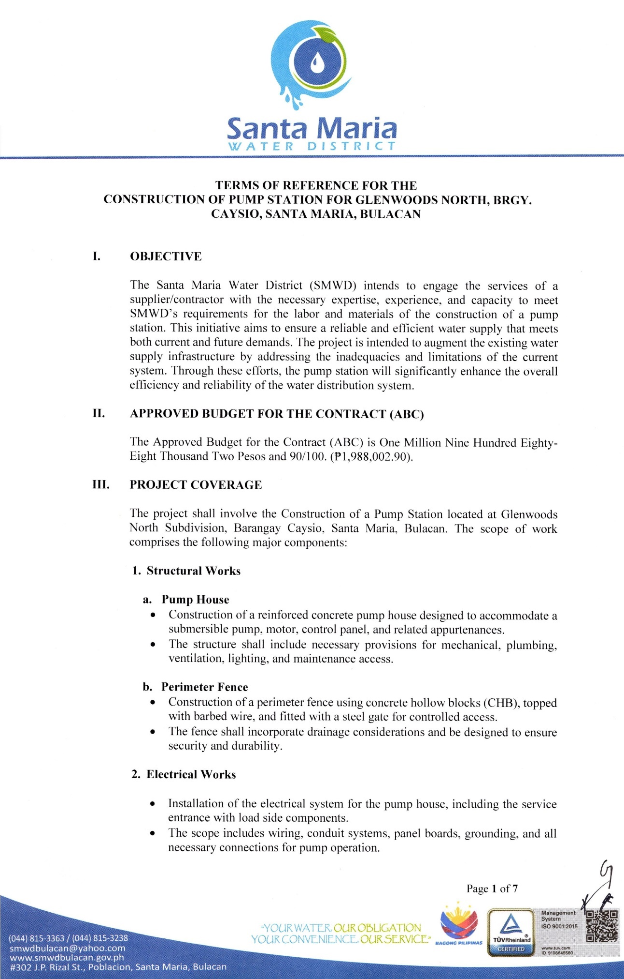
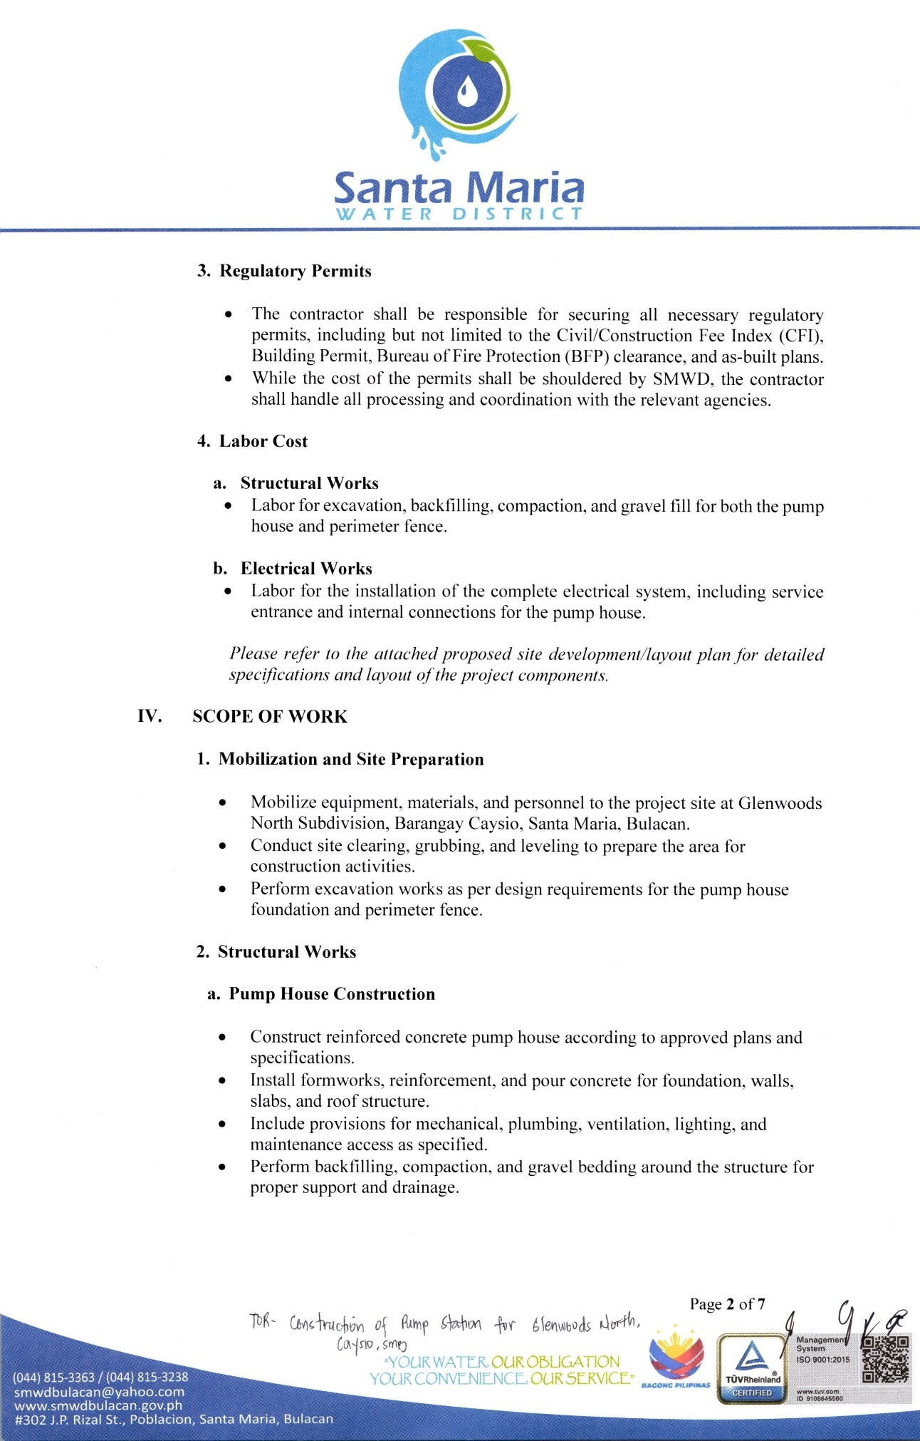
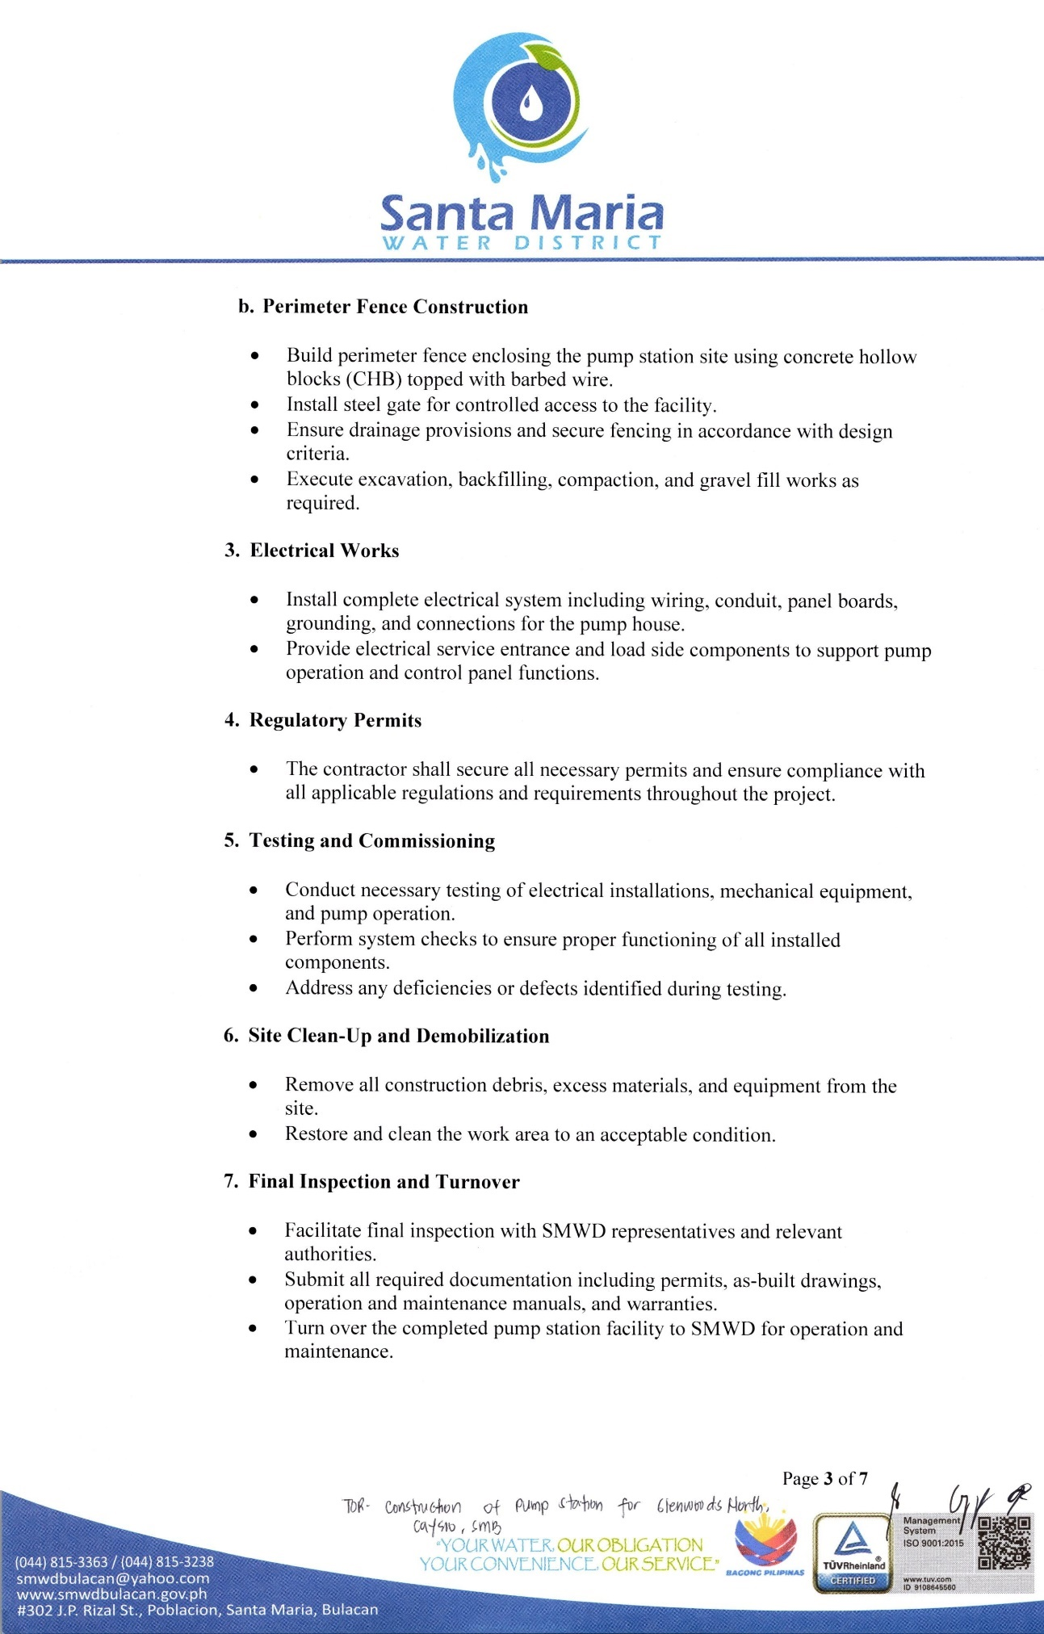
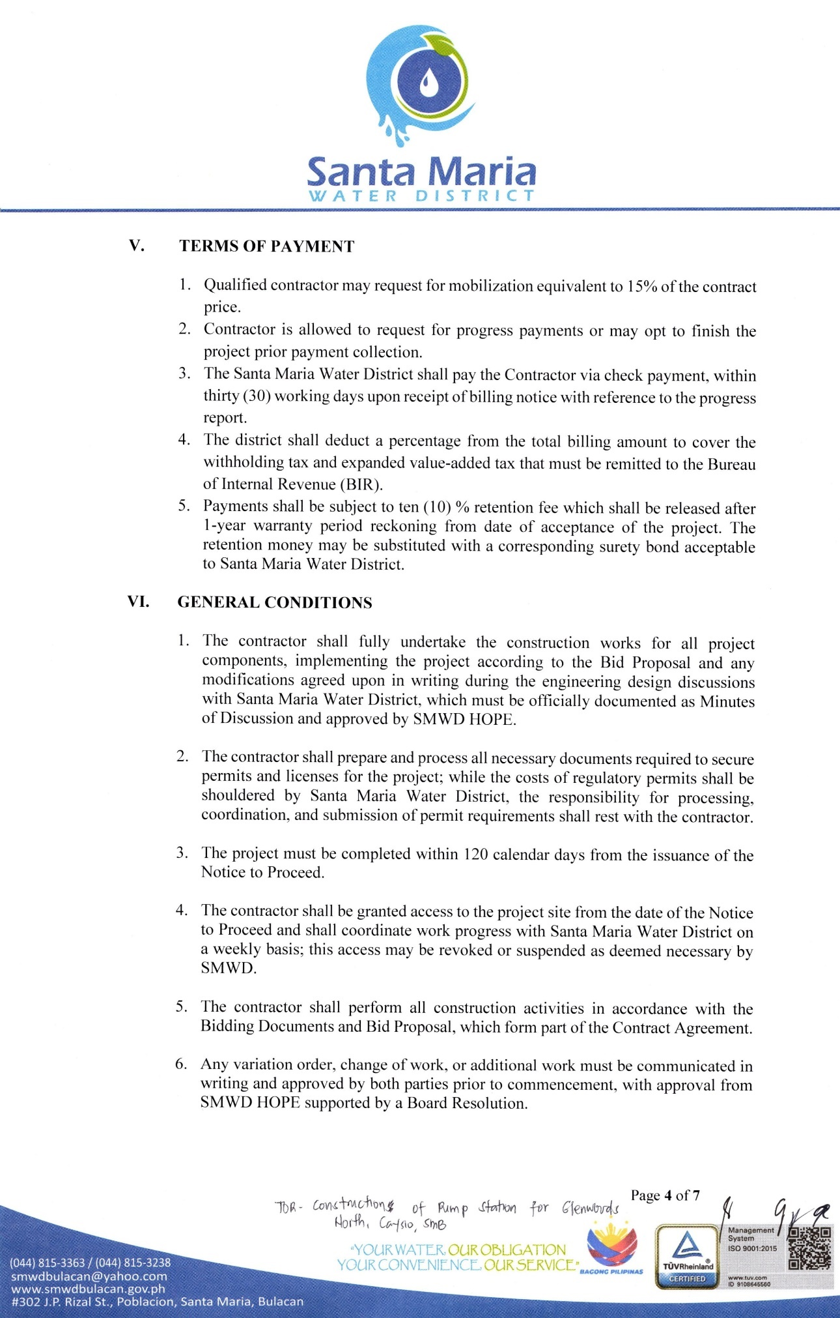
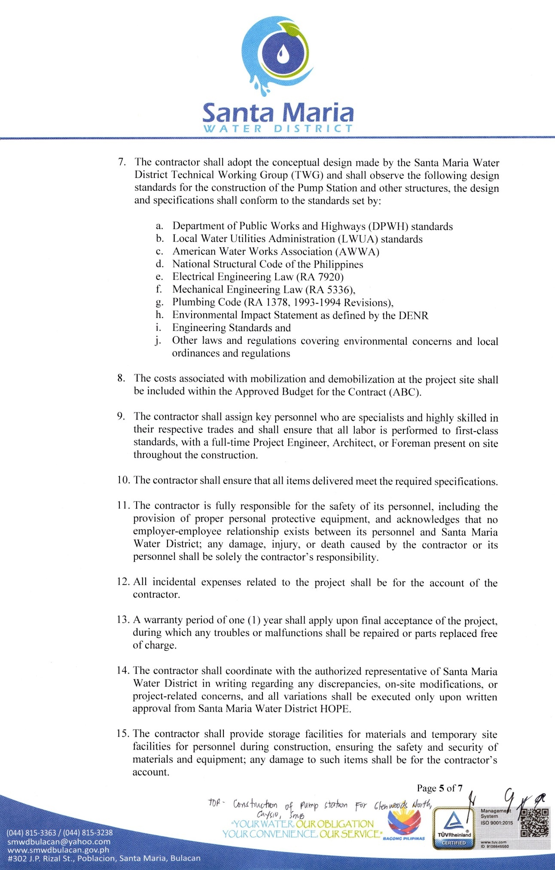
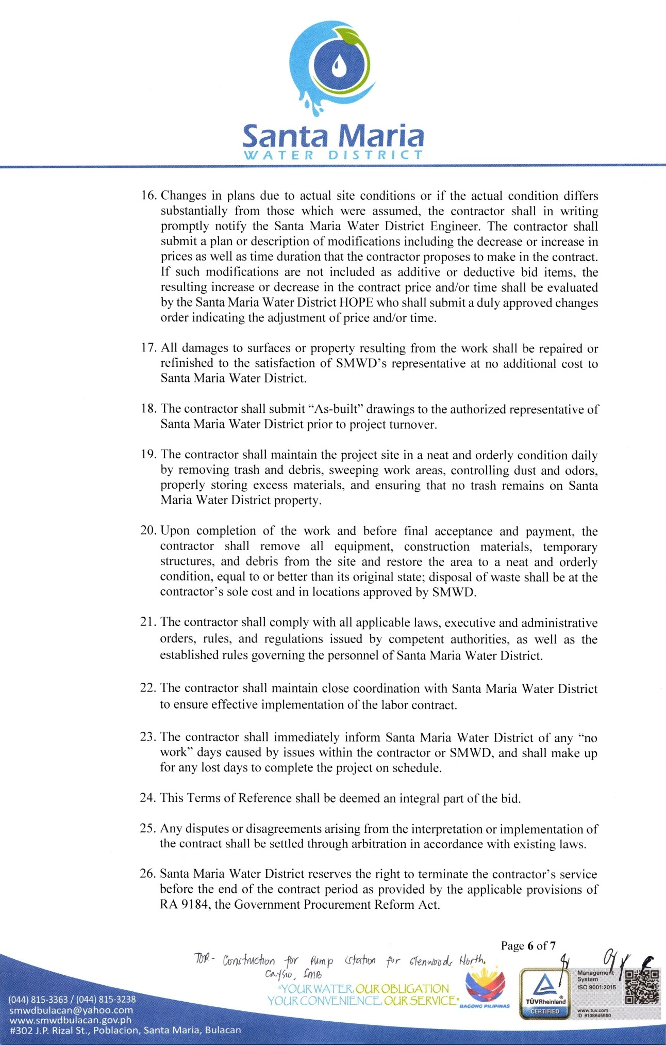
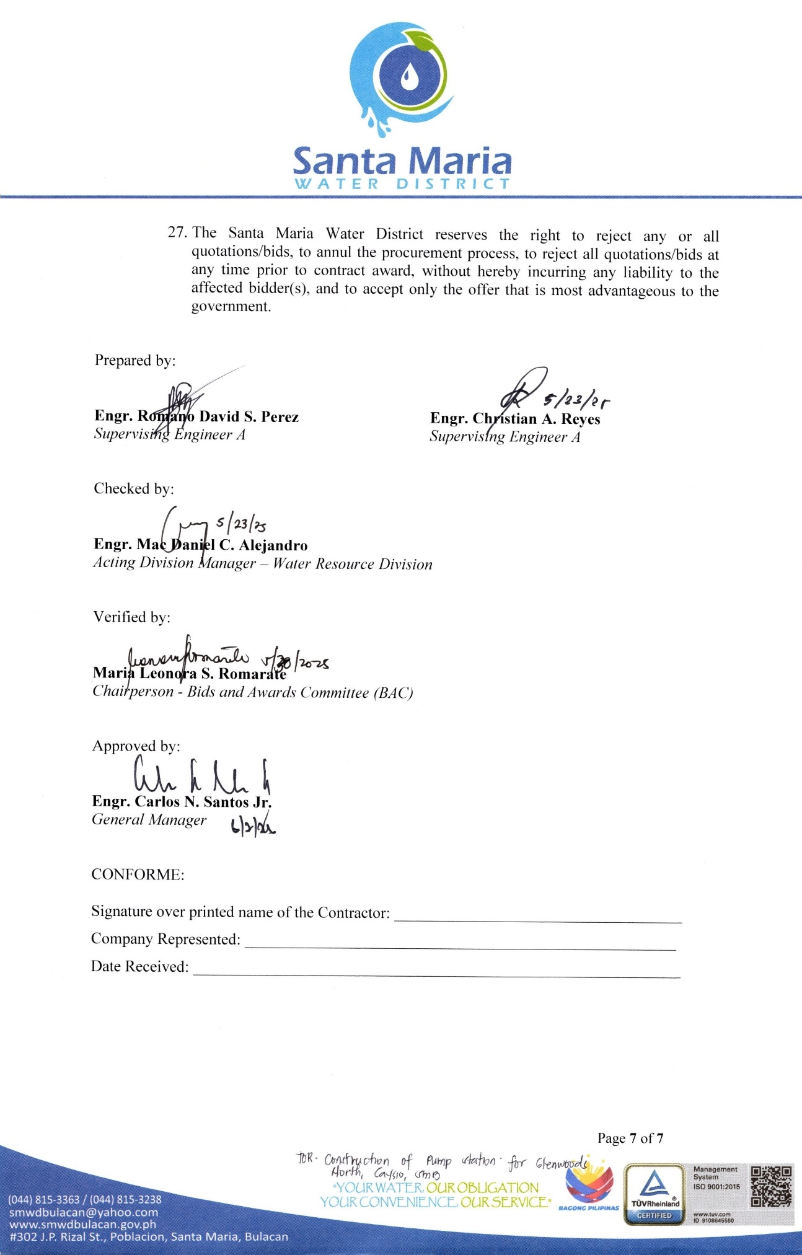

Section VII. Drawings

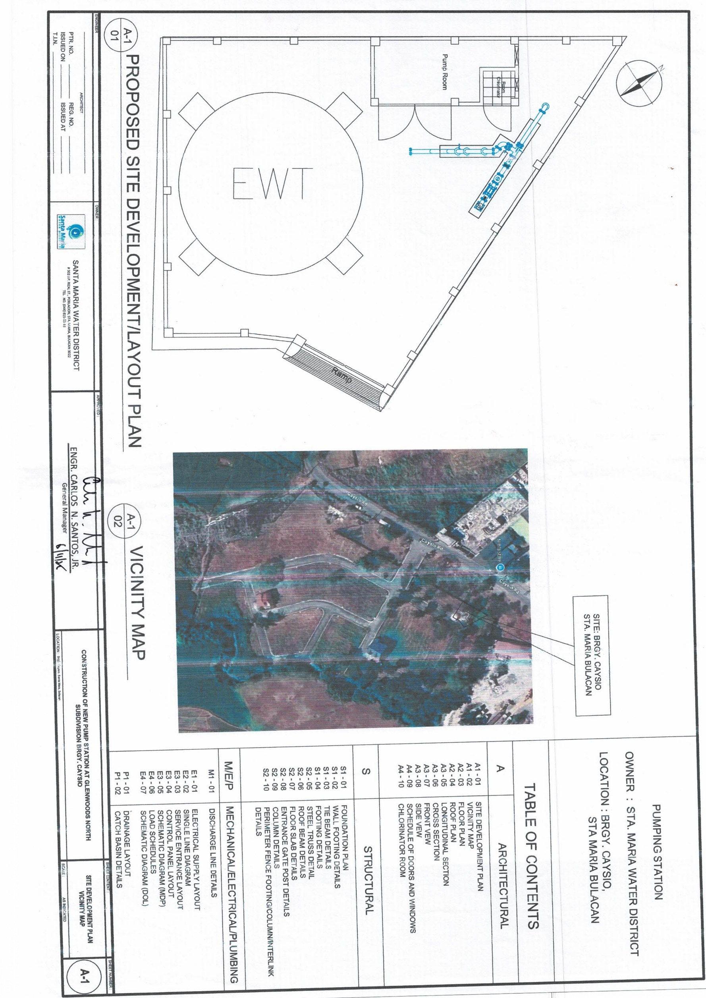

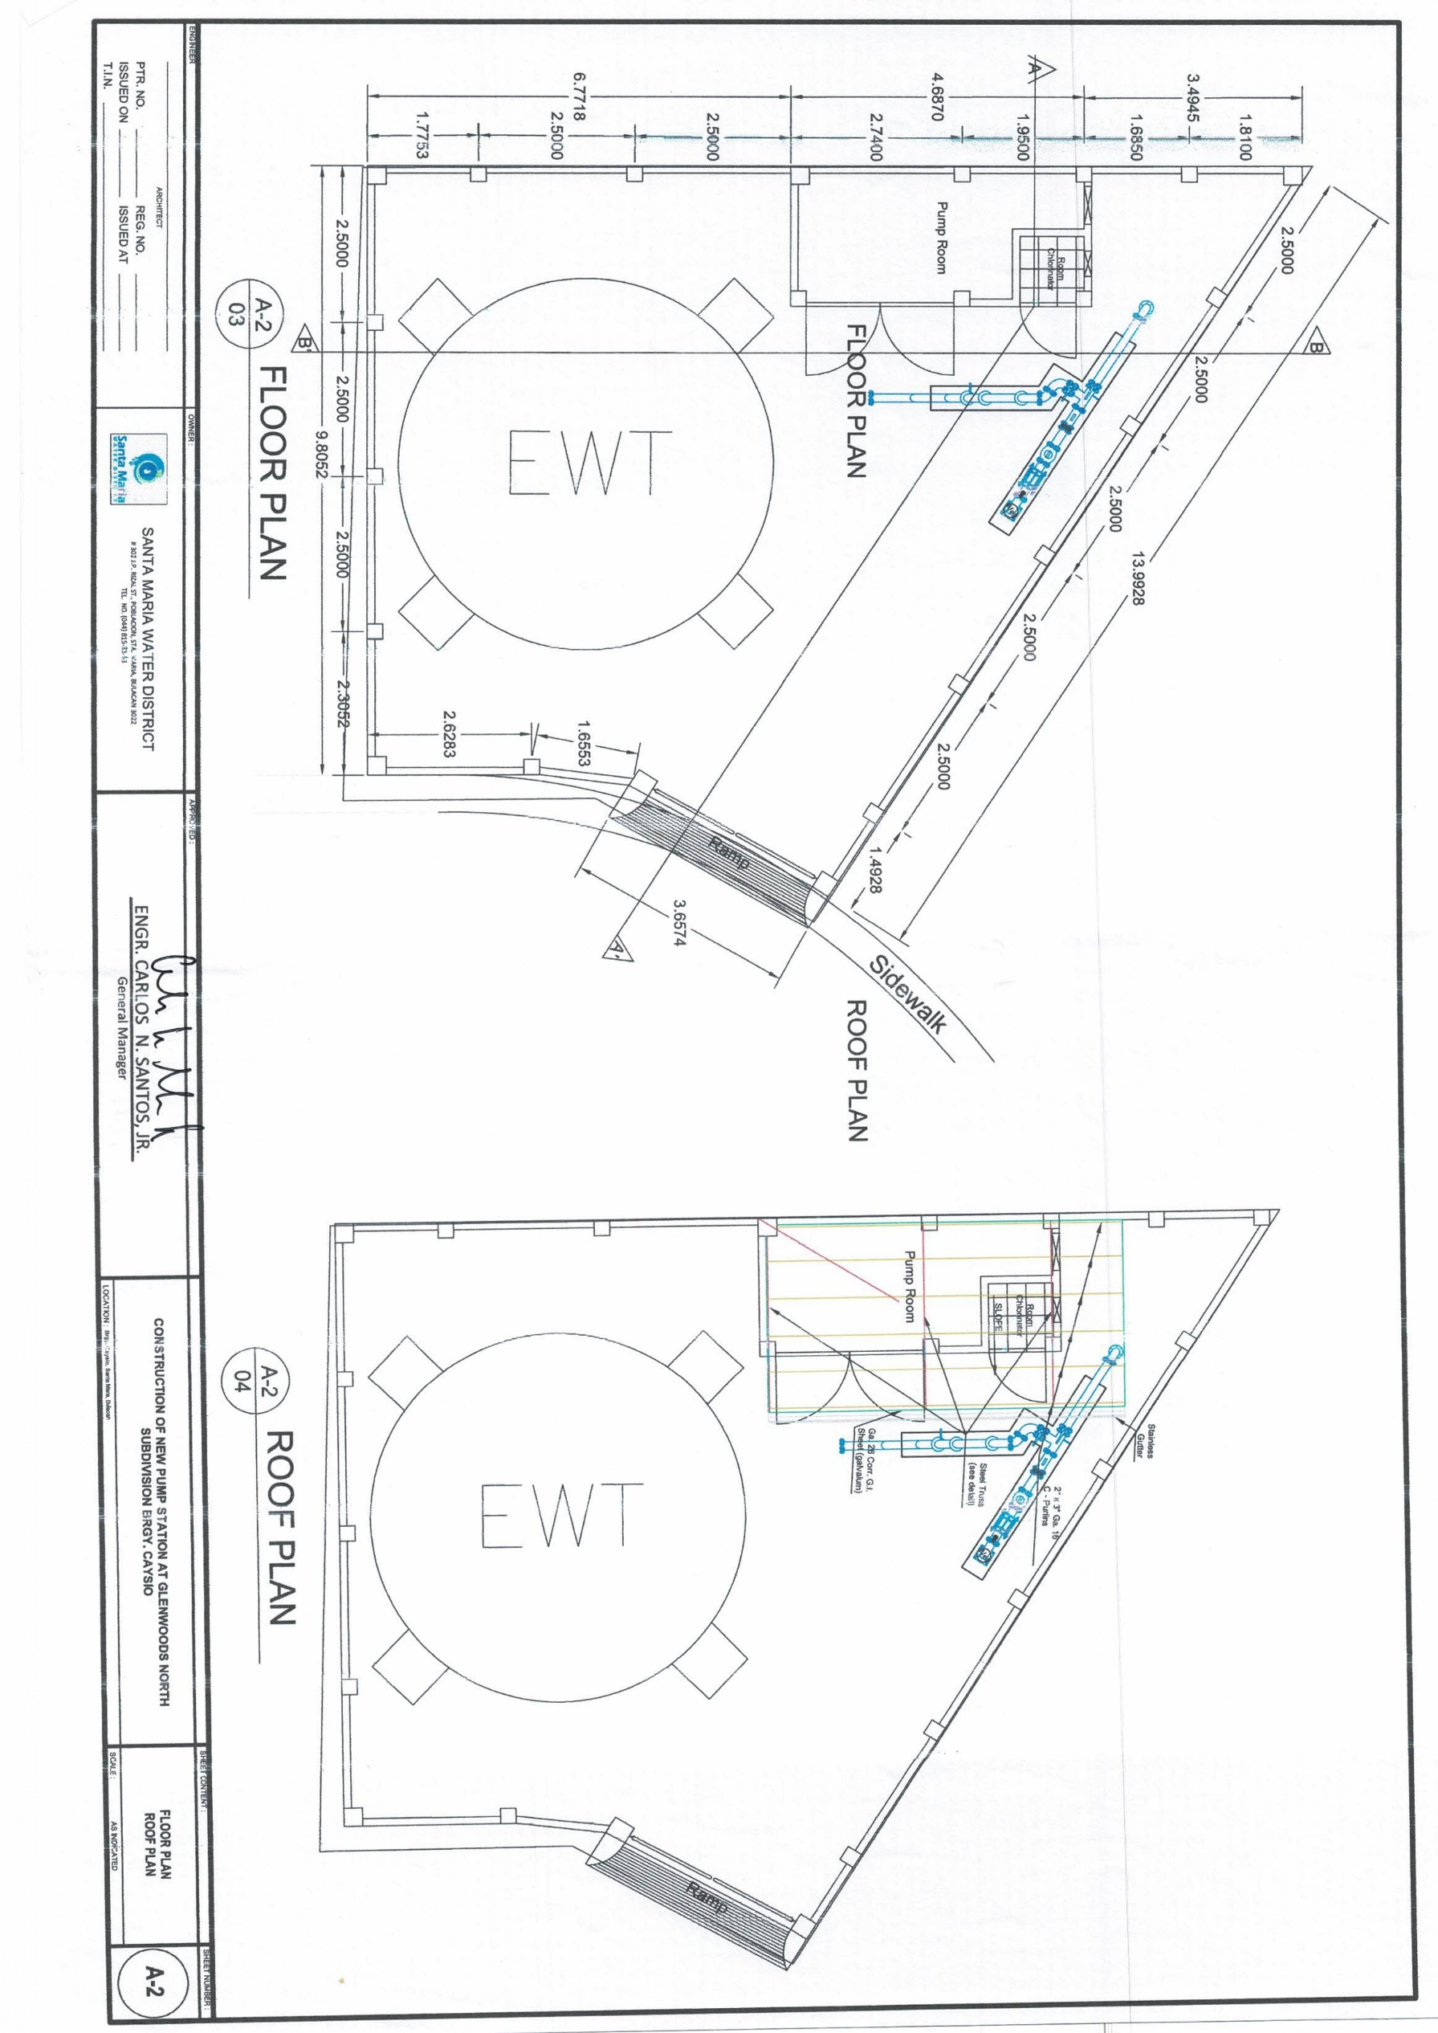

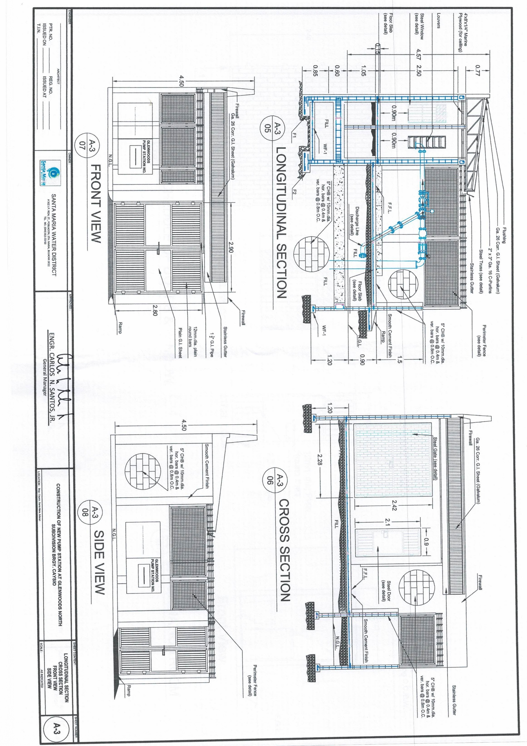

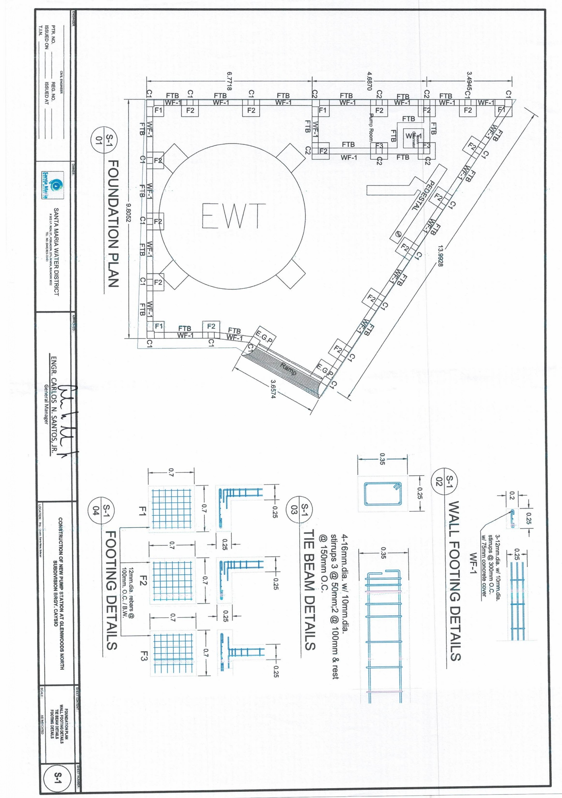

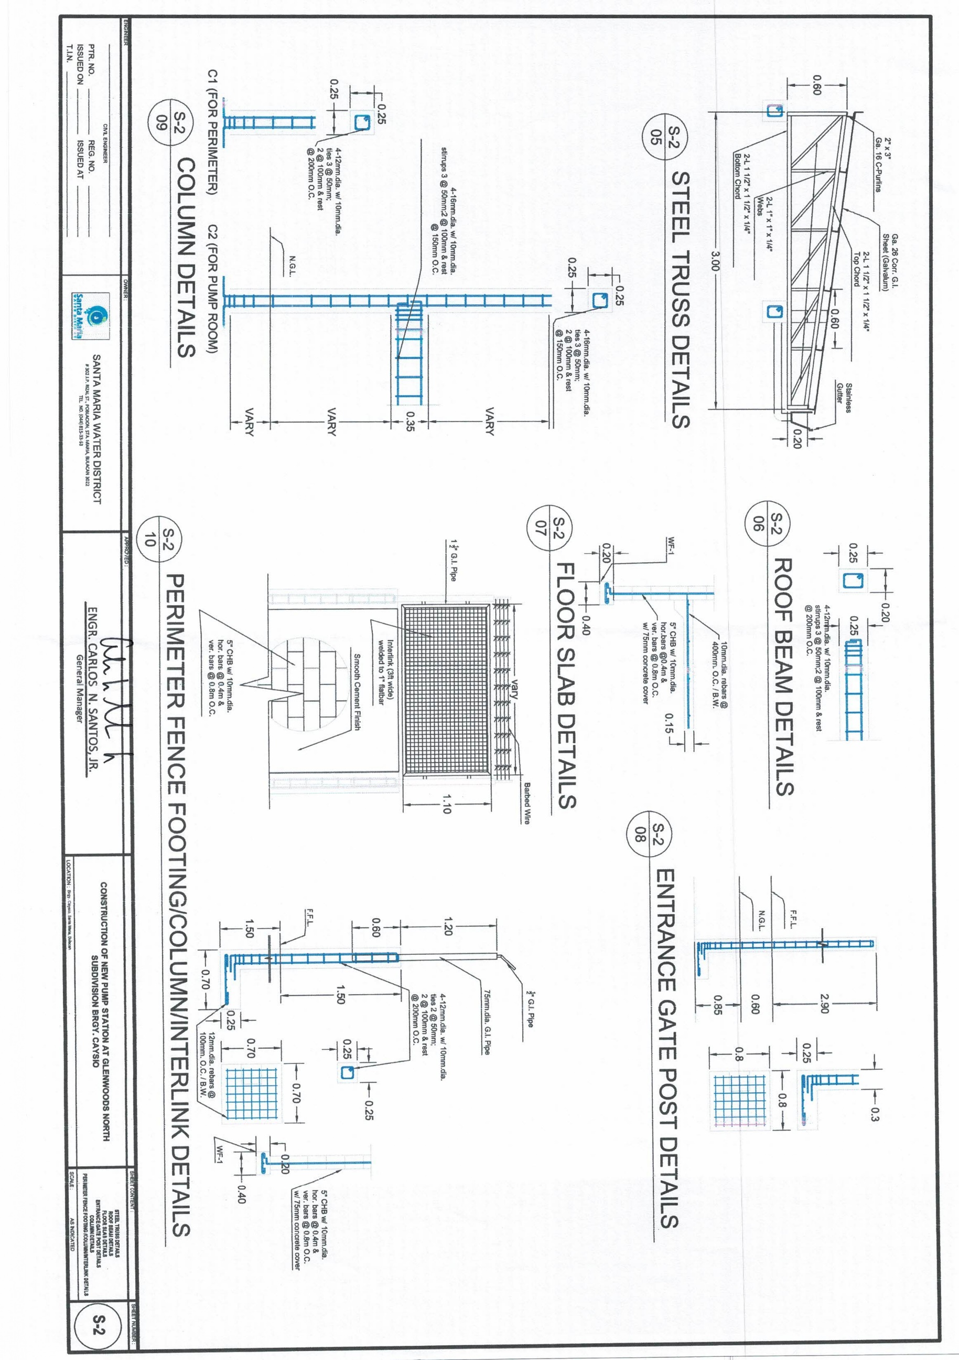

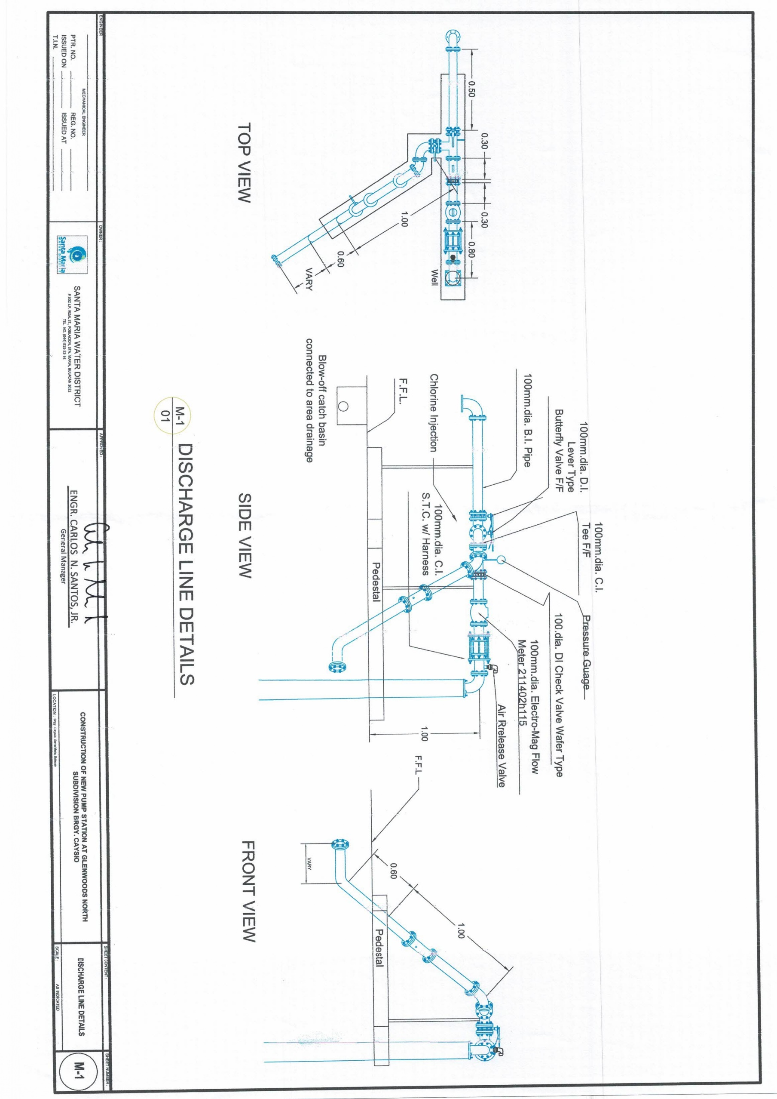
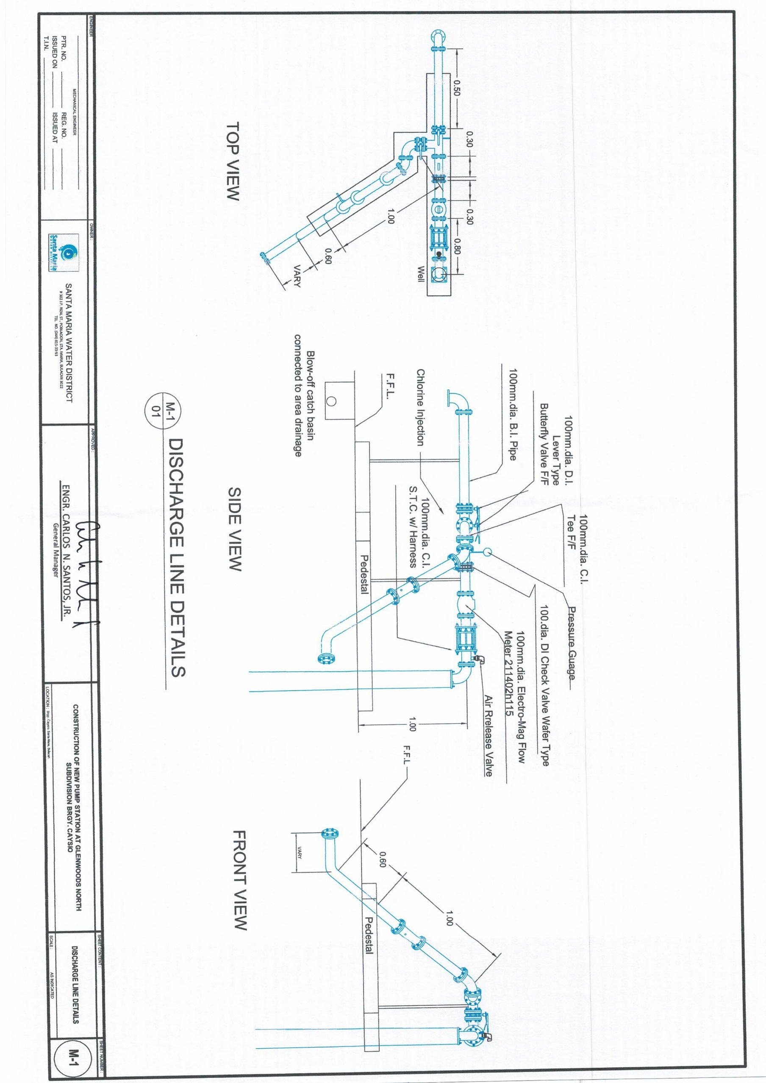

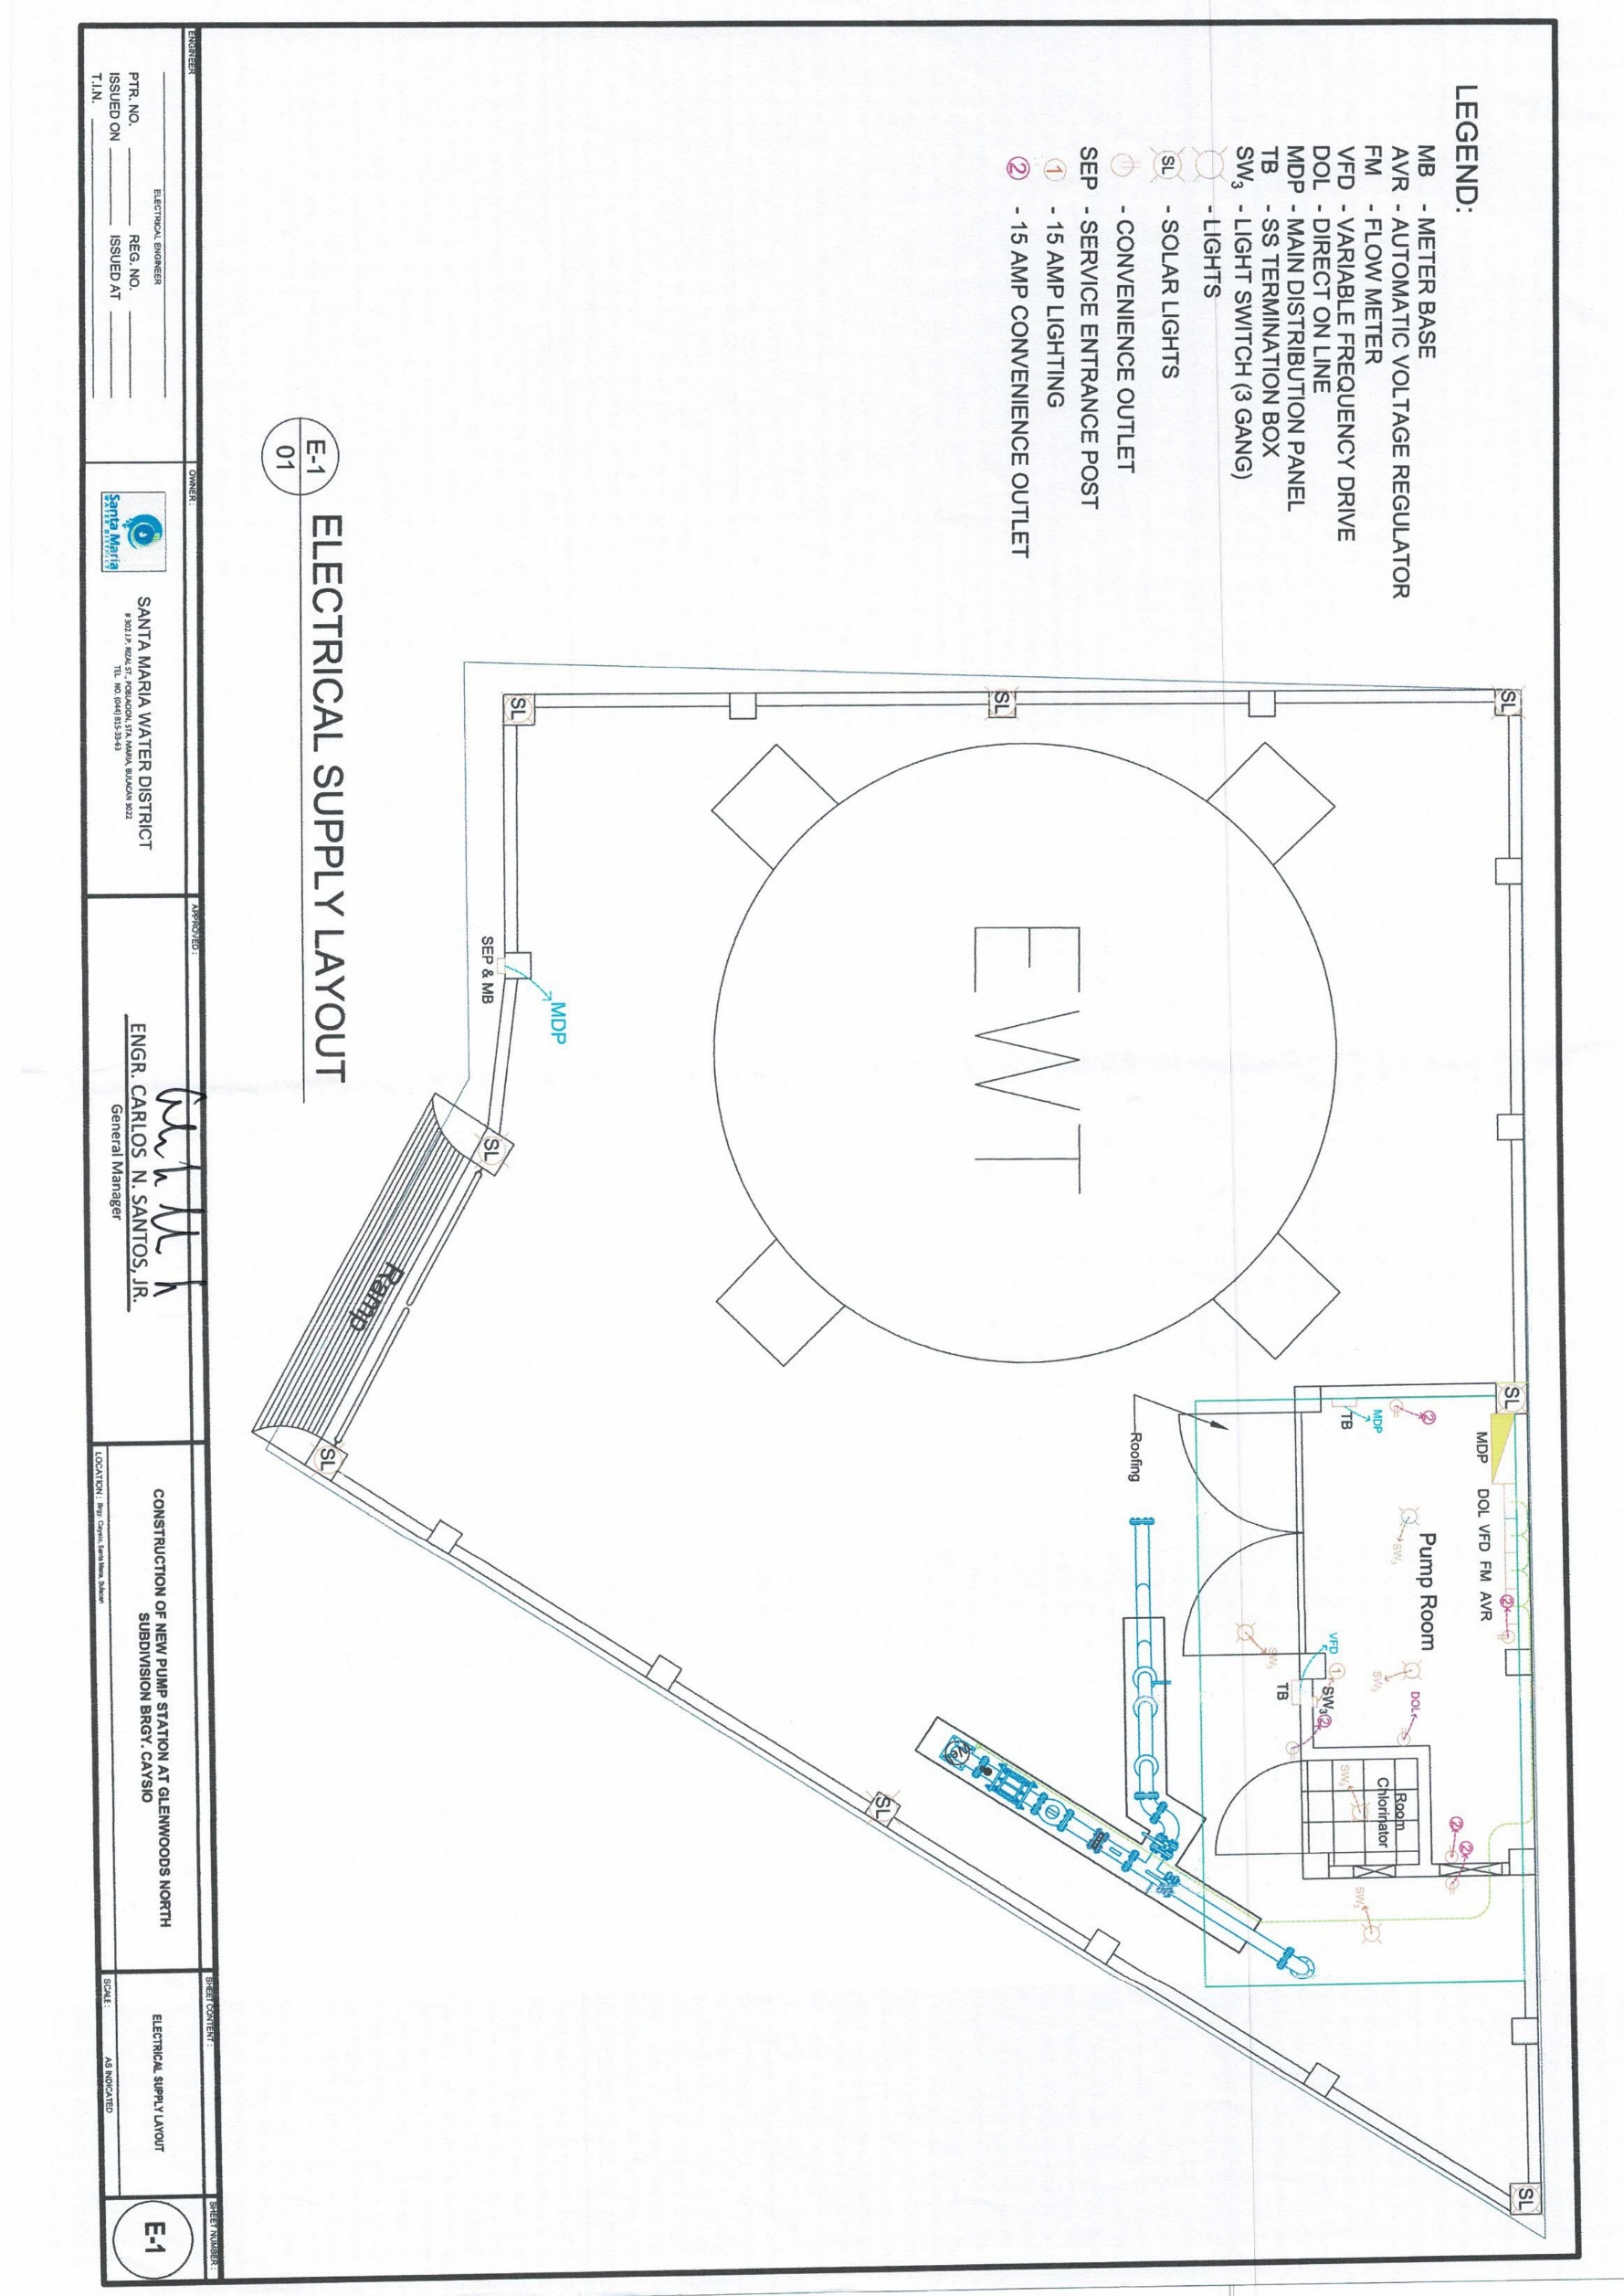

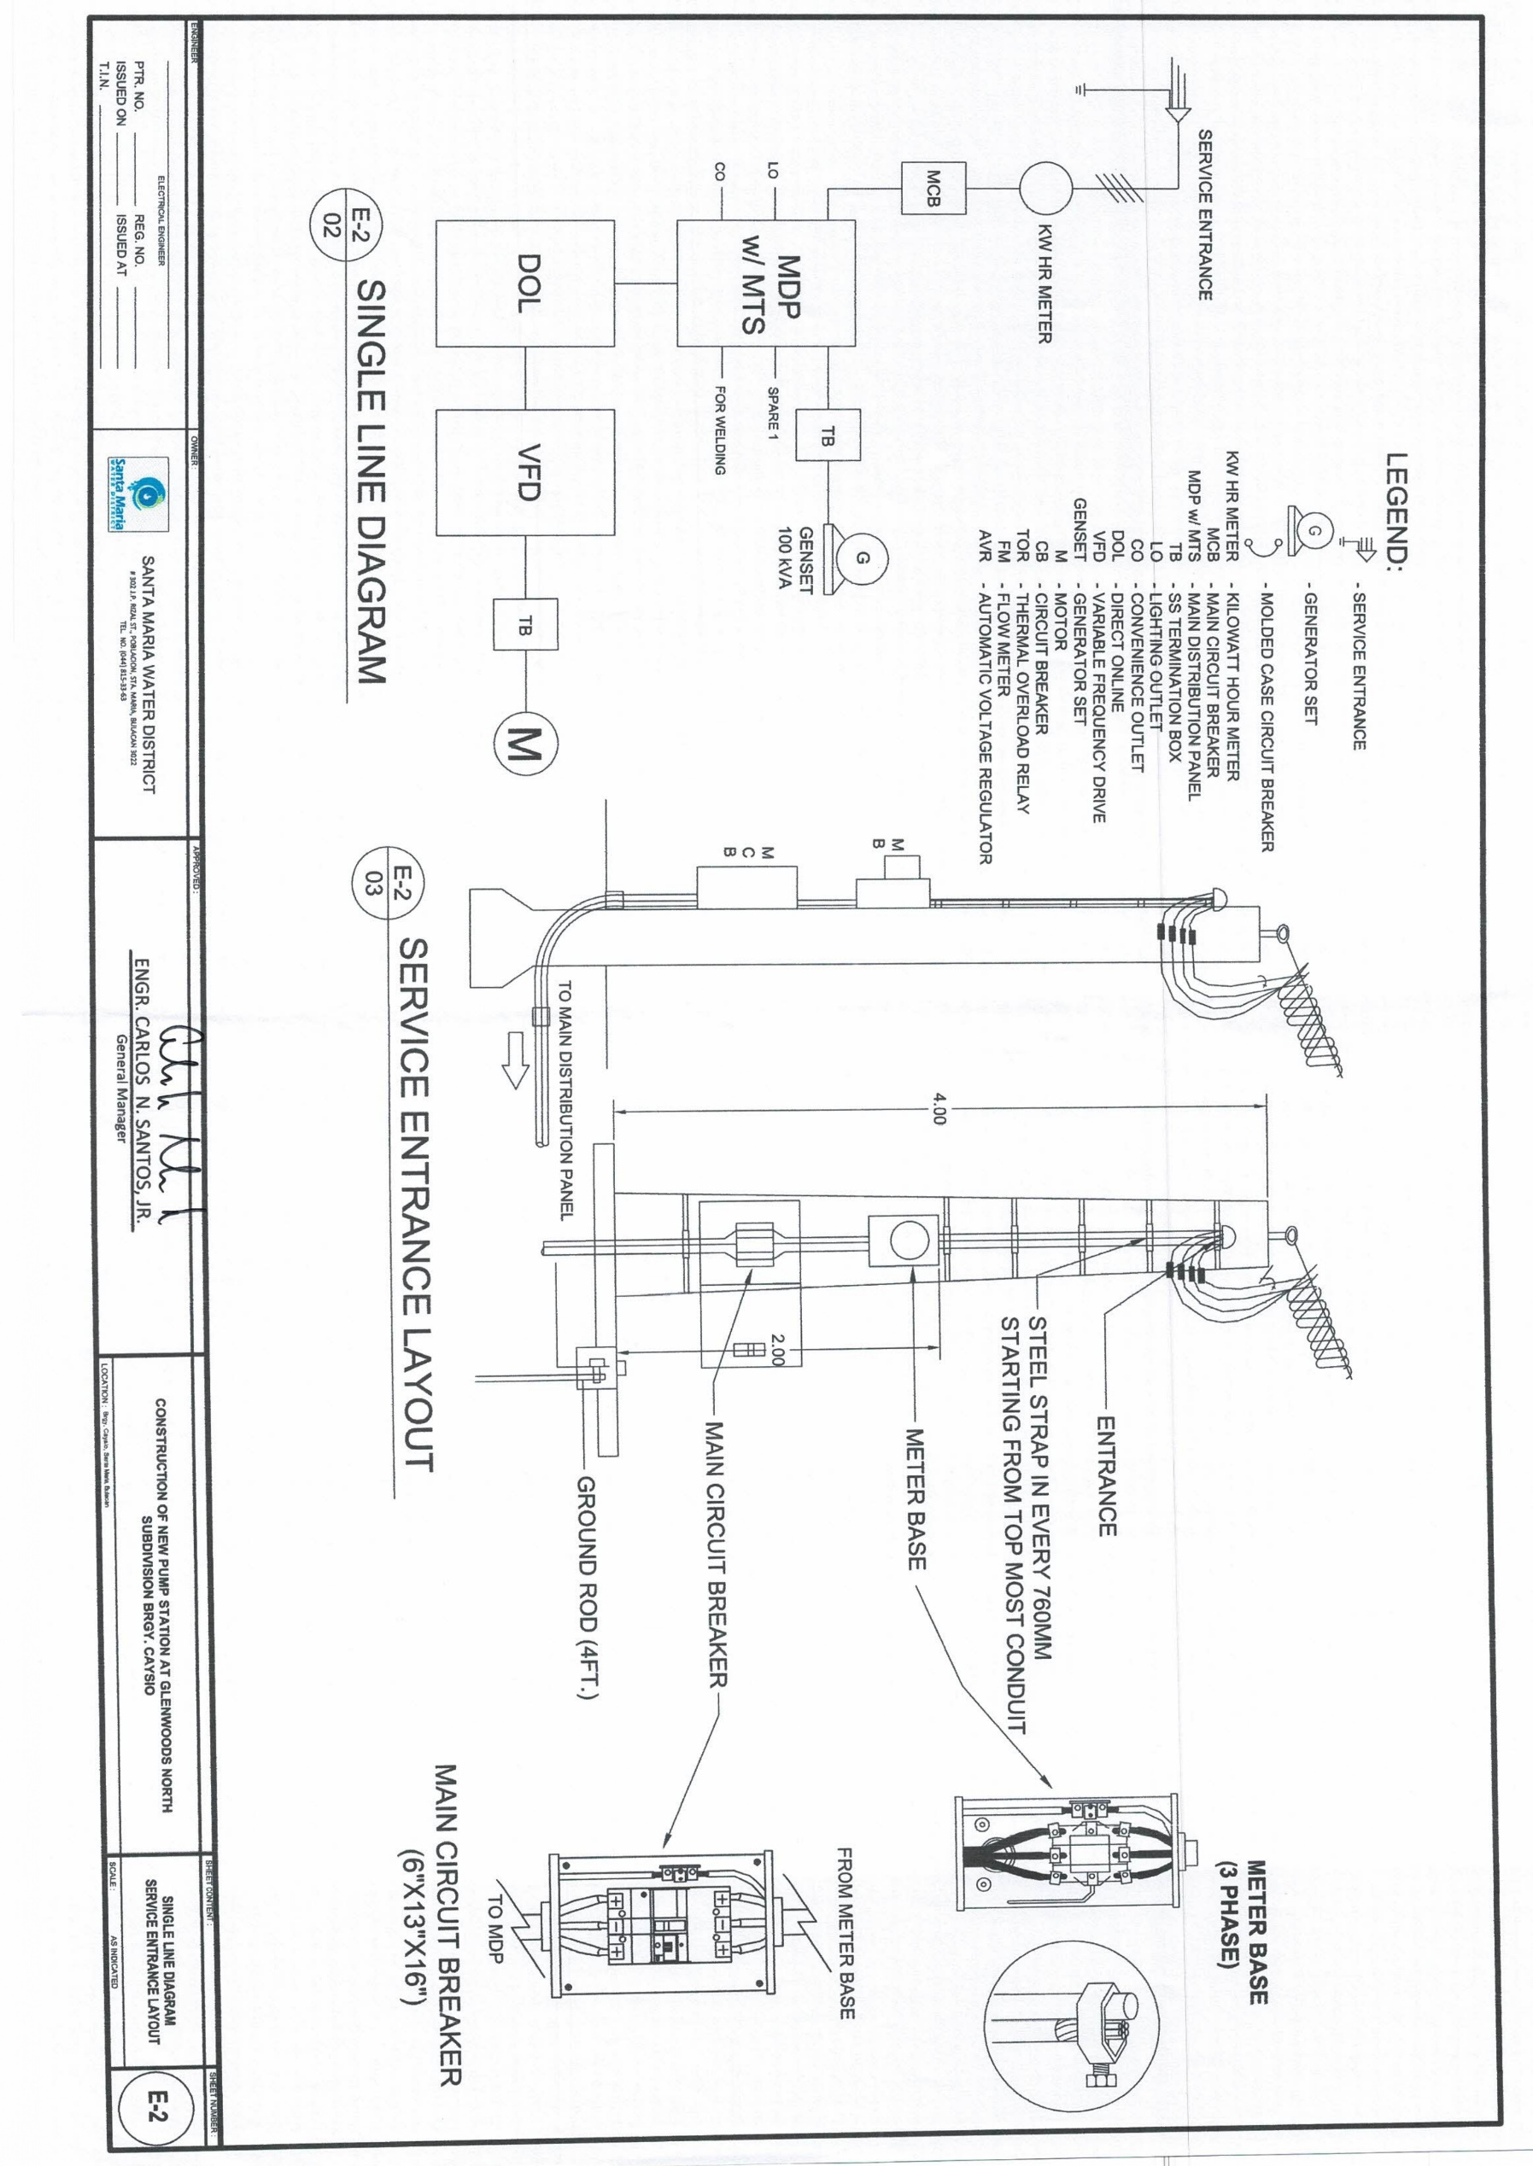

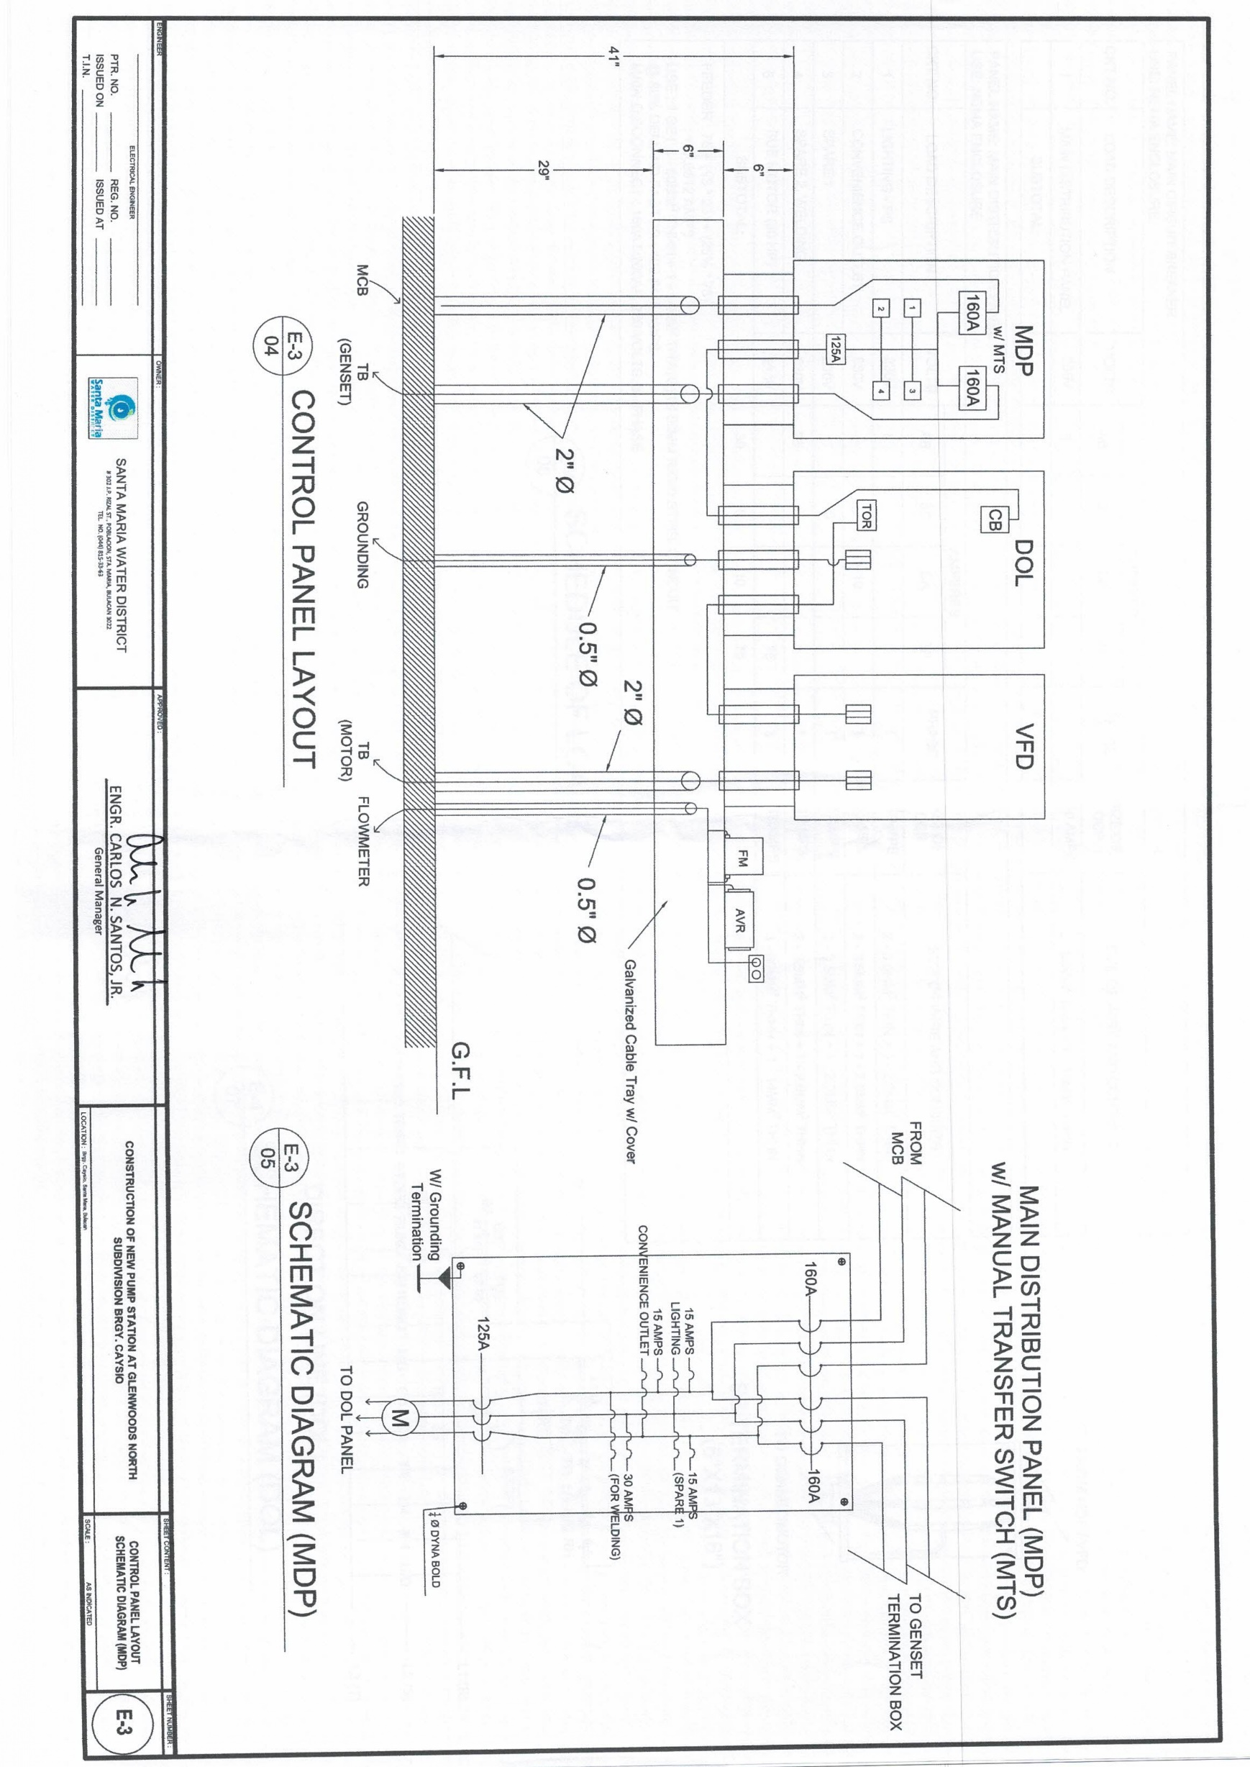

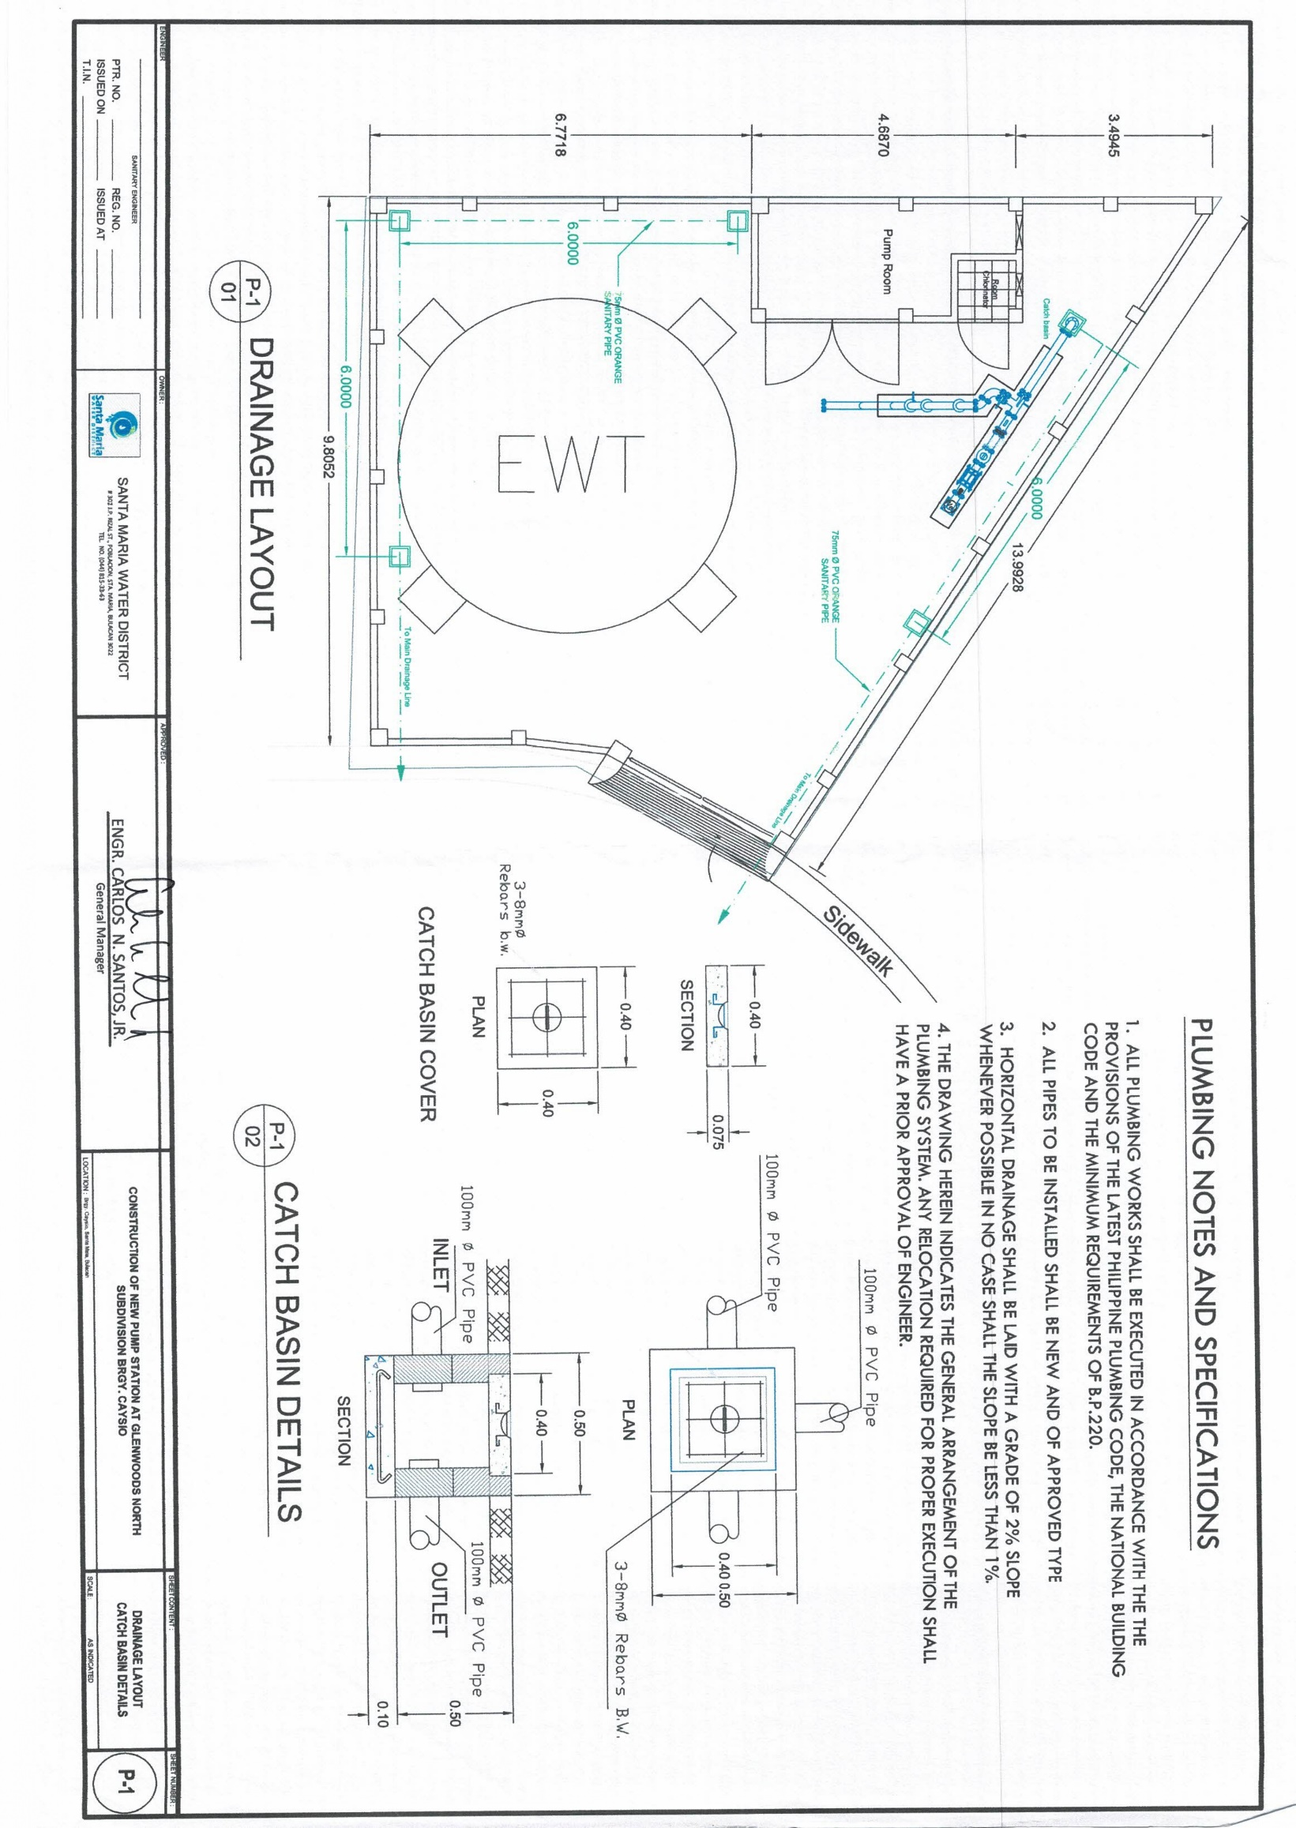

Section VIII. Bill of Quantities

Notes on the Bill of Quantities

Objectives

The objectives of the Bill of Quantities are:

      - to provide sufficient information on the quantities of Works to be performed to enable Bids to be prepared efficiently and accurately; and

      - when a Contract has been entered into, to provide a priced Bill of Quantities for use in the periodic valuation of Works executed.

In order to attain these objectives, Works should be itemized in the Bill of Quantities in sufficient detail to distinguish between the different classes of Works, or between Works of the same nature carried out in different locations or in other circumstances which may give rise to different considerations of cost. Consistent with these requirements, the layout and content of the Bill of Quantities should be as simple and brief as possible.

Daywork Schedule

A Daywork Schedule should be included only if the probability of unforeseen work, outside the items included in the Bill of Quantities, is high. To facilitate checking by the Entity of the realism of rates quoted by the Bidders, the Daywork Schedule should normally comprise the following:

- A list of the various classes of labor, materials, and Constructional Plant for which basic daywork rates or prices are to be inserted by the Bidder, together with a statement of the conditions under which the Contractor will be paid for work executed on a daywork basis.

- Nominal quantities for each item of Daywork, to be priced by each Bidder at Daywork rates as Bid. The rate to be entered by the Bidder against each basic Daywork item should include the Contractor’s profit, overheads, supervision, and other charges.

Provisional Sums

A general provision for physical contingencies (quantity overruns) may be made by including a provisional sum in the Summary Bill of Quantities. Similarly, a contingency allowance for possible price increases should be provided as a provisional sum in the Summary Bill of Quantities. The inclusion of such provisional sums often facilitates budgetary approval by avoiding the need to request periodic supplementary approvals as the future need arises. Where such provisional sums or contingency allowances are used, the SCC should state the manner in which they will be used, and under whose authority (usually the Procuring Entity’s Representative’s).

The estimated cost of specialized work to be carried out, or of special goods to be supplied, by other contractors should be indicated in the relevant part of the Bill of Quantities as a particular provisional sum with an appropriate brief description. A separate procurement procedure is normally carried out by the Procuring Entity to select such specialized contractors. To provide an element of competition among the Bidders in respect of any facilities, amenities, attendance, etc., to be provided by the successful Bidder as prime Contractor for the use and convenience of the specialist contractors, each related provisional sum should be followed by an item in the Bill of Quantities inviting the Bidder to quote a sum for such amenities, facilities, attendance, etc.

Signature Box

A signature box shall be added at the bottom of each page of the Bill of Quantities where the authorized representative of the Bidder shall affix his signature. Failure of the authorized representative to sign each and every page of the Bill of Quantities shall be a cause for rejection of his bid.

These Notes for Preparing a Bill of Quantities are intended only as information for the Procuring Entity or the person drafting the Bidding Documents. They should not be included in the final documents.

BILL OF QUANTITIES
Name of Project: CONSTRUCTION OF PUMPHOUSE, PERIMETER FENCE, AND SITE DEVELOPMENT OF GLENWOODS PUMP STATION AT BRGY. CAYSIO

Item | Description of Work | Unit | Qty. | Unit Cost | Total Cost
I | STRUCTURAL WORKS
 | A. Pump House
 | CEMENT | bags | 176
 | WHITE SAND | cu.m | 15
 | GRAVEL ¾ | cu.m | 27
 | SOIL FILL | cu.m | 15
 | DEFORMED ROUND BAR 10mm | pcs. | 135
 | DEFORMED ROUND BAR 12mm | pcs. | 50
 | GI WIRE NO. 16 | kgs. | 8
 | PLYWOOD ORDINARY 4 X 8 X ¼ | pcs. | 20
 | COCO LUMBER 2 X 3 X 12 | pcs. | 240
 | NAIL COMMON 1 | kgs. | 2
 | NAIL COMMON 2 | kgs. | 2
 | NAIL COMMON 3 | kgs. | 3
 | NAIL COMMON 4 | kgs. | 3
 | CONCRETE HOLLOW BLOCK NO. 5 | pcs. | 440
 | CONCRETE HOLLOW BLOCK NO. 4 | pcs. | 65
 | 5" x 6" x 12" LOUVER BLOCKS | pcs. | 6
 | FLOOR TILES | pcs. | 22
 | 0.80m x 1.80m STEEL DOOR w/ HINGE | set | 1
 | 0.9m x 2.10m STEEL DOOR W/ HINGE | set | 1
 | 0.60m x 1.2m STEEL WINDOW w/ GLASS | set | 1
 | PAINT RED LEAD PRIMER | gal. | 20
 | GI SHEET 26 (3 X 8) | sq.m. | 14
 | GI GUTTER 8 | pcs. | 2
 | PRE-PAINTED END FLASHING 8FT | pcs. | 5
 | ROOF FRAMES (TRUSSES) | l.m. | 70
 | 2" x 3" Ga. 16 C-PURLINS | pcs. | 8
 | TEXT SCREW 1 ½ | pcs. | 100
 | ALUMINUM BLIND RIVETS 3/16 X 1" | pcs. | 200
 | SILICON SEALANT TUBE | pcs. | 35
 | PADLOCK 50 | pcs. | 2
 | CABLE TIE NO.8 | pcs. | 25
 | METAL SCREW 3/16 x 1 ½ | pcs. | 20
 | ALL AROUND SEALANT | liters | 3
 | TOX # 8 w/ SCREW | pcs. | 20

 | CUTTING DISK 4 | pcs. | 25
 | GARDEN HOSE 1/2 | mtr | 6
 | HOSE BIB 1/2 | pcs. | 1
 | HDPE TUBING 1/2 SDR 11 (BLUE) | mtr | 150
 | PLASTIC ADAPTOR 1/2 | pcs. | 2
 | WATER FAUCET | pcs. | 1
 | CHLORINATOR BRACKET MOUNT | pcs. | 1
 | ALUMINUM STAND w/ BRACE FOR AVR | pcs. | 1
 | PAINTING OF WALL & CEILING | Sq.m. | 110
 | B. Perimeter Fence
 | CEMENT | bags | 300
 | WHITE SAND | cu.m | 20
 | GRAVEL 3/4 | cu.m | 26
 | SOIL FILL | cu.m | 10
 | DEFORMED ROUND BAR 10mm | pcs | 1500
 | DEFORMED ROUND BAR 12mm | pcs | 120
 | GI WIRE NO. 16 | kg | 50
 | PLYWOOD ORDINARY 4 X 8 X 1/4 | pcs | 10
 | COCO LUMBER 2 X 3 X 12 | pcs | 50
 | NAIL COMMON 1 | kg | 3
 | NAIL COMMON 2 | kg | 3
 | NAIL COMMON 3 | kg | 4
 | NAIL COMMON 4 | kg | 4
 | CONCRETE HOLLOW BLOCK NO. 5 | pcs | 940
 | 3"Ø G.I. PIPE | pcs | 3
 | 1 1/2"Ø G.I. PIPE | pcs | 15
 | 1" x 3/16" FLAT BAR | pcs | 15
 | 3' WIDE STEEL MATTING | pcs | 5
 | SOLVENT CEMENT | pcs | 5
 | PVC PIPE 3" | pcs | 10
 | BARBED WIRE | roll | 2
 | WELDING ROD | kg | 6
 | 6" REINFORCED CONCRETE PIPE | pcs | 53
 | 2.4m (H) x 1.0m (W) STEEL GATE w/ HINGE | set | 1
 | PAINT RED LEAD PRIMER | gal | 20
 | METAL SCREW 3/16 x 1 1/2 | pcs | 20
 | PAINTING w/ LOGO | sq.m | 210

II | ELECTRICAL WORKS (Pump House including electrical for Service Entrance with Load Side)
 | ENTRANCE EYEBOLT 1/2" | pcs | 1
 | ELECTRICAL TAPE BIG | rolls | 3
 | RUBBER TAPE | rolls | 3
 | STRANDED WIRE 60mm THHN (RED) | mtrs | 56
 | STRANDED WIRE 60mm THHN (YELLOW) | mtrs | 56
 | STRANDED WIRE 60mm THHN (BLACK) | mtrs | 56
 | STRANDED WIRE 14mm THHN (WHITE) | mtrs | 56
 | STRANDED WIRE 3.5mm THHN (RED) | mtrs | 150
 | STRANDED WIRE 2.0mm THHN (WHITE) | mtrs | 150
 | UPVC JUNCTION BOX | pcs | 4
 | UTILITY BOX 2"X4" | pcs | 6
 | PLATE COVER W/ SWITCH 3 GANG | pcs | 1
 | UNIVERSAL DUPLEX OUTLET 2 GANG W/ GROUND | pcs | 5
 | WATER PROOF SINGLE SOCKET IP66 | pcs | 2
 | RECEPTACLE 4"X4" | pcs | 5
 | LED BULB 11W | pcs | 5

 | POLY ELECTRICAL PVC PIPE 2" | pcs | 10
 | POLY ELECTRICAL PVC LONG ELBOW 2" | pcs | 15
 | POLY ELECTRICAL PVC PIPE 1/2" | pcs | 25
 | "MAIN DISTRIBUTION PANEL w/ MTS  (see Schematic Diagram)" | set | 1
 | "SS TERMINATION BOX 6""x13""x16""  (see Schematic Diagram)" | set | 2
 | GALVANIZED CABLE TRAY W/ COVER 8"x8"x10ft | set | 1
 | "MAIN CIRCUIT BREAKER 6""x13""x16""  (see Schematic Diagram)" | pcs | 1
 | SOLDERLESS CONNECTOR 60mm | pcs | 3
 | DYNA BOLT 1 1/2" x 1/4" | pcs | 17
 | ENTRANCE CAP 2 1/2" | pcs | 1
 | GROUNDING ROD 1/2" with clamp (4 ft) | set | 1
 | LOCK NUT WASHER 2" | pcs | 6
 | END CAP WASHER 2" | pcs | 6
 | METAL CLAMP 2 1/2" (U-TYPE) | pcs | 12
 | METAL CLAMP 1/2" | pcs | 12
 | ELECTRICAL CONDUIT PIPE 2 1/2" x 8ft | pcs | 1
 | ELECTRICAL CONDUIT PIPE 1/2" x 4ft | pcs | 1
 | GI NIPPLE 50mm X 4 (Schd. 40) | pcs | 1
 | GROUNDING CLAMP 8mm | pcs | 1
 | GI PIPE 1/2" (Schd. 40), for Solar Light | pcs | 4
 | COMPACT SOLAR STREET LIGHT 15 watts | pcs | 8
III | REGULATORY PERMITS
 | CFI, Building Permit, BFP, as-built plans, and other local permits  (The costs shall be shouldered by the SMWD; however, the processing and securing of all necessary permits shall be done by the contractor.) | lot | 1
IV | LABOR COST
 | A. Structural Works
 | Pump House | lot | 1
 | *Labor - Excavation | cu.m | 6
 | *Labor - Backfilling and Compaction | cu.m | 12
 | *Labor - Gravel Fill | cu.m | 4
 | Perimeter Fence | lot | 1
 | *Labor - Excavation | cu.m | 35
 | *Labor - Backfilling and Compaction | cu.m | 15
 | *Labor - Gravel Fill | cu.m | 6
 | B. Electrical Works (Pump House including electrical for Service Entrance with Load Side) | lot | 1
 | GRAND TOTAL

Section IX. Checklist of Technical and Financial Documents

Notes on the Checklist of Technical and Financial Documents

The prescribed documents in the checklist are mandatory to be submitted in the Bid, but shall be subject to the following:

- GPPB Resolution No. 09-2020 on the efficient procurement measures during a State of Calamity or other similar issuances that shall allow the use of alternate documents in lieu of the mandated requirements; or

- any subsequent GPPB issuances adjusting the documentary requirements after the effectivity of the adoption of the PBDs.

The BAC shall be checking the submitted documents of each Bidder against this checklist to ascertain if they are all present, using a non-discretionary “pass/fail” criterion pursuant to Section 30 of the 2016 revised IRR of RA No. 9184.

Checklist of Technical and Financial Documents
- TECHNICAL COMPONENT ENVELOPE

Class “A” Documents

Legal Documents
⬜ | - Valid PhilGEPS Registration Certificate (Platinum Membership) (all pages);  or
⬜ | - Registration certificate from Securities and Exchange Commission (SEC), Department of Trade and Industry (DTI) for sole proprietorship, or Cooperative Development Authority (CDA) for cooperatives or its equivalent document;  and
⬜ | - Mayor’s or Business permit issued by the city or municipality where the principal place of business of the prospective bidder is located, or the equivalent document for Exclusive Economic Zones or Areas;  and
⬜ | - Tax clearance per E.O. No. 398, s. 2005, as finally reviewed and approved by the Bureau of Internal Revenue (BIR).
Technical Documents
⬜ | - Statement of the prospective bidder of all its ongoing government and private contracts, including contracts awarded but not yet started, if any, whether similar or not similar in nature and complexity to the contract to be bid; and
⬜ | - Statement of the bidder’s Single Largest Completed Contract (SLCC) similar to the contract to be bid, except under conditions provided under the rules; and
⬜ | - Philippine Contractors Accreditation Board (PCAB) License;  or  Special PCAB License in case of Joint Ventures;  and registration for the type and cost of the contract to be bid; and
⬜ | - Original copy of Bid Security. If in the form of a Surety Bond, submit also a certification issued by the Insurance Commission;  or  Original copy of Notarized Bid Securing Declaration; and
 | - Project Requirements, which shall include the following:
⬜ | - Organizational chart for the contract to be bid;
⬜ | - List of contractor’s key personnel (e.g., Project Manager, Project Engineers, Materials Engineers, and Foremen), to be assigned to the contract to be bid, with their complete qualification and experience data;
⬜ | - List of contractor’s major equipment units, which are owned, leased, and/or under purchase agreements, supported by proof of ownership or certification of availability of equipment from the equipment lessor/vendor for the duration of the project, as the case may be; and
⬜ | - Original duly signed Omnibus Sworn Statement (OSS);  and if applicable, Original Notarized Secretary’s Certificate in case of a corporation, partnership, or cooperative; or Original Special Power of Attorney of all members of the joint venture giving full power and authority to its officer to sign the OSS and do acts to represent the Bidder.
Financial Documents
⬜ | - The prospective bidder’s audited financial statements, showing, among others, the prospective bidder’s total and current assets and liabilities, stamped “received” by the BIR or its duly accredited and authorized institutions, for the preceding calendar year which should not be earlier than two (2) years from the date of bid submission; and
⬜ | - The prospective bidder’s computation of Net Financial Contracting Capacity (NFCC).
Class “B” Documents
⬜ | - If applicable, duly signed joint venture agreement (JVA) in accordance with RA No. 4566 and its IRR in case the joint venture is already in existence;  or  duly notarized statements from all the potential joint venture partners stating that they will enter into and abide by the provisions of the JVA in the instance that the bid is successful.
- FINANCIAL COMPONENT ENVELOPE
⬜ |  | - Original of duly signed and accomplished Financial Bid Form; and
Other documentary requirements under RA No. 9184
⬜ |  | - Original of duly signed Bid Prices in the Bill of Quantities; and
⬜ |  | - Duly accomplished Detailed Estimates Form, including a summary sheet indicating the unit prices of construction materials, labor rates, and equipment rentals used in coming up with the Bid; and
⬜ |  | - Cash Flow by Quarter.



